**Melting Ice and Sea Level Rise:**

**Which Affects Sea Level the most––Melting Land Ice or Sea Ice?**

**PURPOSE**

The purpose of this lesson is to investigate the effect of melting land and sea ice on sea level.

**EXPERIMENTAL DESIGN**

In this experiment, you will construct two models (one with melting sea ice and another with melting land ice) to answer the following question:

**Which Affects Sea Level the most––Melting Land Ice or Sea Ice?**

**Hypothesis**

After reading through the methods section below, write a hypothesis that includes the independent and dependent variables in the experiment.

*Hypothesis:*

**Methods**

**Part A: Sea Ice**

1. 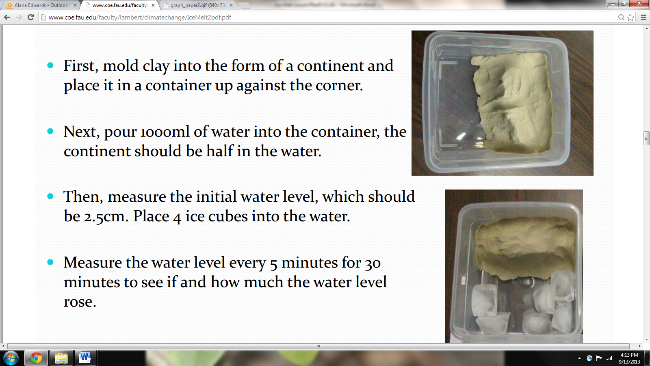Have each team collect supplies for part A of the experiment (plastic container, heat lamp, 4 ice cubes, ruler, and water).
2. Pour water into container (making sure the land mass is not covered).
3. Carefully place 4 ice cubes into the water to represent floating sea ice.
4. Set up heat lamp next to container, tilting it toward the ice. Turn on the lamp.
5. Use the ruler to measure the initial water level from the bottom of the container.
6. Record level of the water in the table every 5 minutes until the ice melts.
7. Write your results in the table and include a title for the table.
8. Construct a line graph that summarizes your results. Label the axes and include a title and legend.

**Part B: Land Ice**

1. Have each group collect supplies for part 2 of experiment (plastic container, heat lamp, 4 ice cubes, ruler, and water).
2. Pour water into container (making sure the land mass is not covered).
3. Carefully place 4 ice cubes on top of the land mass in order to represent land ice.
4. 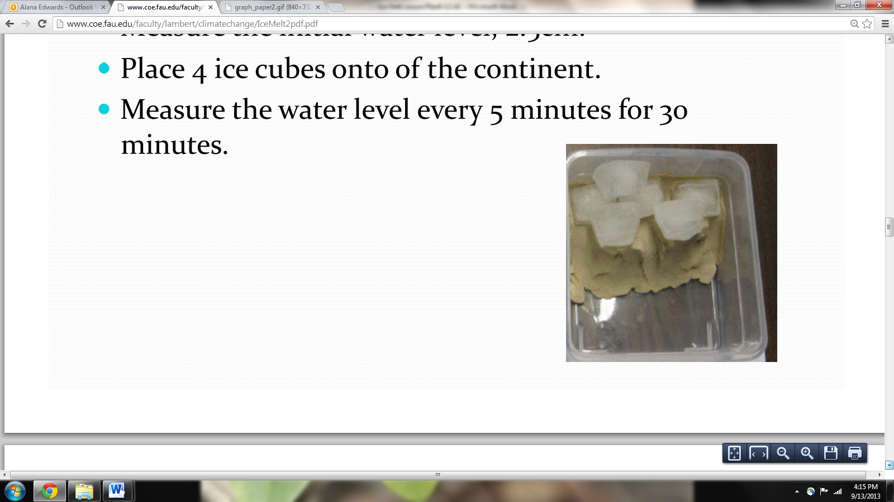Set up heat lamp next to container, tilting it toward the ice. Turn on the lamp.
5. Use the ruler to measure the initial water level from the bottom of the container.
6. Record level of the water in the table every 5 minutes until the ice melts.

(You may carefully push the ice off the land into the water to speed up the melting after 20 minutes.)

1. Write your results in the table and include a title for the table.
2. Construct a line graph that summarizes your results. Label the axes and include a title and legend.

**Results**

**Table - Title: ______________________________________________________________________**

|  |  |  |  |  |  |  |  |
| --- | --- | --- | --- | --- | --- | --- | --- |
| **Water Level (cm) in each container** | **Initial**  **Water Level** | **5 min** | **10 min** | **15 min** | **20 min** | **25 min** | **30 min** |
| Sea Ice |  |  |  |  |  |  |  |
| Land Ice |  |  |  |  |  |  |  |

**Graph - Title: ______________________________________________________________________**



**Findings**

Write a summary of your results.

**CONCLUSIONS: DEVELOPING EXPLANATIONS FROM EVIDENCE**

1. Was your hypothesis supported by the data or evidence?
2. Explain your rationale for the results.
3. What recommendations do you have for improving the experiment and for further study?
4. What are some impacts of sea level rise?

**THE SCIENTISTS’ EXPLANATION**

Throughout history, Earth has continuously cooled and warmed. As a result of these cooling and warming periods, the area and volume of the ice on Earth’s surface has increased and decreased. When the planet is in a period of a colder climate, there is more frozen water in the form of ice; hence sea level is lower. During interglacial periods, ice melts and sea level rises.

So does it matter which type of ice––land or sea ice––melts? In this experiment, you should have observed that even though the floating ice (or sea ice) is melting, it does not contribute to a rise in water level. Sea level does not rise from the melting of sea ice or icebergs because the ice was already floating, and displacing water. On Earth, the polar sea ice floats as the surface of the Arctic Ocean. As floating ice melts, it does not contribute to sea level rise because of one unique properties of water. Water in the solid form (ice) is less dense than water, which causes it to float. Only about 10% of the ice floats above the surface, and when ice melts, the volume of the water that was displaced by ice equals the melted ice or water. This is known as Archimedes Principle. In other words, the change in volume exactly counterbalances the extra volume of the ice that was up above the water's surface.

The melting of the land ice does affect the level of the water. When ice over land melts, it adds to the volume of water in the container, causing the level of the water to rise. On Earth, most of the ice is stored in the ice sheets covering Greenland and Antarctica. The Greenland Ice Sheet is experiencing record surface melting with a record rate of loss in the past decade. If Greenland melted, sea levels could rise by about 24 feet (7.2 meters). If the West Antarctica Ice Sheet melted, ocean levels could rise by 16 to 20 feet (5 to 6 meters). But if all of the ice on Antarctica melted, sea level could rise by 200 feet (61 meters). The Ocean Drilling Distance Learning Program shows a simulation of a similar experiment.

<http://oceandrilling.coe.tamu.edu/curriculum/Sea_Level/Ice_Volume/activity.html>