Melting Ice
Today, ice and snow still cover 10% of Earth’s landmasses and 7% of the oceans. This is a reminder that we are still in an ice age, as you learned in the Temperature Over Time module. An ice age, a period of time when Earth has permanent ice caps and global temperatures approximately equal to or lower than present temperatures, is divided into glacial and interglacial periods. The last major glacial climate reached its peak about 20,000 years ago as glaciers covered vast areas of Europe and North America. During this time period, so much water was in the form of ice that sea level was about 120 m (395ft) lower than today. Scientists think this last glacial period ended about 18,000 years ago as two orbital cycles synchronized to cause warmer summers across the Northern Hemisphere. Earth has been in a warmer interglacial period since then; and for the past 8,000 years, ice core records indicate that Earth’s climate has been relatively stable.
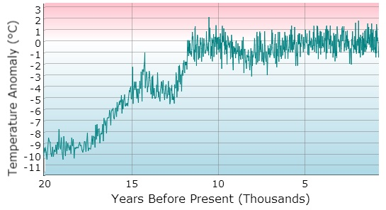
Temperature Anomaly Data Over the Last 20,000 Years
Places on Earth where it is so cold that water is in its solid form as snow or ice are known as the cryosphere. The cryosphere includes ice and snow (precipitation made of ice crystals) in the form of frozen ground, such as permafrost, ice sheets, glaciers, and sea ice. The following provides a brief description of each of these forms of ice and snow.

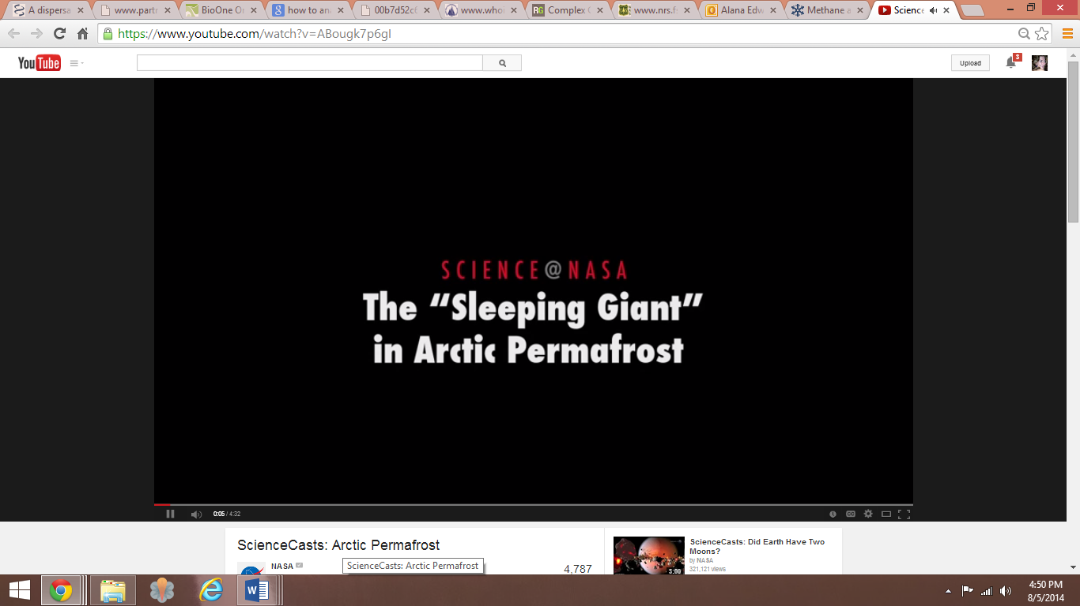
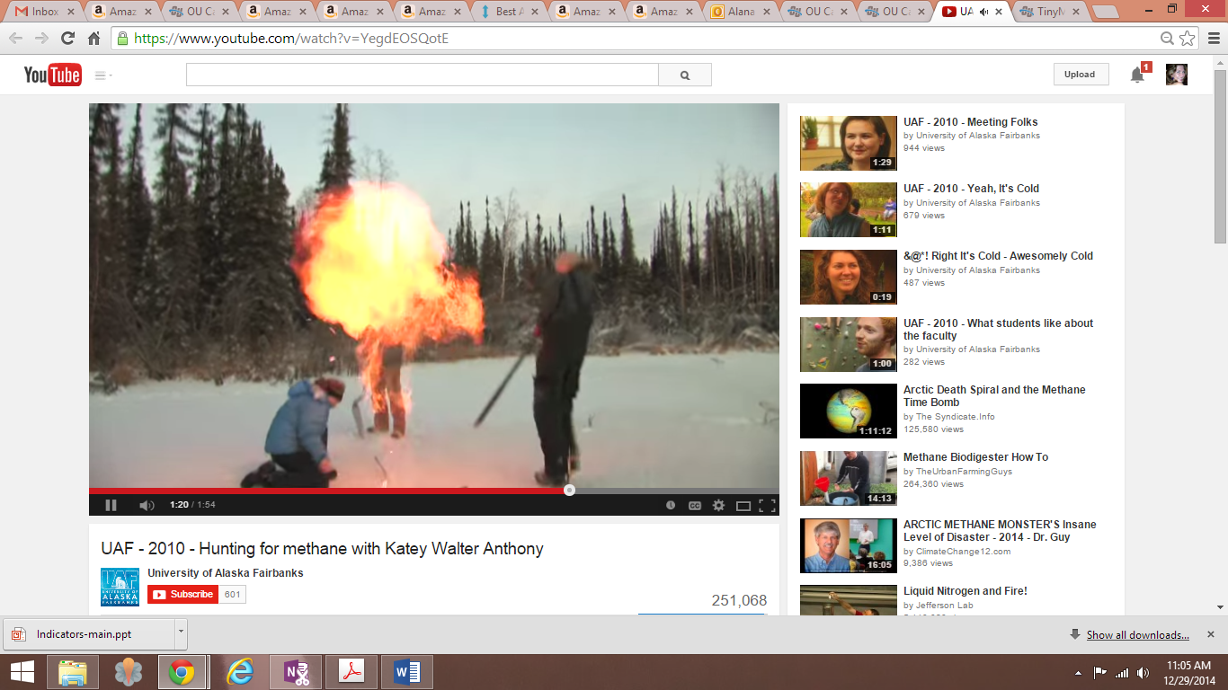
Permafrost
Video Source: NASA
Video Source: University of Alaska Fairbanks
Permafrost is permanently frozen ground that acts to insulate or trap moisture, heat, and methane deep under the surface. Permafrost may be a few meters to over 1,000 meters thick and thousands of years old. Permafrost is found at high latitudes near the poles and at high altitudes. Deep permafrost covers vast areas in Alaska, northern Canada, Siberia, and the Tibetan Plateau.
Permafrost stores massive amounts of carbon. As permafrost melts due to warming, organic material at Earth’s surface can be exposed to the air and decomposed or oxidized, producing carbon dioxide (CO₂). Lakes and small ponds may also result from the melting permafrost. These small bodies of water are low in oxygen and perfect for bacteria that do not require oxygen, such as methanogenic bacteria. These bacteria release methane, also a greenhouse gas.
Melting of permafrost also causes erosion, disappearance of lakes, landslides, and ground subsidence or sinking of land.

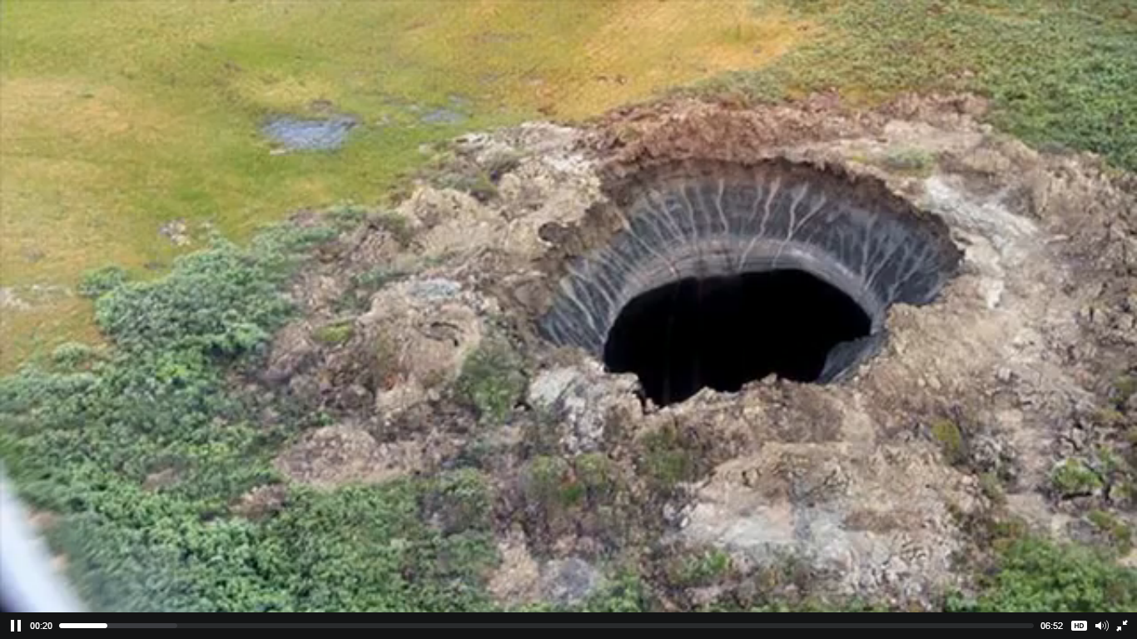
Behind the Mysterious Holes in Siberia
Video Source: PBS Newshour
In July of 2014, three mysterious craters were discovered in Siberia by reindeer herders. Russian researchers think that the Siberian permafrost is melting or thawing due to warmer temperatures. As the permafrost melted, areas may have collapsed and formed these craters, which are similar to sinkholes. This collapse of land allowed methane gas to escape into the atmosphere.

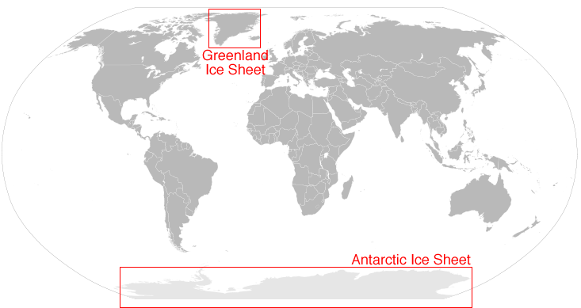
Together, the Greenland and Antarctic Ice Sheets contain more than 99 percent of the freshwater ice on Earth. Image Source: NSIDC
Glaciers and Ice Sheets (Land Ice)
Glaciers originate on land as snow that remains long enough to transform into ice. Glaciers form when snow accumulates over many years and is compressed into large, thick masses of ice. Glaciers are usually larger than one-tenth of a square kilometer. Glaciers are like rivers of ice because they can actually flow.
Ice sheets are large glaciers or masses of ice and snow that cover more than 50,000 square kilometers. Ice sheets form when winter snow does not melt completely during the summer months. There are two ice sheets on Earth and they cover most of Greenland and Antarctic. These ice sheets contain more than 99% of the freshwater ice on Earth!
Mountain glaciers develop high in mountainous regions and are found in northern Canada, on Antarctica, and in the Andes and Himalayas, and Alps. While mountain glaciers are melting at an unprecedented rate, they are not melting everywhere.
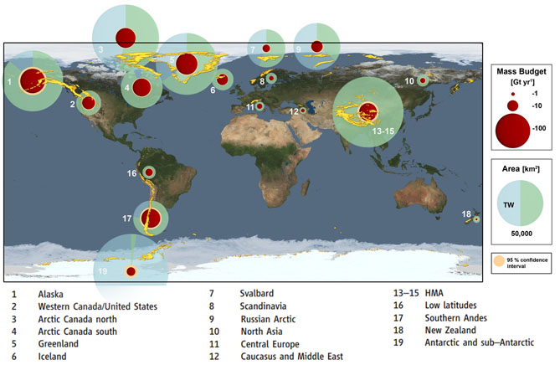
Change in glacial mass is determined by a combination of satellite altimetry (ICESat), satellite gravimetry (GRACE), and field observations. The red circles indicate glacial mass loss from 2003 to 2009. The largest glacial mass loss has occurred in Alaska, Arctic Canada, Greenland, the Himalayans, and the southern Andes.
Image Source: NASA
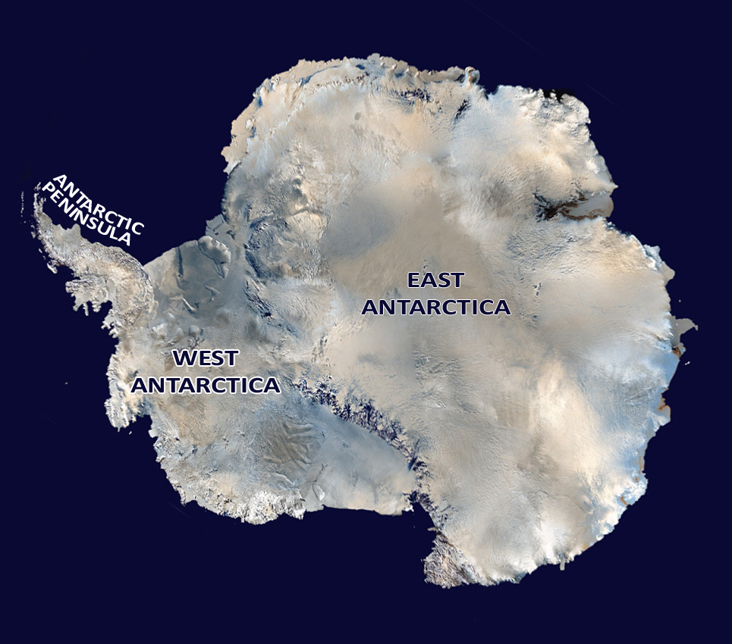
Antarctic Ice Sheet
Image Source: NASA
The continent, Antarctica, is isolated from the rest of the climate system by global winds and the Antarctic Circumpolar Current. The continent is covered by an ice sheet averaging 1.6 kilometers (1 mile) in thickness. The Antarctic Ice Sheet covers an area larger than the U.S. and Mexico combined. The Antarctica ice sheet contains 90% of the fresh water on Earth. If all of this ice on Antarctica melted, global sea level would rise at least 61 meters (200 feet).
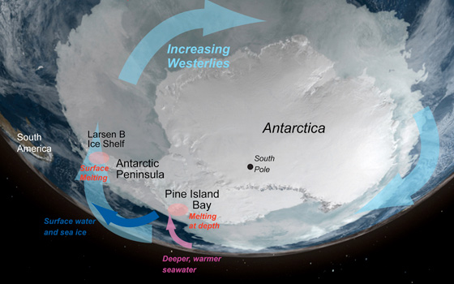
There are three areas of this vast ice sheet that are affected by global warming in different ways.
Image Source: NASA
The East Antarctica Ice Sheet, containing about 83% of the ice, sits on the continental landmass and is very stable. The West Antarctica Ice Sheet, containing 13% of the ice, developed over underwater islands. This sheet is unstable with potential to melt causing sea levels to rise approximately 5 to 6 meters (16 to 20 feet). In the spring of 2014 scientists at NASA and University of Irvine, California published a study concluding the West Antarctica Ice Sheet appears to be in an irreversible state of decline. The following video explains the study’s findings.
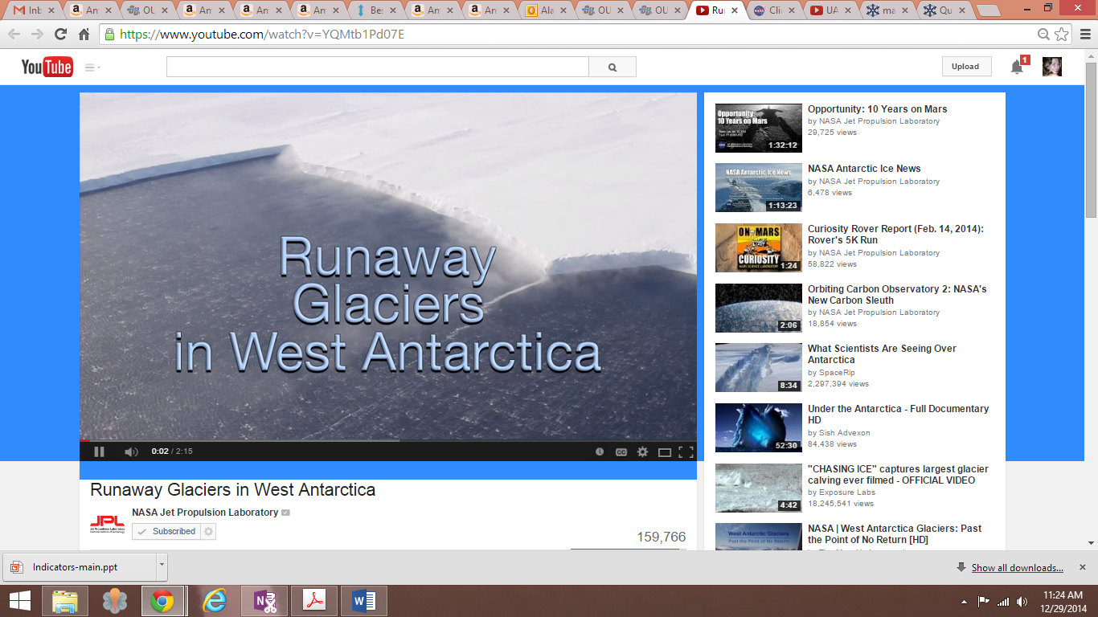
Rising ocean temperatures are melting the ice from underneath. Once the West Antarctica ice shelves melt, ice streams can accelerate. Ice streams, which are deep and fast flowing rivers of ice, make up the edge of this huge ice sheet. They are channelized glaciers that flow more rapidly than the surrounding mass of ice. Also, the interior of the ice sheet can melt more rapidly causing the entire West Antarctica Ice Sheet to collapse.
Video Source: NASA Jet Propulsion Laboratory
In recent decades, the third area of the ice sheet covering Antarctica, the Antarctic Peninsula has also been showing significant effects of warming ocean currents. In 2002, the 12,000-year-old Larsen B Ice Shelf on the northeast margin of the peninsula suddenly collapsed over a few days. An ice shelf is an area that occurs when an ice sheet extends over the sea. Events such as this reveal that ice shelves can rapidly collapse.
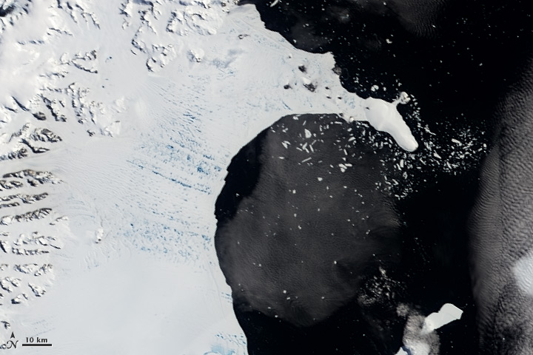
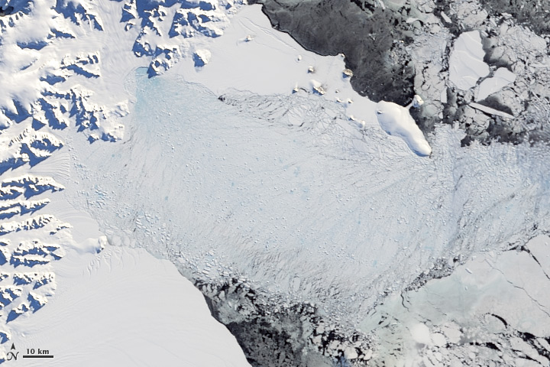
Larsen B Ice Shelf on January 31, 2002 (left) and April 13, 2002 (right). Image Source: NASA

Greenland Ice Sheet
Greenland was named by Erik the Red, the first European settler around the year 982. Erik the Red named the island “Greenland” to lure more colonists. The large island, more than four times the size as Texas, is covered by snow and ice. Some areas of ice can be as thick as 2 kilometers (1.2 miles) and as old as 110,000 years. An ice cap, a miniature ice sheet covering less than 50,000 square kilometers, covers 80% of Greenland. An ice cap is usually centered on the highest area of a mountain and ice flows away toward the ice cap’s edges. The Greenland ice sheet is the second largest mass of ice on Earth next to Antarctica.
Over the last century, the average temperature of Greenland has risen by as much as 3°C (5.4° F). This warming is causing the exterior edges of the ice sheets, as well as the associated glaciers, to melt at a rapid rate.
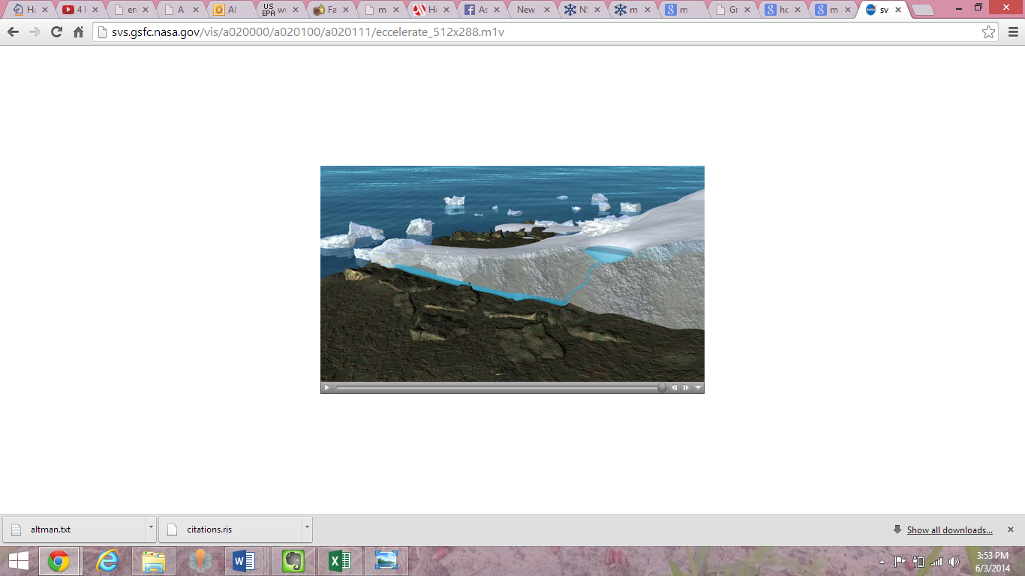
There has also been an increase in the number of days that meltwater flows along the surface of the ice. As flow increases, vertical channels known as moulins can form in the ice sheet. Moulins appear like the “potholes” in the ice sheets. The meltwater flows downward through the moulin to the bedrock and acts as a lubricant at the base of the glacier. This allows the glacier to flow more easily, which enhanced melting further.
View a visualization of how meltwater forms a Moulin. Video Source: NASA

Sea Ice

Sea ice is a layer of floating ice that forms on the surface of the ocean as the seawater temperature decreases below -1.9°C (28.6°F). Sea ice that forms in the Arctic is able to last multiple years and may be as thick as 3 to 4 meters (9.8 to 13.12 feet), whereas sea ice near Antarctica melts each year during the summer.

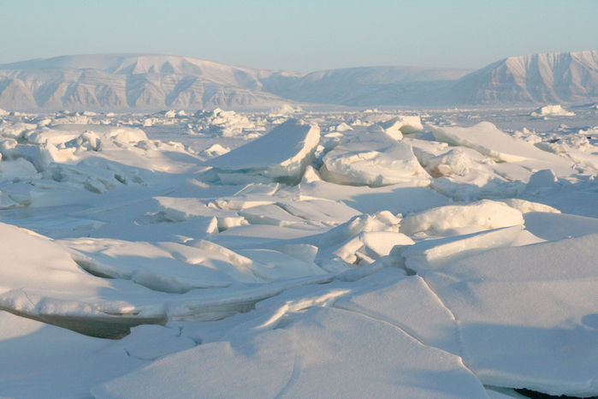
The volume of Arctic sea ice is decreasing due to global warming. Even though sea ice in the Arctic polar sea ice is melting, it does not contribute directly to sea level rise. This is due to one unique property of water––water in the solid form (ice) is less dense than water. When ice melts, the volume of the water that was displaced is taken up by the melted ice. This is known as Archimedes Principle. The change in volume exactly counterbalances the extra volume of the ice that was up above the water's surface.
Broken Sea Ice North of Greenland. Photo Credit: Courtesy Andy Mahoney, NSIDC

However, melting of the polar sea ice acts as a climate feedback. Arctic Sea ice and snow reflect more sunlight (have a higher albedo) than water. When this ice and snow melts, the darker, ocean water absorbs more heat, causing the Arctic Ocean to heat up even more. This is example of a positive feedback. In other words, it amplifies an already warming trend.

How do we know if the melting that you just read about will have major impacts on our planet? The National Snow and Ice Data Center (NSIDC) gathers satellite and field observation datasets from NASA, NSF, NOAA, and other programs. With these data, they provide monthly updates on ice extent in both the northern and southern hemisphere and provide us with information about just how much impact we may experience from these changes.
INVESTIGATION 2: Is Greenland Ice Melting?
The temperature of Greenland has risen by as much as 3°C (5.4°F), but how rapid is the ice covering Greenland melting? In this investigation you will use Google Earth to explore the melting of two massive glaciers––the Jakobshavn and Petermann Glaciers.
You will use Google Earth to visually observe how our planet has been changing over the last few decades. You may have used Google Earth before, but for these explorations, you will be downloading .KML and .KMZ files. KML stands for Keyhole Markup Language and the .KMZ files are several .KML files that have been zipped.
You will be interacting with the Places window on the left of your screen. Once you open a .KMZ file, you will notice a folder with several files underneath. Each of these represents a layer and they are stacked one on top of another so that if all of the boxes of each file in a folder is checked, only the file at the top of the list will be visible. This means that you will need to check (to view) and uncheck (to hide) these files throughout these activities.
When you first download any files, they will be placed in your temporary places folder. However, when you close out Google Earth, you have the option to either save them or discard them. If you save them, they will go to the “My Places” folder. You will also use many of the tools at the top of the screen. Before you begin, make sure that you have Google Earth installed on your computer
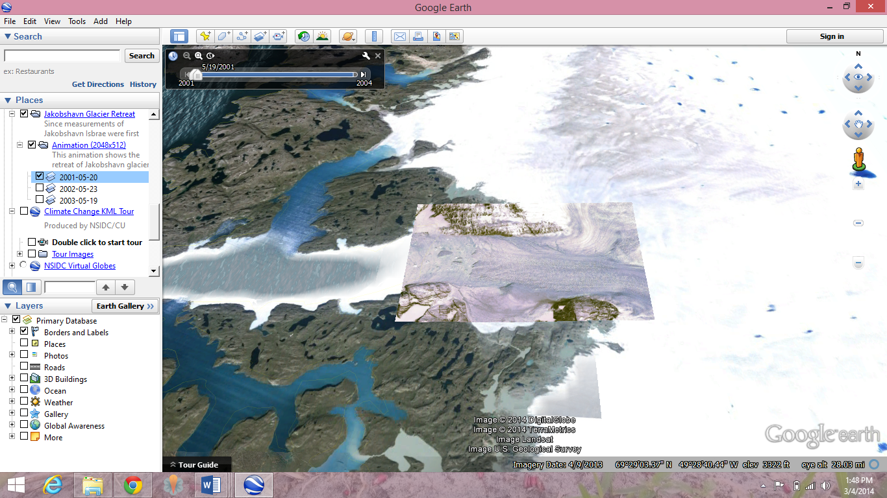
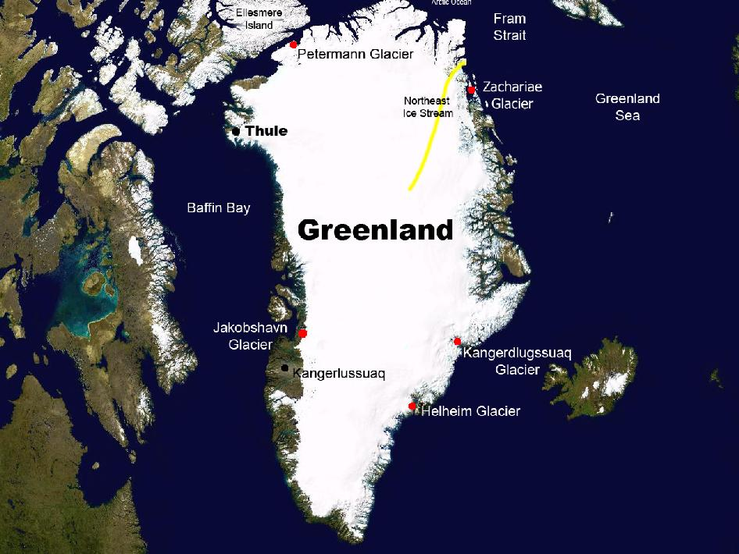
Exploration 1: The Melting of Jakobshavn Glacier
Map of Greenland showing approximate location of Jacobshavn Glacier. Image Source: NASA
The Jakobshavn Glacier, or Jakobshavn Isbræ in Danish, is located along the west coast of Greenland. For most of this century, it extended out into the ocean as a long, narrow sheet of ice, known as an ice tongue. Ice tongues form when glaciers move rapidly out into the ocean. Jakobshavn Glacier is Greenland's largest outlet glacier and the fastest flowing with a surface velocity of 7 km (4.4 miles) year. Consequently, the melting of Jakobshavn Glacier has the potential to contribute to sea level rise more than any other single feature in the Northern Hemisphere. For the last several decades, this glacier has been melting or retreating.
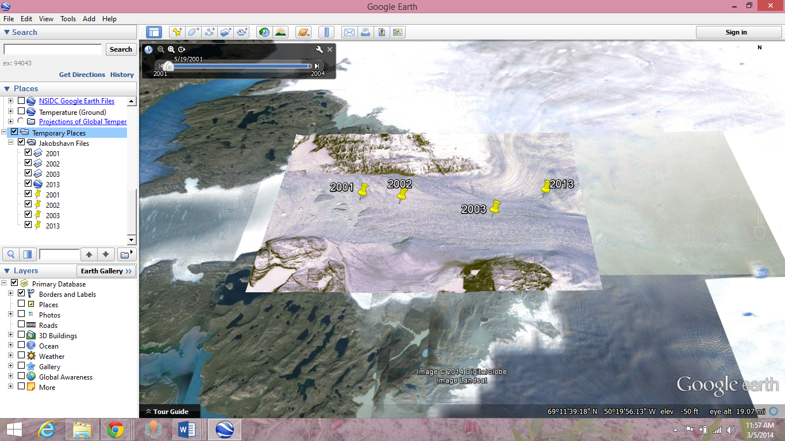
In this exploration, you will determine the rate of change (the retreating or melting) of Jakobshavn Glacier over several time periods. Using Google Earth, you will first mark the location of the retreating terminus, which is the lower-most end of the glacier, for different years. You will then measure the distance between each terminus to determine how far back the glacier has retreated. You will also calculate the rate of melting of the glacier. To begin, follow the steps below.
- Download the Jakobshavn files (source: NASA).
- Once downloaded, you can open the file in Google Earth two ways:
  - Go to the location of the file and double click, OR
  - Open Google Earth>File>Open and navigate to the location of your file.
- When the file is open, you should see it in your Temporary Places under Places (If you have several files already on this list, you will need to scroll down).
- If the map is not zoomed in on the glacier, double click on Jakobshavn Files.
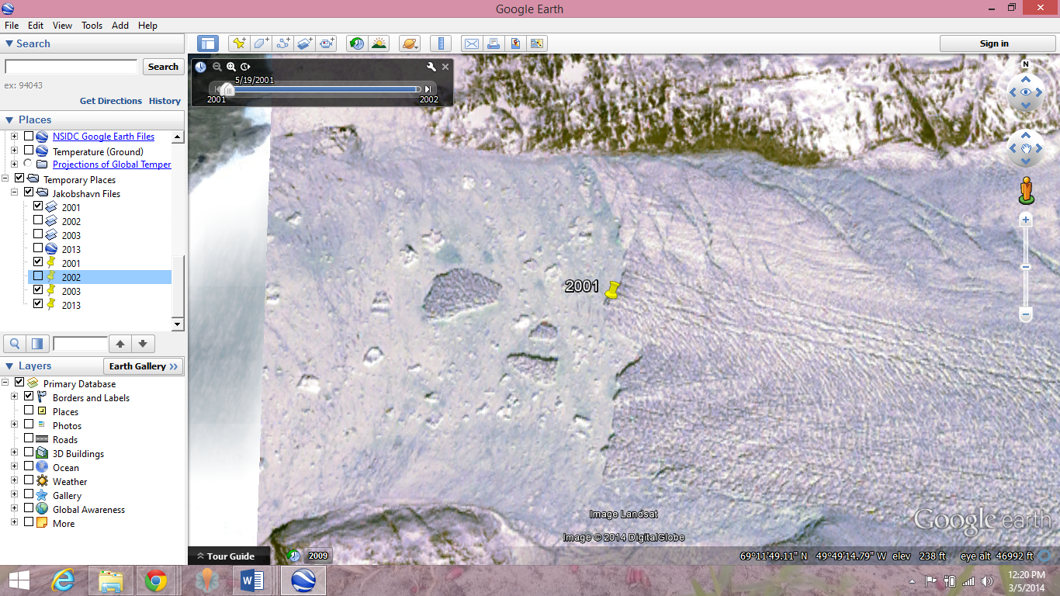
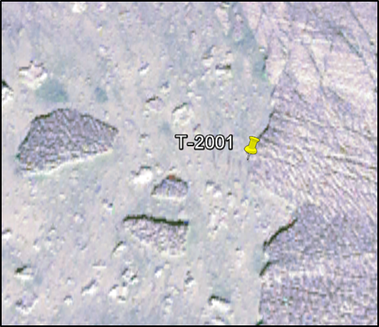
- You will view ONE of these files at a time. First, uncheck the box next to the Jakobshavn Files and notice that all files below will uncheck. Now check the 2001 glacier layer. Be patient as it may still need to load or you might have to check and uncheck a couple of times before the image will appear.
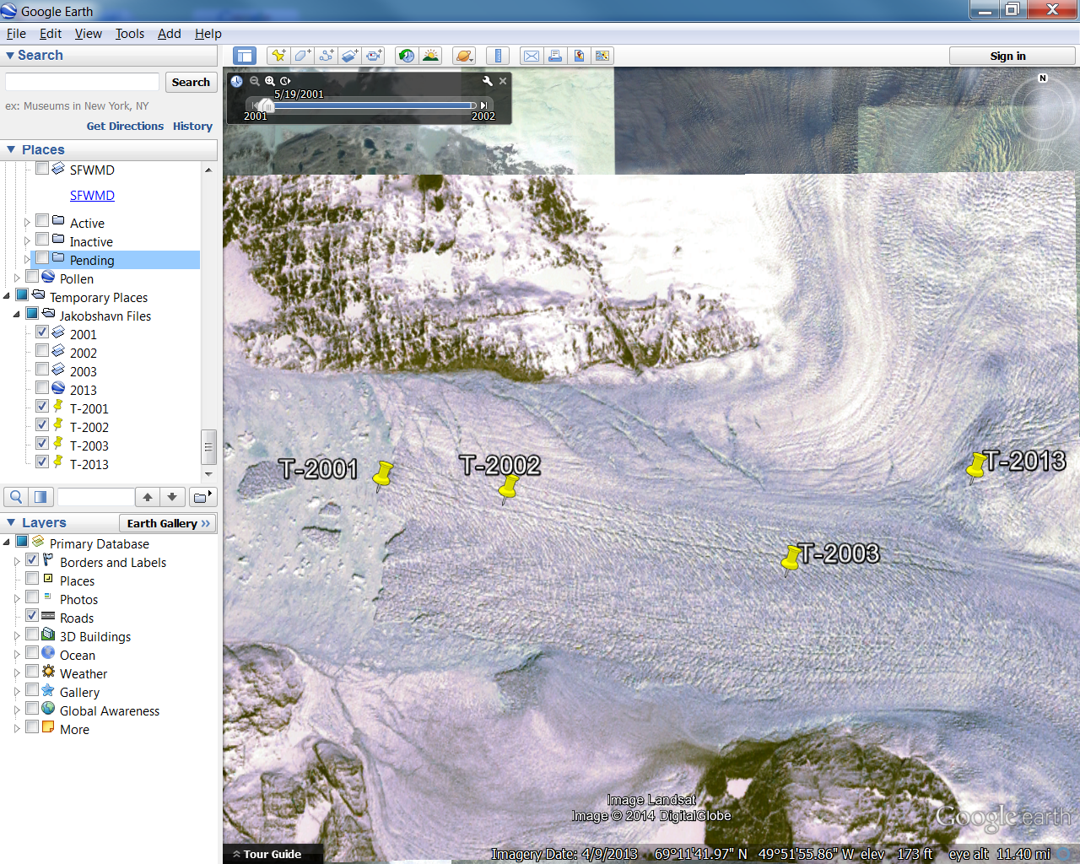
- To mark the terminus with a Placemark, follow these steps. Zoom in to see the terminus of the Jakobshavn Glacier in 2001. Mark this 2001 terminus by creating a Placemark. To do this, select the yellow pin in the top menu bar (image on right). Once selected, a pin will appear on your map with a flashing yellow box around it, indicating that the Placemark can be moved. Move the Placemark to the terminus as seen in the picture and, in the dialogue box, name it T-2001. Click OK and the Placemark will be added to your map and your list on the left in Places.
- Create Placemarks called T-2002, T-2003 and T-2013. Remember that you will need to uncheck the box next to the previously marked terminus and glacier layer files. (You may need to click on and off the selected glacier layer a couple of times for it to activate on the map.)
- Once you have created all four Placemarks, make sure that all Placemarks are checked (under Places) and that only the 2001 glacier layer is checked. The 2002, 2003 and 2013 glacier layers should be unchecked. Your map should appear as the one below.
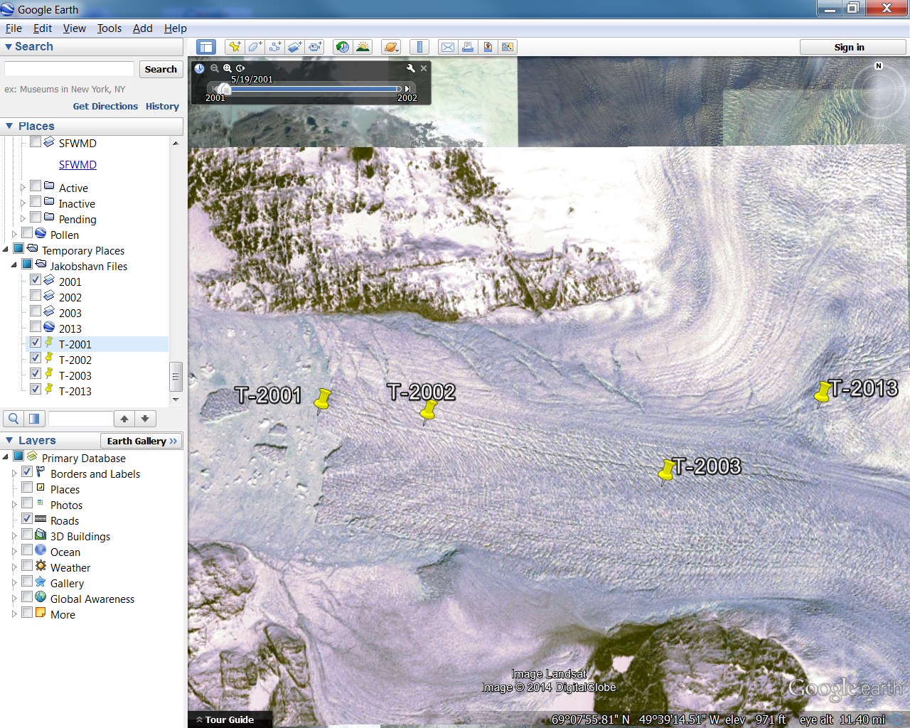
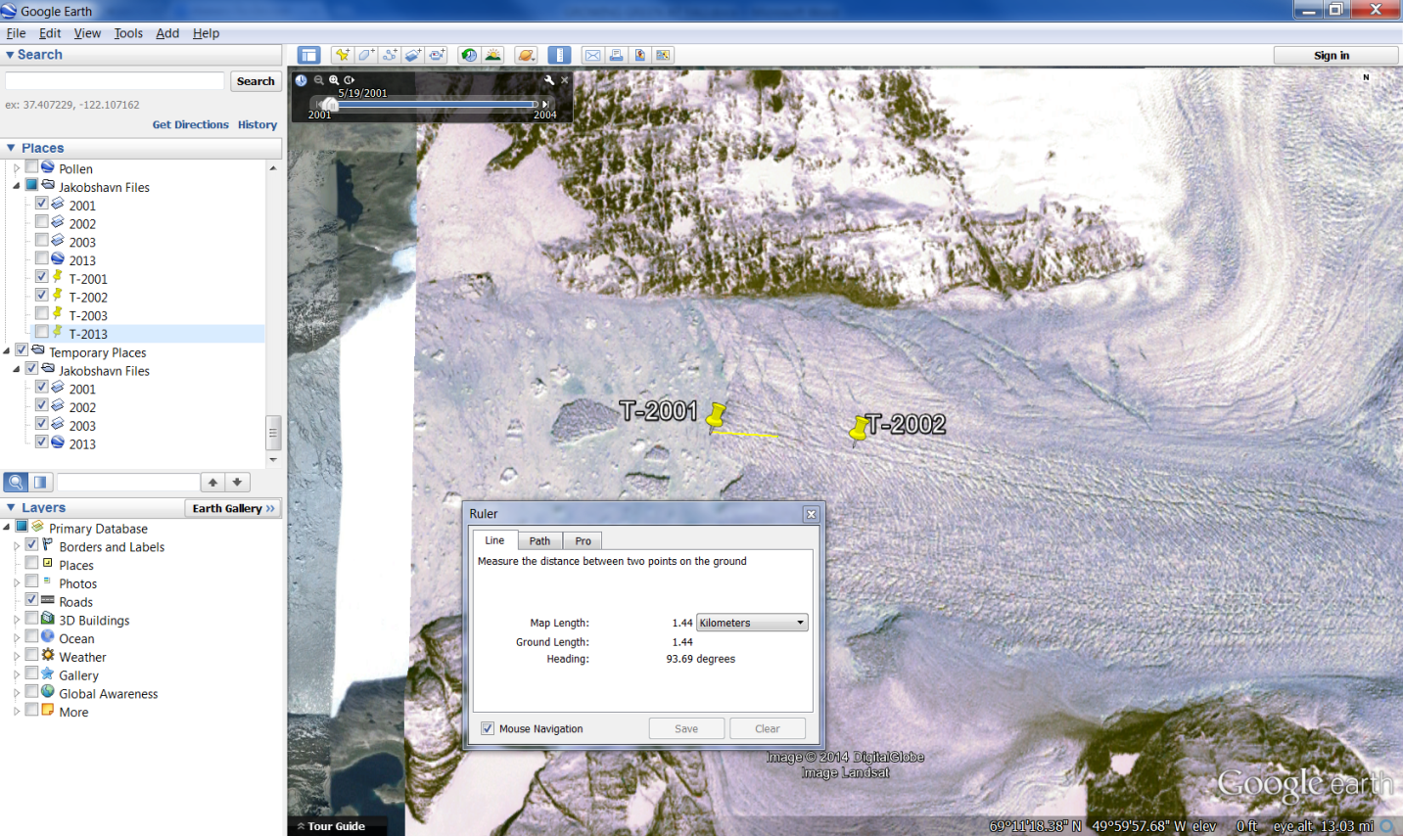
- To measure the distance between each terminus, follow these steps. First, you will measure between Placemarks T-2001 and T-2002 using the Ruler tool. Once you click on it, a dialogue box will appear. If it appears in front of your Placemarks, move it out of the way so that you can see them. Click on the point of the first Placemark and then click on the second. The distance will appear in the dialogue box. Make sure that you have selected kilometers from the dropdown menu. Repeat this procedure for Placemarks T-2002 to T-2003 and T-2003 to T-2013. Record the distance for each time span in the table below.

Time Span |  | Retreat Distance (km) | Rate of Change/Year
1850 | 1964 | ~60 km | ~0.53 km/yr
2001 | 2002 | ~3.10 km (1.93 mi) | ~3.10km/yr
2002 | 2003 | ~7.27 km (4.51 mi) | ~7.27 km/yr
2003 | 2013 | ~4.71 km (2.93 mi) | ~0.47km/yr
2001 | 2013 | ~14.27 km (8.86 mi) | ~0.84km/yr

- Calculate the rate of change per year for the time spans given and record this rate in the table above: retreat distance/range of years
- Compare the retreat distance of 2002-2003 with that of 2001 -2013. What do you notice about the amount of retreat during these two time periods?
In one year (2002-2003), Jakobshavn Glacier retreated approximately one-half the distance as it did between 2001 and 2013.
- How does Jakobshavn Glacier’s yearly rate of retreat since 2001 compare to that before 1964?
Jakobshavn Glacier was retreating approximately 0.53km/yr before 1964 and approximately 0.84km/yr since 2001.

Scientists’ Explanation of the Retreat of Jakobshavn Glacier
NASA scientists have been able to estimate the amount of retreat at the Jakobshavn Glacier as far back as 1851. For several decades, the glacier experienced a period of relative stability and little retreat or melting from the 1950s to the early 1990s. Then in the 1990s, the melting began to accelerate. Scientists attribute this acceleration to warmer temperatures, which lead to a longer melt period and more days each year where the ice melts rather than freezes. From 2000 to 2011, scientists estimate that Jakobshavn Glacier contributed nearly 1 mm to global sea level. While this may not sound like much, this glacier alone accounts for approximately 4% of the sea level rise recorded in the 20th century.
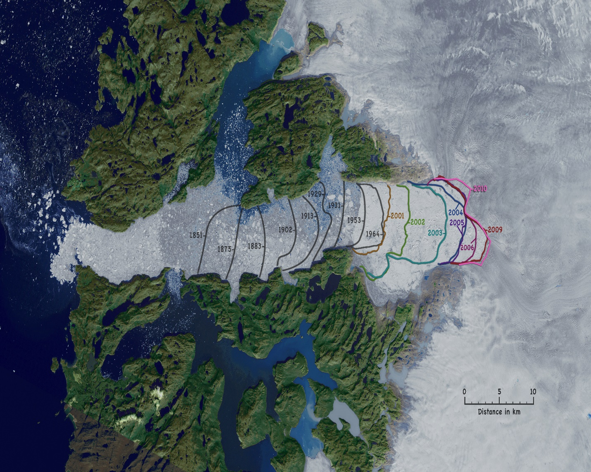
The graphic below shows that this acceleration seems to have leveled off in the late 2000s. However, recent studies are showing that we may begin to see another period of acceleration. They believe that in the next few decades the rate of retreat will accelerate yet again and by 2100, Jakobshavn Glacier will have retreated approximately 50 kilometers inland.
Orthographic View of Jakobshavn Calving Front: 1851 to 2010. Image Credit: NASA

Exploration 2: Melting of the Petermann Glacier
Map of Greenland showing approximate location of Petermann Glacier. Image Source: NASA.
In the last several years, the Petermann Glacier, located in the northwestern region of Greenland, is sliding toward the sea. The glacier recently experienced two major calving events––one in August 2010 and the other in July 2012. Calving occurs when huge chunks of ice break off at the end or terminus of a glacier to form icebergs. Both of these events resulted in icebergs so large that they are referred to as ice islands.
In this activity, you will use Google Earth and the Polygon Tool to measure the approximate size of each of these islands.
- Download the Petermann Glacier files (source: NASA).
- Once downloaded, you can open the file in Google Earth two ways:
  - Go to the location of the file and double click, OR
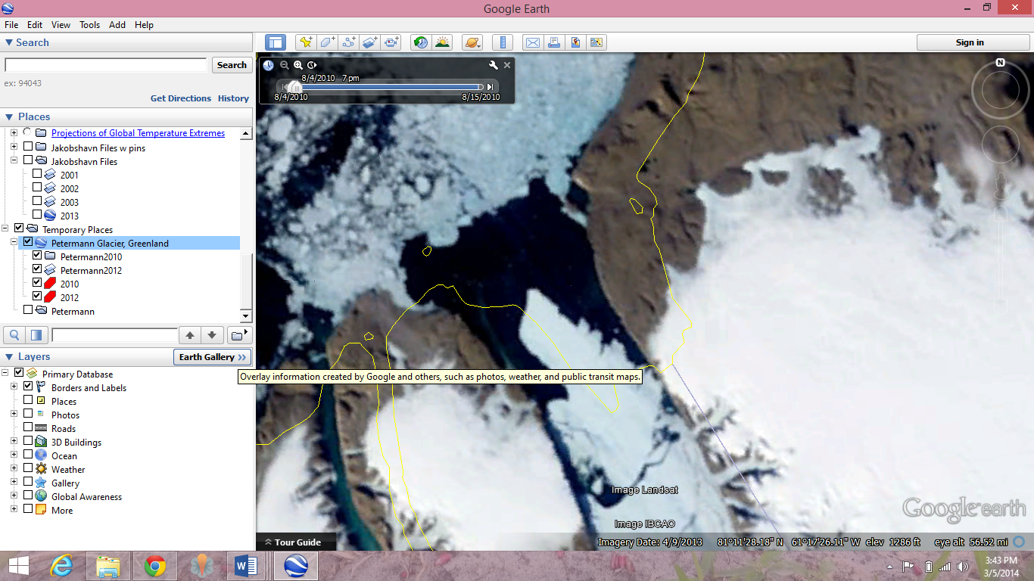
  - Open Google Earth>File>Open and navigate to the location of your file.
- When the file is open, you should see it in your Temporary Places under Places (if you have several files already on this list, you will need to scroll down).
- If the map is not zoomed in on the glacier, double click on Petermann Glacier, Greenland.
- You will view ONE of these files at a time. First, uncheck the box next to the Petermann Glacier, Greenland and notice that the two files below will uncheck. Now check Petermann2010. Be patient as it may need time to load or you might have to check and uncheck a couple of times before the image will appear. The 2010 and 2012 Petermann Glaciers should appear in Google Earth as they do in the graphic above.
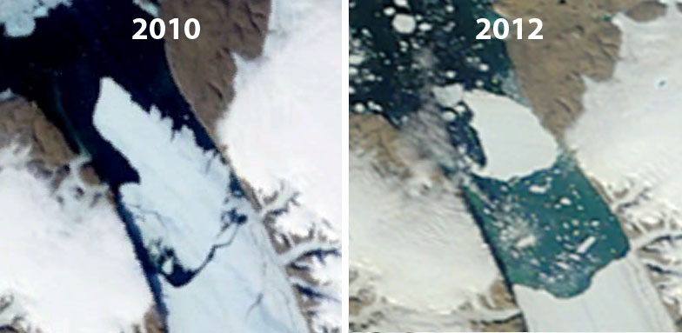
Calving Ice Islands – The 2010 and 2012 Petermann Glacier calving events. Image Source: Google Earth

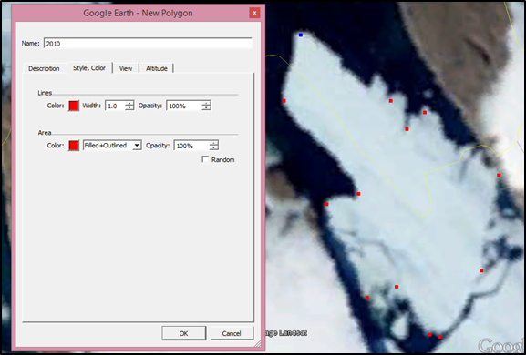
- To create a polygon to measure the area of each ice island, follow these steps. You are going to draw an outline of the ice island using the polygon tool. You may need to zoom in so that you can see the edge of the island in more detail. Click on the Add Polygon tool (on right) in the menu bar at the top of the screen. Once you click on it, a dialogue box will appear (on right). If it appears in front of the island, move it out of the way so that you can see. Next, start clicking on points around the edges of the island. Make sure that your points do not overlap. See the photo for an example. In the dialogue box, change the name to 2010 and click on the Style, Color tab, changing the color from white to something that you can see. Click OK. NOTE: YOU WILL ONLY BE ABLE TO SEE THE POLYGON THAT YOU HAVE CREATED IF YOU HIDE (UNCHECK) THE .KML FILE. UNCHECK PETERMANN 2010 IF YOU CAN’T SEE THE POLYGON.
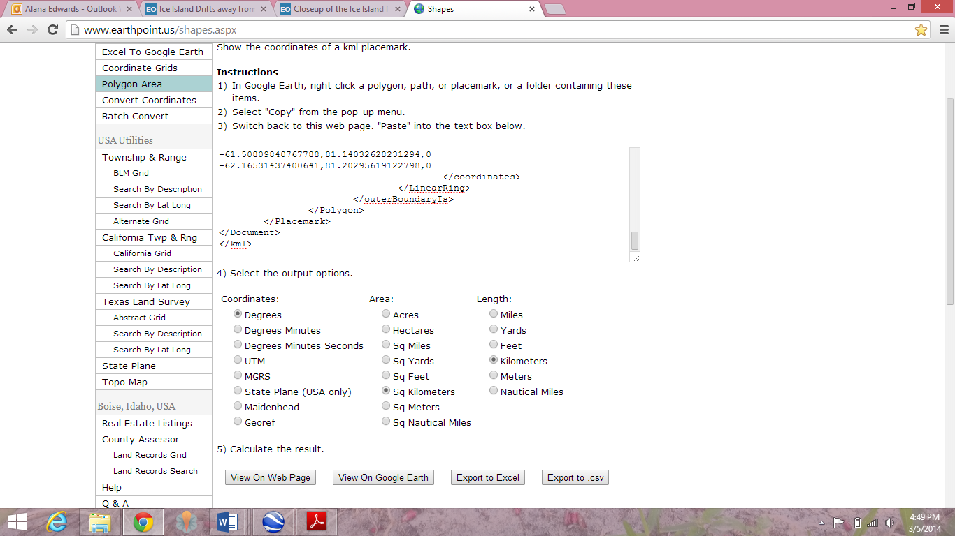
- Repeat step 6 for the Petermann2012 layer, creating another polygon and naming it 2012. You will need to make sure that the 2010 layer is unchecked before you can start. You may choose a second color for this polygon.
- You should now have two polygons representing the ice islands. Again, if you can’t see them, uncheck the boxes next to the 2010 and 2012 layers.
- Determine the area in square kilometers of each polygon and fill in the table. Right click on the 2010 polygon and select copy (On a Mac, press and hold the Control (Ctrl) key while you click the mouse button.) Open this page http://www.earthpoint.us/shapes.aspx.
- In the space under number 3, right click and paste the 2010 polygon information into the text box. You will see code pasted into the box.
- Under number 4, select degrees, square kilometers and kilometers.
- Under number 5 (Calculate the result), click View on Web Page. On the web page you should now be able to see the area in kilometers. Record the estimated area of each island in your table. Repeat for the 2012 polygon.
Year | Area of Ice Islands (km²)
2010 | ~250 km²
2012 | ~126.56 km²

- Use Google to determine the size of your city in km². To do this, type in: size of <name of your city>. For Example, if you live in Delray Beach, type: "size of Delray Beach" in the Google search bar. The results returned should be your city in square miles and km². If your city doesn’t show in the results, try the largest city near you. How do the 2010 and 2012 ice islands compare in size to the city where you live? Students’ responses will vary.
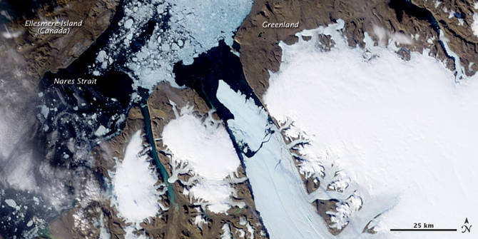
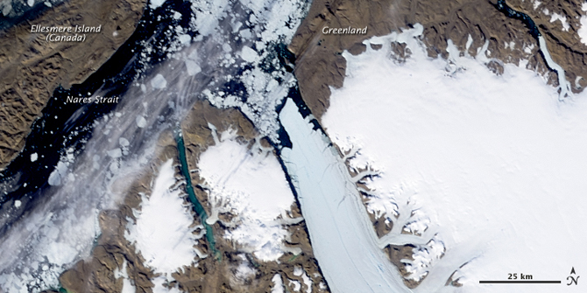
Scientists’ Explanation for Calving Ice Islands - Petermann Glacier 2010 and 2012
The Petermann Glacier just before (top) and after (bottom) a calving event on August 5, 2010. Image Source: NASA
On Aug. 5, 2010, an ice island of approximately 250 km² (100mi²) broke off of Petermann Glacier. Within hours the Canadian Ice Service detected the event as almost real-time data from NASA’s Aqua satellite via a device called MODIS (Moderate Resolution Imaging Spectroradiometer). Aqua is a polar-orbiting satellite that makes multiple passes each day over the polar regions of Earth. Below are two images of before and after the calving event. Media outlets compared the size of the island to four times the size of Manhattan!
About two years later, July 16, 2012, there was another large calving event. This time it was an area about twice the size of Manhattan measuring approximately 130 km² (50 mi²). Since 2001, NASA scientists have been monitoring this particular crack in the glacier.
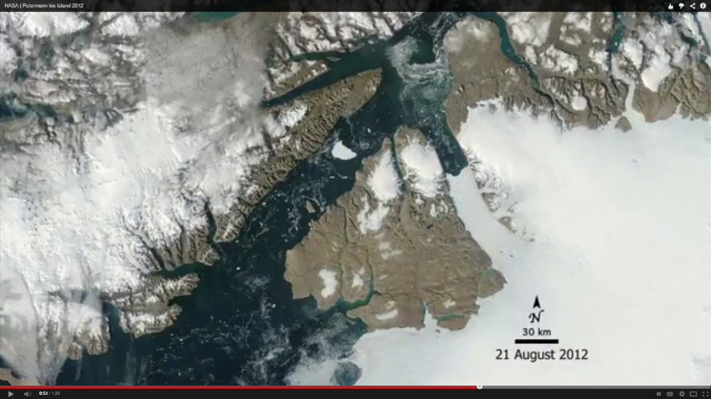
Once again, AQUA captured images of the event. Currents carried the ice island out of the outlet channel at a rate of about 1 km per day. Watch this video showing the rest of the island’s journey as it moves out of the outlet channel and into the Nares Strait. (This visualization does have one small error. Do you hear this error in the narration? Hint: You just measured the area of the ice island.)
View this video documenting the 2012 Petermann Glacier calving event. Video Source: NASA Goddard

INVESTIGATION 3: Is Arctic Sea Ice Melting?
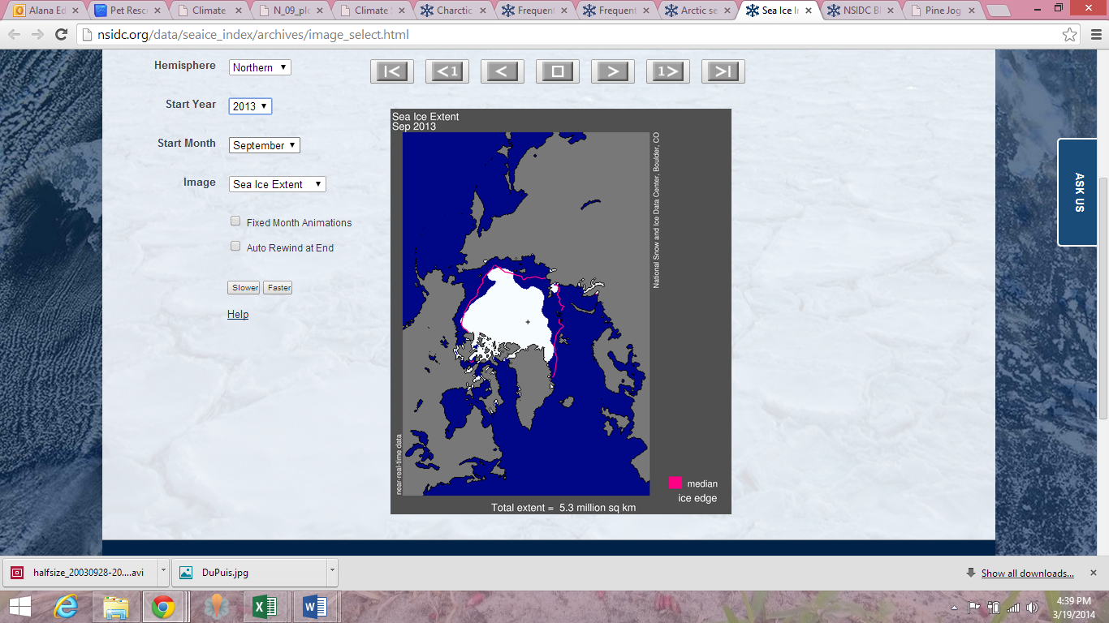
The National Snow and Ice Data Center (NSIDC) compiles satellite and field observation datasets from NASA, NSF, NOAA, and other programs. With these data, they provide monthly updates on ice extent in both the northern and southern hemispheres. You will notice that the data begins in 1979. This is because satellite records only date back to that year. Read more about Arctic sea ice before satellites.
In this investigation, you will look at some of the NSIDC data to see how sea ice extent in the Arctic has changed over the last half century.
Exploration 1: Sea Ice Extent
Use the NSIDC Interactive Sea Ice Graph to explore changes in the sea ice extent over the past few decades.
- http://nsidc.org/arcticseaicenews/charctic-interactive-sea-ice-graph/

To answer the following questions, you will need to select the year in the legend on the right side of the graph and then hold your cursor over the line to obtain the data.
- Use the Interactive Sea Ice Graph to determine the highest (generally mid-March) and lowest (generally mid-September) sea ice extent in millions of km² for the years listed in the table. Record the area to the nearest 0.1 million km².
Area of Sea Ice (km²)
DATE | 1983 | 1993 | 2003 | 2013
Highest  March 14th | 16.3 million km² | 16.0 million km² | 15.1 million km² | 15.1 million km²
Lowest  Sept. 13th | 7.2 million km² | 6.2 million km² | 6.1 million km² | 5.1 million km²

- Follow the steps below to calculate the average percentage of end-of-winter sea ice extent decrease per decade in million km² for the 1983-2013 March 14th dates.
  - Calculate the overall change in sea ice extent from 1983 to 2013.
16.3 million km² - 15.1 million km² = 1.2 million km²

  - Calculate the percentage of sea ice loss from 1983 to 2013.
1.2 million km² /16.3 million km² = 0.07 or 7% loss

  - Calculate the average percentage loss per decade.
0.07/3 = 0.025 or 2.5% per decade

- Follow the steps below to calculate the average percentage of end-of-summer sea ice extent decrease per decade in million km² for the 1983-2013 September 13th dates.
  - Calculate the overall change in sea ice extent from 1983 to 2013.
7.2 million km² - 5.1 million km² = 2.1 million km²

  - Calculate the percentage of sea ice loss from 1983 to 2013.
2.1 million km² /7.2 million km² = 0.29 or 2.9% loss

  - Calculate the average percentage loss per decade.
0.29 /3 decades = 0.1 or 10% loss per decade

d. How does the rate of summer Arctic sea ice melt over the last decade compare to that of the previous decade?
More melting of summer sea ice occurred between 2003 and 2013 than between 1993 and 2003.

- The IPCC states that there has been a downward trend of 3.8% per decade in the annual average extent of sea ice in the Arctic from 1979-2012. Explain why you calculated a larger percentage loss above.
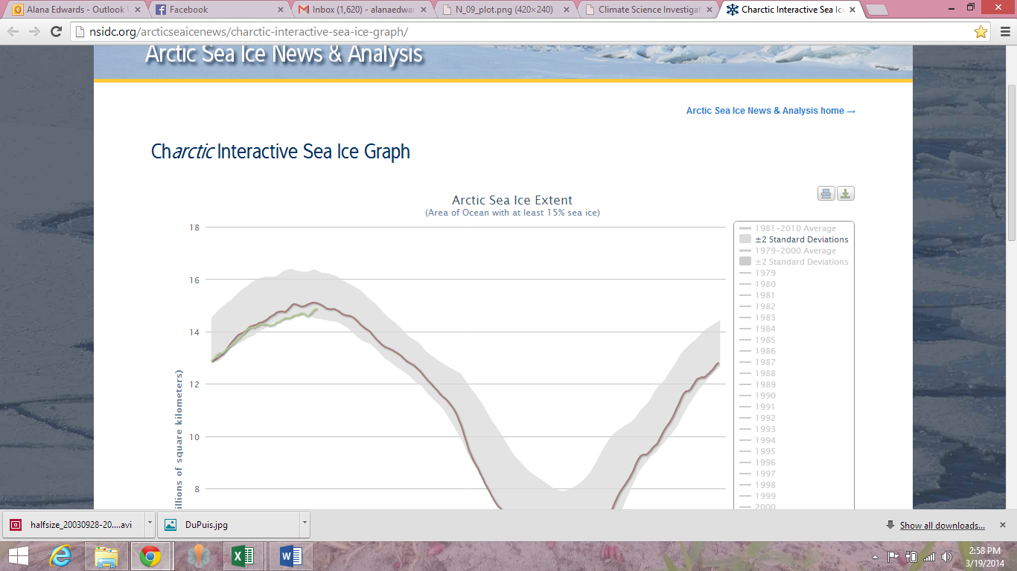
Students only recorded the highest and lowest ice extent and the IPCC presents an average for the years. The years examined were also slightly different.
Note: If you’d like to keep your graph, you can download it by clicking on the Export to raster or vector image button.
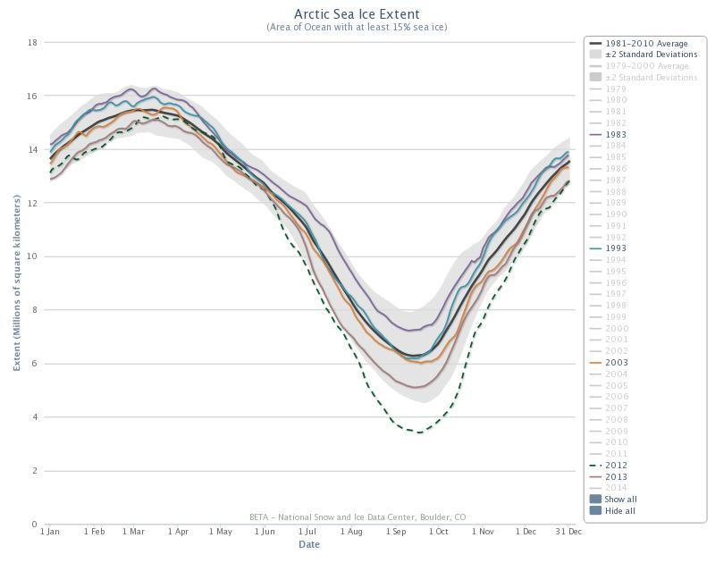
- Click on 1981-2010 Average (top button) to compare highest and lowest sea ice extent.
  - What was the highest and lowest average end-of-winter sea ice extent and corresponding year?
The highest winter sea ice extent was 16.2 million km² in 1980, and the lowest winter sea ice extent was 14.7 million km² in 2014.
  - What was the highest and lowest average end-of-summer sea ice extent and corresponding year?
The highest summer ice extent was 7.6 million km² (1980), and the lowest summer sea ice extent was 3.4 million km² (2012).

Read more about why the NSIDC chose the average for 1981-2010.
Exploration 2: The Rate of Sea Ice Melt Over the Past Few Decades
For this exploration you will analyze geospatial data for sea ice extent as well as anomaly trends of that data over time. The following two definitions will help you throughout this exploration.
- An anomaly is a departure from the long-term average. A positive anomaly means that the sea ice extent was greater than the long-term average, and a negative anomaly means that the sea ice extent was less than the long-term average. Anomalies are useful in analyzing trends.
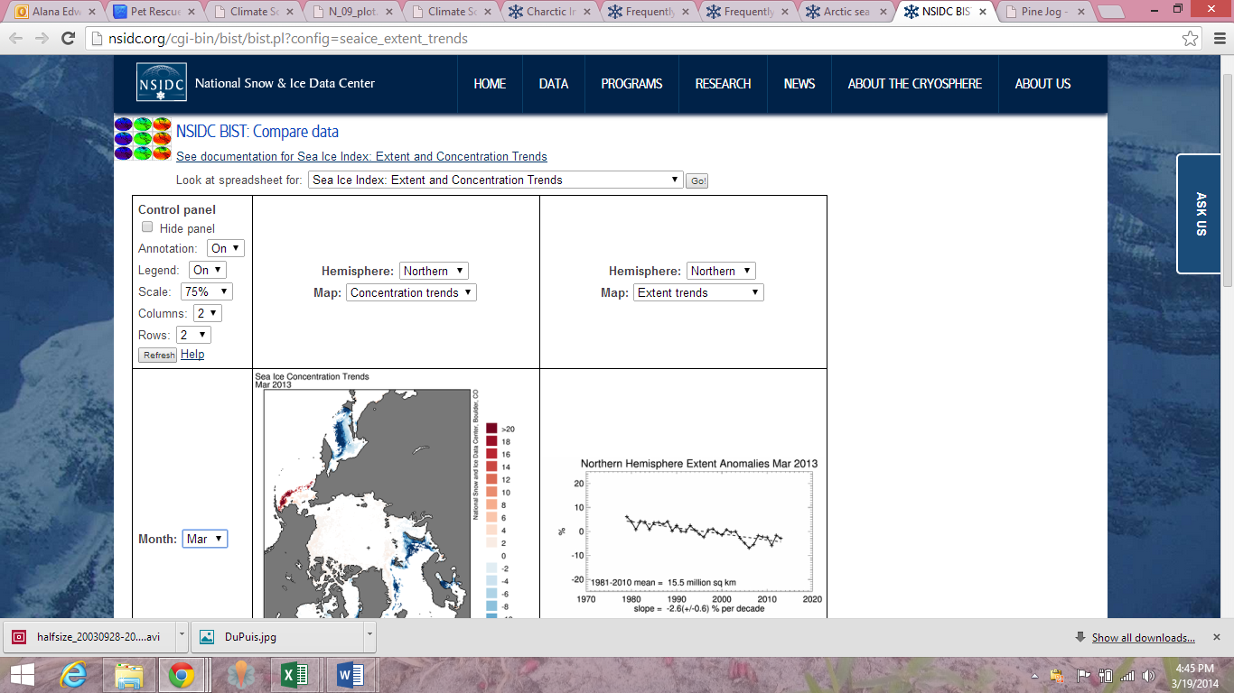
- The slope of a line is a measurement of how steep the line is. The slope of a line is also known as the rate of change. It is calculated by the following equation: Slope = vertical change (rise)/horizontal change (run) = y² - y¹/ x² – x¹
Go to: http://nsidc.org/cgi-bin/bist/bist.pl?config=seaice_extent_trends
- In the first column, second row choose the month of March from the dropdown menu.
- In the first column, third row, choose the month of September from the dropdown menu.
- In the first column, first row, click on the refresh button.
- You should now see the Sea Ice Concentration Trends for the most recent March and September months in the second and third rows under the second column.
- You should also see a graph that shows the March and September Sea Ice Extent Anomalies for 1979 to the most current year in the second and third rows under the third column.
Using these data trends, answer the following questions.

- Compare the March and September Sea Ice Concentration Trends in the second column. What month and region appears to be experiencing the most melting?
The most melting occurs in September along the edges of the sea ice.

- Focus on the March and September Sea Ice Extent Anomalies data shown in the third column.
  - Compare and contrast the data for March 1979-2014 to the data for September 1979-2014.
Both graphs show variability in sea ice extent and a decrease in sea ice extent over the period. The September anomalies show greater sea ice extent variability and a more rapid rate of decrease than the March anomalies.
  - What is the slope or rate of change for the data for March 1979-2014?
The extent of March sea ice is decreasing at a rate of -2.6 (+/- 0.06)% per decade.
  - What is the slope or rate of change for the data for September 1979-2013?
The extent of September sea ice is decreasing at a rate of -13.7 (+/- 3.0) % per decade.

- Explain why the lowest ice extent is in in late summer (September) rather than in early summer (June or July).
The ocean has a higher heat capacity than land. Therefore, it takes more energy to raise the temperature of the ocean than to raise the temperature of land. This property of water causes oceans to be generally warmer later in the summer season or early fall than in the early summer, resulting in more melting of floating sea ice.
- Explain why there is less change over the 30 years in the ice extent for late winter/early spring data compared to late summer/early fall data?
During the winter months, the air temperature is below freezing, so there less overall melting. Whereas during the summer months, the air temperature is above freezing more days and more ice melts.
Scientists’ Explanation for Arctic Sea Ice Melting

Scientists are discovering a rapid and continuing decline of extent of Arctic sea ice, with a record minimum in 2012 of 3.6 million km² (1.39 million miles²). In this investigation you compared sea ice extent for both the end-of-winter and end-of-summer from 1983 to 2013. Scientists have calculated that the surface area of the winter and summer Arctic Sea Ice declined by 2.7% and 10%, respectively, per decade from 1978. You should have calculated a similar decrease in ice extent for 1983 to 2013 period for the end-of winter sea ice extent and the end-of-summer sea ice extent.
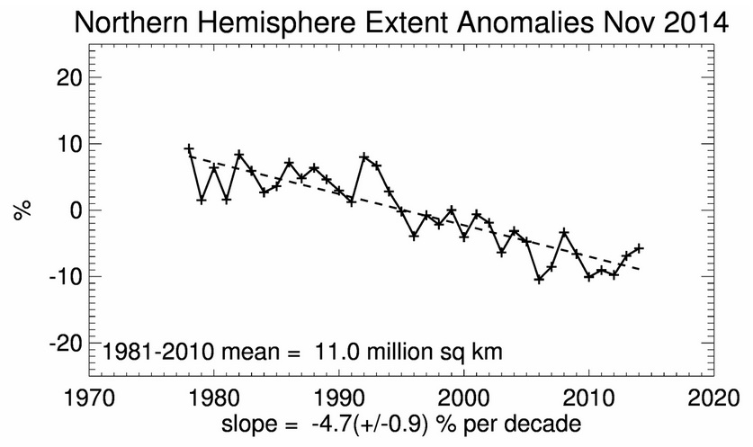
The IPCC’s latest assessment (AR5) reports a downward trend of 3.8% per decade in the annual average extent of sea ice in the Arctic from 1979 through 2012. The late summer sea ice extent has decreased even more, by between 9.4 to 13.6 percent per decade, and the eight lowest sea ice extents since 1979 have occurred in the last eight years (2007-2014). This rate of melting is faster than predicted by the climate models.
Image Source: NSIDC
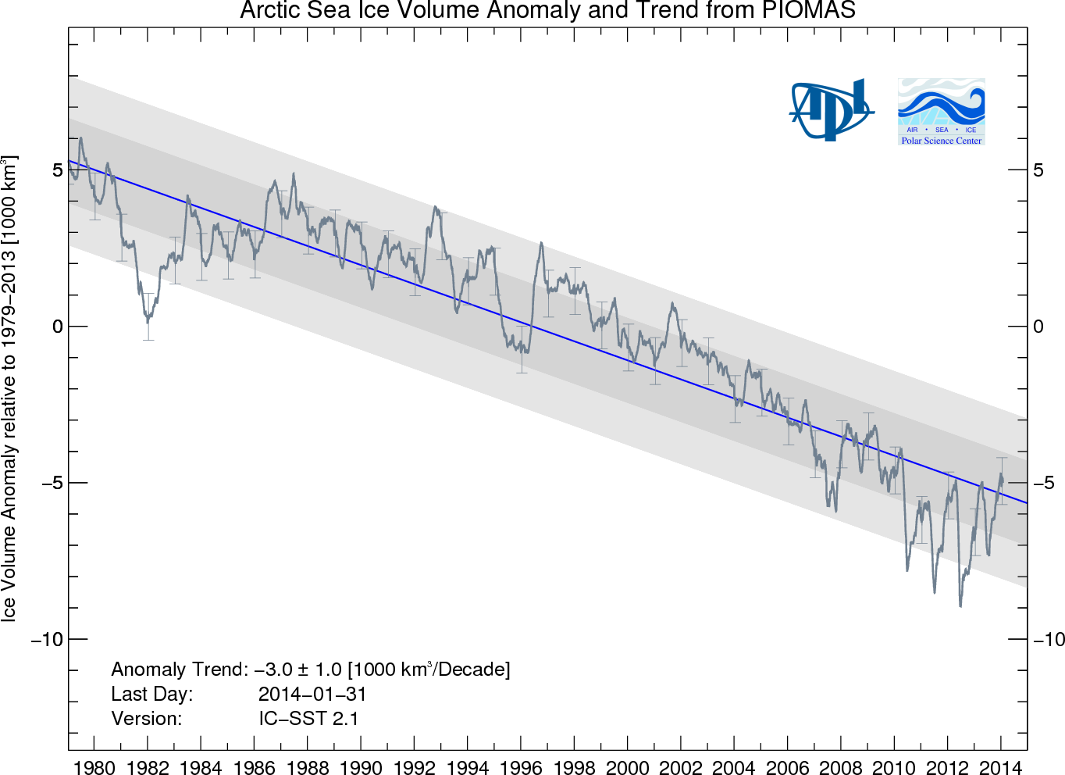
Annual ice may be approximately 1 meter (3.3 feet) thick in the winter, while multiyear ice survives summer melt and can be 5 to 7 meters (16.4 – 23 feet) thick. Observations of the thickness or volume of sea ice have been more limited. However, the European Space Agency (ESA) CryoSat satellite was launched in October 2010 and has enabled scientists to estimate sea ice thickness and volume for the last three years. While this data is suggesting thicker ice in 2013 than 2012, it is important to analyze the longer-term trend. The NSIDC estimated that ice volume in October 2013 still ranks among the lowest of the past 30 years.

Source: Polar Science Centre, University of Washington

View this NOAA video the to learn more about the melting Arctic.

https://www.youtube.com/watch?v=fPAc5D3Tow0

The video is based on the Arctic Report Card: Update for 2013. To learn more and keep up with current news in the Arctic, see http://www.arctic.noaa.gov/reportcard/ and http://nsidc.org/arcticseaicenews/.
Continuing the trends reported in the previous IPCC report, the annual Arctic sea ice extent decreased over the period 1979-2012. The rate of this decrease was very likely between 3.5 and 4.1% per decade (0.45 to 0.51 million km2 per decade). – IPCC report

