Are Extreme Weather Events Increasing?

Exploration 2: Global Extreme Weather Events

Part A: Extreme Weather Events Around the Globe
A heat wave is generally a period of several days to weeks of abnormally hot weather that may or may not be accompanied by high humidity. The World Meteorological Organization defines a heat wave as five or more consecutive days of temperatures 5°C (9°F) above the average maximum temperature. Because the average maximum temperature varies from one location to another, what is considered a heat wave in one location may not be considered a heat wave in another. For sake of simplicity in this investigation, we will refer to a heat wave as 3 consecutive days over 95°F.
- Locate and label the seven continents, Greenland, China, India, Brazil, and the following oceans (Atlantic, Pacific, Indian, Arctic, and the Southern, also known as the Antarctic) on the world map.
- The 2012 World Resources Institute reports a list of extreme events that have occurred over the past year. Locate the following extreme events on the world map provided.
The locations are bolded. Write the number of the event listed below on your world map. Make a legend to code the events as a heat wave, drought, tropical cyclone/hurricane, flood, or cold wave/snow.
Numbers | Month | Extreme Weather Events
1 | January | Heavy rains caused flooding and landslides in Brazil causing 13,000 residents to flee their homes.
2 | February | Worse cold wave in Eastern and Central Europe in 26 years lasted 3 weeks causing temperatures to drop to -40°F. There were 650 deaths related to this cold wave.
3 | February | Heavy rainfall caused record breaking flooding in Queensland, Australia causing 3,000 people to evacuate their homes.
4 | March | Tropical cyclone Irina hit Madagascar leaving 21,000 people homeless.
5 | April | Severe drought affects the South and Southwest United States.
6 | May | 2,000 homes and about 2,470 acres of crops are affected by major flooding in Rwanda.
7 | May | Northeastern Brazil experiences worst drought conditions in 50 years affecting 1,100 towns.
8 | June | Dry conditions in Western United States cause 5,415 fires burning 1,363,293 acres. The second most in the month of June.
9 | July | Heavy rainfall leads to the worst flooding in Beijing in 60 years causing a total of 95 deaths in July.
10 | August | 2 weeks worth of rainfall falls in Manila, Philippines in the course of 24 hours causing massive landslides and leaving 11 people dead.
11 | August | Massive typhoons hit the East Coast of China causing hundreds of thousands of people to evacuate and resulting in 23 deaths.
12 | October | Hurricane Paul hits the Baja Peninsula in Mexico causing damage to thousands of homes.
13 | October | Southern Australia records the lowest average rainfall since 1900.
14 | October | Hurricane Sandy makes landfall in Northern United States causing $50 billion in damages.
15 | October | Nigeria experiences worst flooding in decades.
16 | November | Unexpected flooding in Great Britain causes damage to thousands of homes.
17 | December | Powerful typhoon hits the Philippines island of Mindanao.

Name(s) ________________________________________________ Period __________ Date ___________________

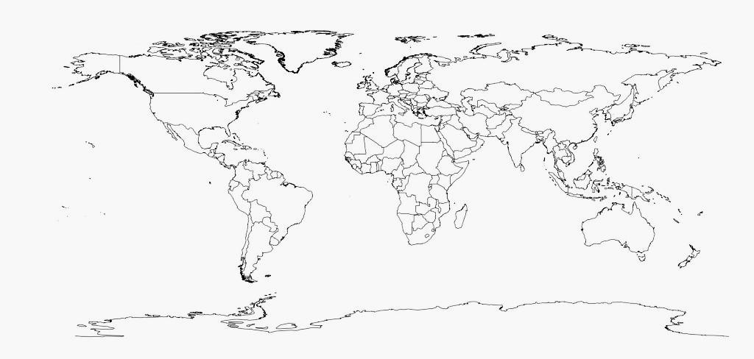
Exploration 2- Part A: Weather Events Around the Globe
(selected events from 2012)

Part B: Recent Extreme Weather Events
1. The National Climatic Data Center (NCDC) is a division of the National Oceanic and Atmospheric Administration (NOAA). The NCDC has the largest collection of weather data. You can go to this site to learn more about recent weather-related events and climate anomalies, which are differences between the average climate and the climate during a specific month or season.
- To begin, go to: http://www.ncdc.noaa.gov/cmb-faq/
- Choose State of the Climate from the left menu.
- Choose Global Analysis, 2014, and Annual.
- Click on Submit. The report will display below on the screen.
- Scroll down to see the map of 2014 Significant Climate Anomalies and Events.
- Click on the link beneath the map to enlarge it.
- Click on the image to enlarge it. (If this doesn’t work, under the view menu at the top of your computer screen,
use “Zoom” to make the print larger.)
- Using this report, describe three interesting events that occurred on three different continents.

2. Follow the procedure above to obtain the most recent month’s State of the Climate report.

Analysis of Findings
Compare a few interesting extreme weather events from the most recent month’s State of the Climate to those in the 2014 annual State of the Climate report.

