Are Extreme Weather Events Increasing?
INTRODUCTION
Over 15 years ago, in 1995, Chicago experienced a four-day heat wave with daytime temperatures ranging from 37°C (98°F) to 41°C (106°F). Nighttime temperatures were also usually warm due to the high humidity. More than 700 people died from heat-related causes during this time. So are heat waves and other extreme weather events increasing? Recently, you have probably noticed more extreme weather-related events in the news – from heat waves to droughts or floods or storms. In late June of 2012, more than 2000 record temperatures were recorded across the U.S., and a widespread, long-lived windstorm, known as a “derecho,” moved from Illinois to Virginia leaving massive devastation. “Derecho” is Spanish for straight and first described back in 1888 when a derecho crossed Iowa. Meanwhile 7 major wildfires, fueled by extreme heat and drought, were burning in Colorado.
In this investigation, you will learn how to analyze temperature data so that you can track extreme weather. First, you will obtain temperature data and use Excel to graph and compare some recent heat waves. You will then locate and label several extreme weather-related events that have occurred throughout the world over the past decade. Finally, you will learn to use the National Climatic Data Center (NCDC) to identify and analyze the most recent weather-related events and climate anomalies.
Climate Central is non-profit journalism and research organization that focuses on helping the public understand climate change and make informed decisions. Read the state-by-state analysis extreme weather for 2011 and view the slide show of images. http://www.climatecentral.org/news/top-ten-states-hit-hardest-by-2011s-extreme-weather/
What were the top ten states “hit the hardest” by extreme weather in 2011? Which state was most affected? Find a news story about a recent extreme weather event. Before you begin, you may also watch the segment from the CBS Sunday Morning show on the extreme weather of 2011: http://www.cbsnews.com/video/watch/?id=7379644n.
Exploration 1: How to Graph Temperature Data and Analyze Recent Heat Waves
A heat wave is generally a period of several days to weeks of abnormally hot weather that may or may not be accompanied by high humidity. The World Meteorological Organization defines a heat wave as five or more consecutive days of temperatures 5°C (9°F) above the average maximum temperature. Because the average maximum temperature varies from one location to another, what is considered a heat wave in one location may not be considered a heat wave in another. For sake of simplicity in this investigation, we will refer to a heat wave as 3 consecutive days over 95°F.

Directions: You will analyze the maximum and minimum temperatures for one city. Follow the directions below to create a graph of the maximum and minimum temperatures for the city you select. Print the answer sheet.

- Go to http://www.wunderground.com/history/ .
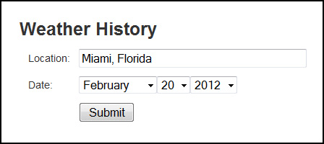
- Under Weather History, in the location field, type in one of the following cities:
  - Niamey, Niger – June 1 – August 31, 2010
  - Sukkur, Pakistan – June 1 – August 31, 2010
  - Guadalupe Pass, Texas – June 1 – August 31, 2011
  - Washington, DC – June 1 – August 31, 2010
  - Baton Rouge, Louisiana – June 1 – August 31, 2010
  - Moscow, Russia – June 1 – August 31, 2010
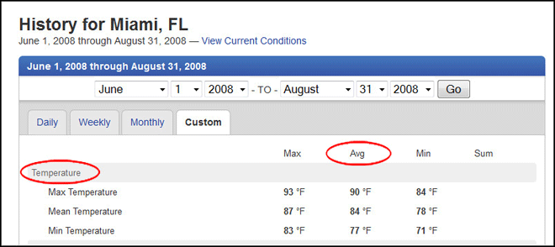
  - King Khaled, Saudi Arabia – June 1 – August 31, 2010

Leave the date field as the default date. You will edit this in the next step. Click Submit.

- Click on the Custom tab and then choose the beginning and end month and day. Click Go.

- Scroll down to the bottom of the page and right (or ctrl) click on Comma Delimited File. Choose Save Link As and name your files appropriately (City Name and Year). After the name, type .csv and then under Save as type, change to All Files. Save the file to a location where you can find it. (MAC USERS: You will not be able to save as a csv file. Save as html and then go to the location where you saved the file. Rename the file changing the .html to.csv.)
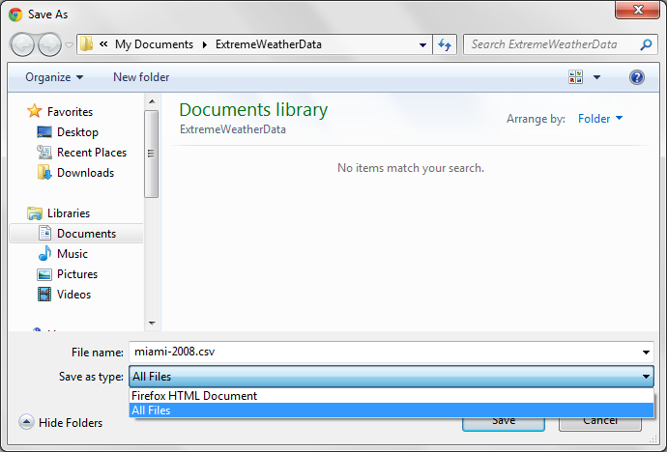

Open the spreadsheet in Excel. This spreadsheet gives us far more information than we are going to use. For this graphing activity, we are only going to examine the first three columns: the date, the maximum temperature and the minimum temperature.
- Your data will now be imported into Excel. You may see #### instead of a date in column A. If so, you will need to expand the width of the column for the date to display correctly in all cells.
- Right click on column C and select Hide.
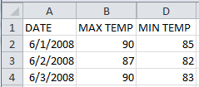
- If Row 1 is empty (no data), right click on 1 to highlight the row and choose delete. All of your data should move up.
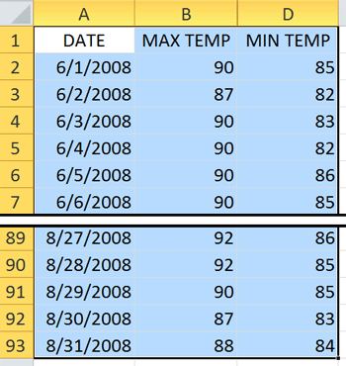
- Change the labels in the column headings as you see in the graphic (on right): Column A – DATE, Column B – MAX TEMP, Column D – MIN TEMP.
- Select all of the data in columns A, B, and D by clicking in cell A1 and dragging to the last cell in D with data. The area should be highlighted blue. (See graphic on left.)
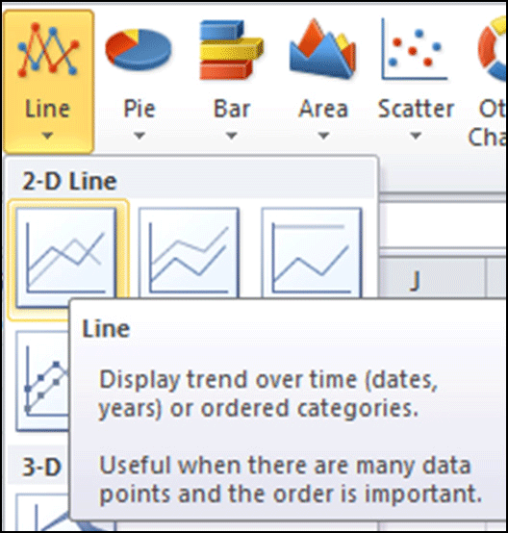
- On the Insert menu, click on Line>2D Line>Line. (See graphic on right.)
- You can edit your graph to change the line colors, include a title, add minor gridlines, etc.
  - Change line colors – Let’s make the max temp red and the min temp blue. Right click (Ctrl+Click on Mac) on the line>Format data series>Select Line color>Solid line>Select your color. You can choose to add other effects here as well.
  - Chart, axis titles and gridlines –Click on your graph and click on the Layout tab under Chart Tools (Excel 2010).
    - Choose Chart title>Above Chart and add the title Max and Min Temperatures in <City Name, Country Name> June - August 2010
    - Choose Axis Titles>Primary Horizontal Axis Title>Title Below Axis. Add the axis title Date.
    - Choose Axis Titles>Primary Vertical Axis Title>Rotated Title. Add the axis title Temperature (°F).
    - Choose Gridlines>Primary Horizontal gridlines>Major & Minor Gridlines.
    - Choose Gridlines>Primary Vertical gridlines>Major & Minor Gridlines.

- Your completed graph should look similar to the graph below. Right click on the graph in the Excel spreadsheet and select copy. Open a Microsoft Office Word document and use the Page Layout to change orientation to Landscape. Right click and select paste. Add your name to the word document and print it to turn in.
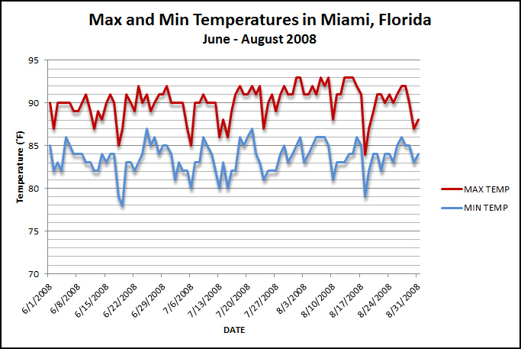
- Answer the questions on the answer sheet as you analyze your findings.

Name(s) ________________________________________________ Period __________ Date ___________________
Are Extreme Weather Events Increasing?
Analysis of Findings
What location did you analyze? ____________________________________________________
Use your Excel spreadsheet to answer the following questions.
1. What was the highest maximum temperature recorded over the 3 months at your location? _________________
2. Identify the number of days throughout the three-month period where temperatures were 95˚F or above. Color those cells green and count the green cells. How many days did you identify in the three-month period? __________
3. For this analysis, we will define a heat wave as a period of 3 or more consecutive days of a maximum temperature greater than 95˚F. How many heat waves did your location experience? ___________
How many days did each heat wave last?

Heat Wave | Length of Heat Wave (Days)
1
2
3
4
5
6
7
8

Use your graph to answer the following questions.
4. Examine the maximum and minimum temperatures for the location. What trends do you observe for these data?

5. Why do you think that heat-related mortality can be greater in cities at higher latitudes than in more tropical cities?

