**Temperature - Investigation 3**

**How Has Temperature Varied Regionally?**

In the previous investigations you have examined how Earth’s climate has fluctuated over geologic history. You have seen that on a global scale Earth has been warming since the industrial revolution in the late 1880s. But is Earth warming on a regional scale? Are the oceans also warming? Are both hemispheres warming? Are the tropics and poles warming? In the next three explorations, you will analyze temperature trends over different geographic regions to answer these questions.

The temperature data used for the following investigations is derived from NASA’s Goddard Institute of Space Sciences (GISS), which is a laboratory in NASA’s [Goddard Space Flight Center](http://www.nasa.gov/goddard/). This institute focuses on a broad study of changes to our environment, addressing both natural and man-made changes that occur on various time periods from one-time climate events such as volcanic explosions, to seasonal and annual effects such as El Niño. Program areas include climate forcings, model development, Earth observations, radiation, atmospheric chemistry, climate impacts, paleoclimate, planetary atmospheres, and other earth science-related disciplines.

In the first exploration, you will compare the change in ocean temperature to that of land.

**Explorations**

**Exploration 1. A Comparison of Change in Land and Ocean Temperatures**

You have learned that temperature has fluctuated several times over Earth’s history. In this exploration, you will investigate if the temperature change of Earth’s ocean is different from the temperature change on land.

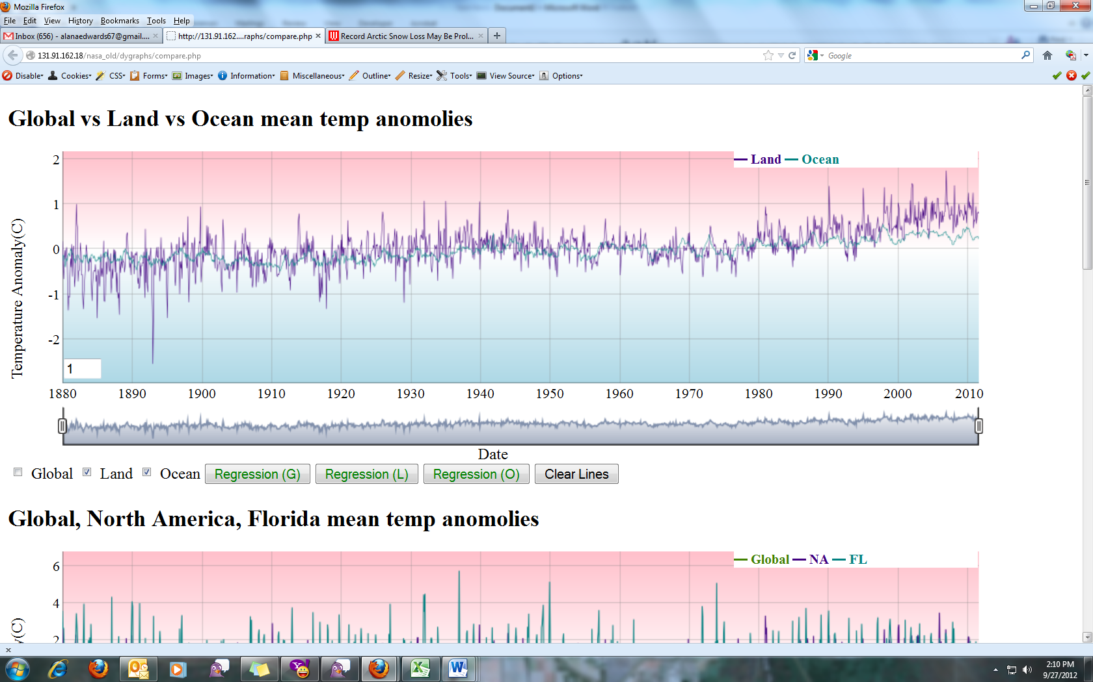

Use the interactive, time series graphing tool at

<http://131.91.162.18/nasa/module-3/regional-temperature/exploration-1> to answer the following questions.

1. Make a few hypotheses before you begin to compare the 130-year land and ocean temperature anomalies.
2. Do you think land and ocean temperature anomalies will both show a warming trend?

_____ Yes _____ No

1. Do you think that the more recent decades will show an increased rate of warming for both land and ocean?

_____ Yes _____ No

1. Which do you think will have a greater range between high and low temperature anomalies?

_____ Land _____ Ocean

1. Which do you think has more variable temperature anomalies over time?

_____ Land _____ Ocean

1. To analyze the land temperature anomaly variation, check the *Global* box beneath the graph to uncheck the global data. Check the box next to *Land*. You should see the land temperature anomaly data displayed on the graph.
2. Describe the general temperature anomaly trend over this time period.
3. What is the lowest temperature anomaly recorded during that time period? What is the highest? What is the range of temperature anomalies (lowest to highest)?
4. To analyze ocean temperature anomaly variation, click on the *Land* box beneath the graph to uncheck it. Check the *Ocean* box. You should see the ocean temperature anomaly data displayed on the graph.
5. Describe the general temperature anomaly trend over this time period.
6. What is the lowest temperature anomaly recorded during that time period? What is the highest? What is the range of temperature anomalies (lowest to highest)?
7. Use the data you recorded in questions 1 – 3 to complete the table below.

|  |  |  |  |
| --- | --- | --- | --- |
| **Geographic**  **Area** | **Lowest Temperature Anomaly (**˚**C)** | **Highest Temperature**  **Anomaly (**˚**C)** | **Range (**˚**C)**  **Lowest to Highest Temperature Anomaly** |
| Land |  |  |  |
| Ocean |  |  |  |

Which area has the smallest range in temperature variation? Which has the largest? Explain why you think this difference occurred.

1. Now check the *Land* box again. You should see temperature anomaly data for both land and ocean. Zoom into the graph for the last 25 years (1985-2010) by moving the slider below the graph. Describe the general temperature anomaly trend over this time period.

**Explanation – Comparison of Change in Land and Ocean Temperatures**

Global sea surface temperature has increased in a similar trend as the global mean temperature. However, temperatures over land have increased more rapidly than those over the oceans. As you learned previously, water has a high heat capacity, which means that it takes more heat energy to raise water’s temperature than it does to raise most other substances. Hence, water can absorb or release a lot of heat with little temperature change. This means that over time, the temperature of water varies less than land. You can see that the ocean temperature anomaly varies less than that of the land on the time series graph.

**Exploration 2. A Comparison of Northern and Southern Hemisphere Temperatures**

In the last exploration, you learned about land and ocean temperature anomaly trends. In this exploration, you will analyze the temperature anomaly trends for the Northern and Southern Hemispheres.

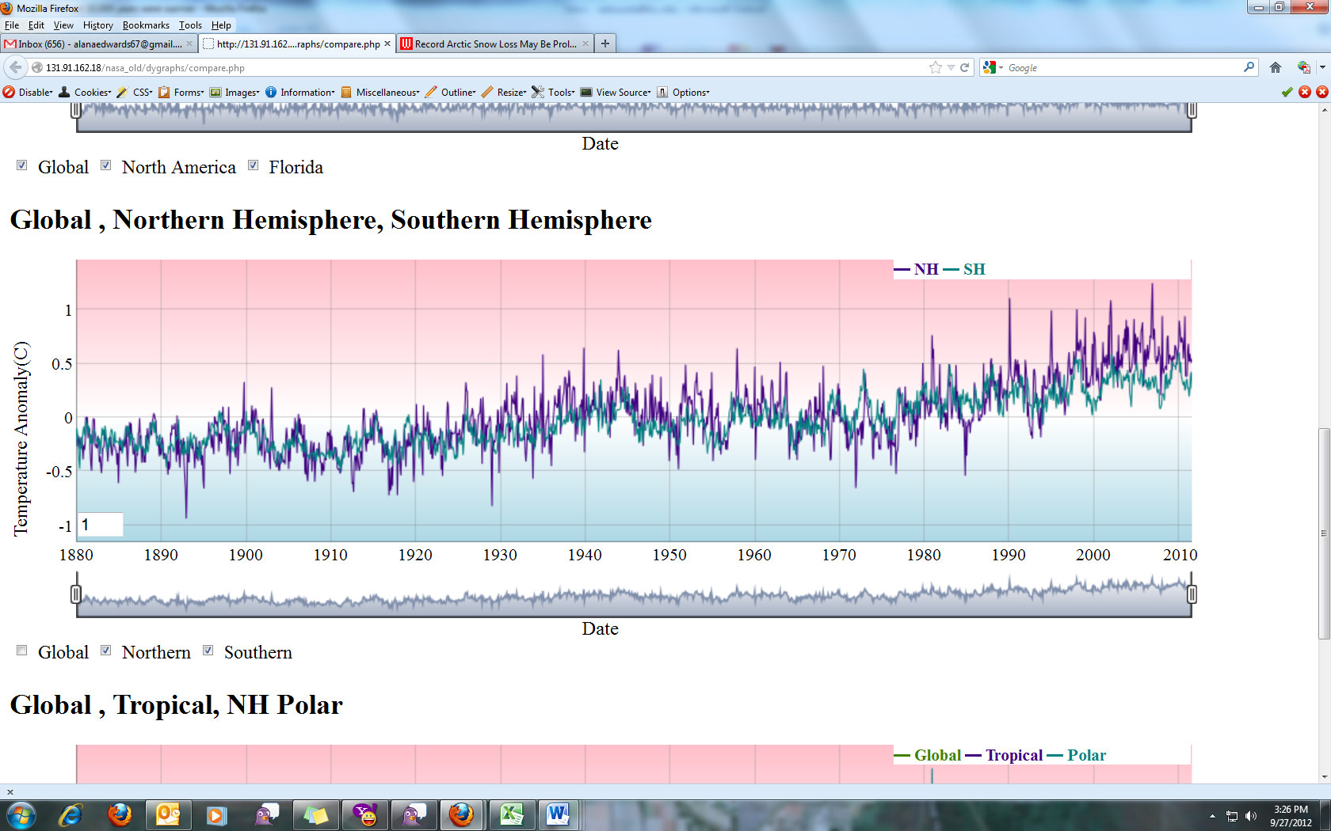

Use the interactive, time series graphing tool at

<http://131.91.162.18/nasa_old/dygraphs/compare.php> to answer the following questions.

1. Make a few hypotheses before you begin to compare the 130-year Northern and Southern Hemisphere temperature anomalies.
2. Do you think Northern and Southern Hemisphere temperature anomalies will both show a warming trend?

_____ Yes _____ No

1. Do you think that the more recent decades will show an increased rate of warming for both Northern and Southern Hemisphere?

_____ Yes _____ No

1. Which do you think will have a greater range between high and low temperature anomalies?

_____ Northern Hemisphere _____ Southern Hemisphere

1. Which do you think has more variable temperature anomalies over time?

____ Northern Hemisphere _____ Southern Hemisphere

1. Uncheck the box next to *Global* and check the *Northern* and *Southern Hemisphere* boxes to display the temperature anomaly data for 1880-2010. Describe the general temperature anomaly trends over this time period.

1. To analyze the Northern Hemisphere temperature anomaly variation, click on *the Southern Hemisphere* box below the graph to uncheck it. Then click on the *Northern Hemisphere* box. You should see the Northern Hemisphere temperature anomaly data.
2. Describe the general temperature anomaly trend over this time period.
3. What is the lowest temperature anomaly recorded during that time period? What is the highest? What is the range of temperature anomalies (lowest to highest)?
4. To analyze the Southern Hemisphere temperature, click on the *Northern Hemisphere* box below the graph to uncheck it. Click on the *Southern Hemisphere* box. You should see the Southern Hemisphere temperature anomaly data.
5. Describe the general temperature anomaly trend over this time period.
6. What is the lowest temperature anomaly recorded during that time period? What is the highest? What is the range of temperature anomalies (lowest to highest)?
7. Now zoom into the graph for the last 25 years (1985-2010).
8. Describe the change in the Northern and Southern Hemispheres temperature anomalies.
9. Which hemisphere is showing more of a warming trend?
10. Which hemisphere shows more variation in temperature anomalies?
11. You previously learned that land warms more quickly than the ocean. Use the map of the Earth to the right and discuss how this relates to your answer in question 5.

**Explanation – A Comparison of Northern and Southern Hemisphere Temperatures**

The Mollwiede projection of Earth shows that there is more landmass in the Northern Hemisphere than in the Southern Hemisphere. While perhaps not obvious just at a glance, the Northern Hemisphere’s surface is about 40% landmass and is covered by about 60% water in the Northern Hemisphere. The Southern Hemisphere’s surface is about 20% landmass and is covered by 80% water.

You learned in the previous exploration that the land on earth is warming more quickly than the oceans due to the oceans’ heat capacity. The reason that the Northern Hemisphere is warming more quickly is that this hemisphere has more landmass.

**Exploration 3. A Comparison of Regional Temperature Anomalies**

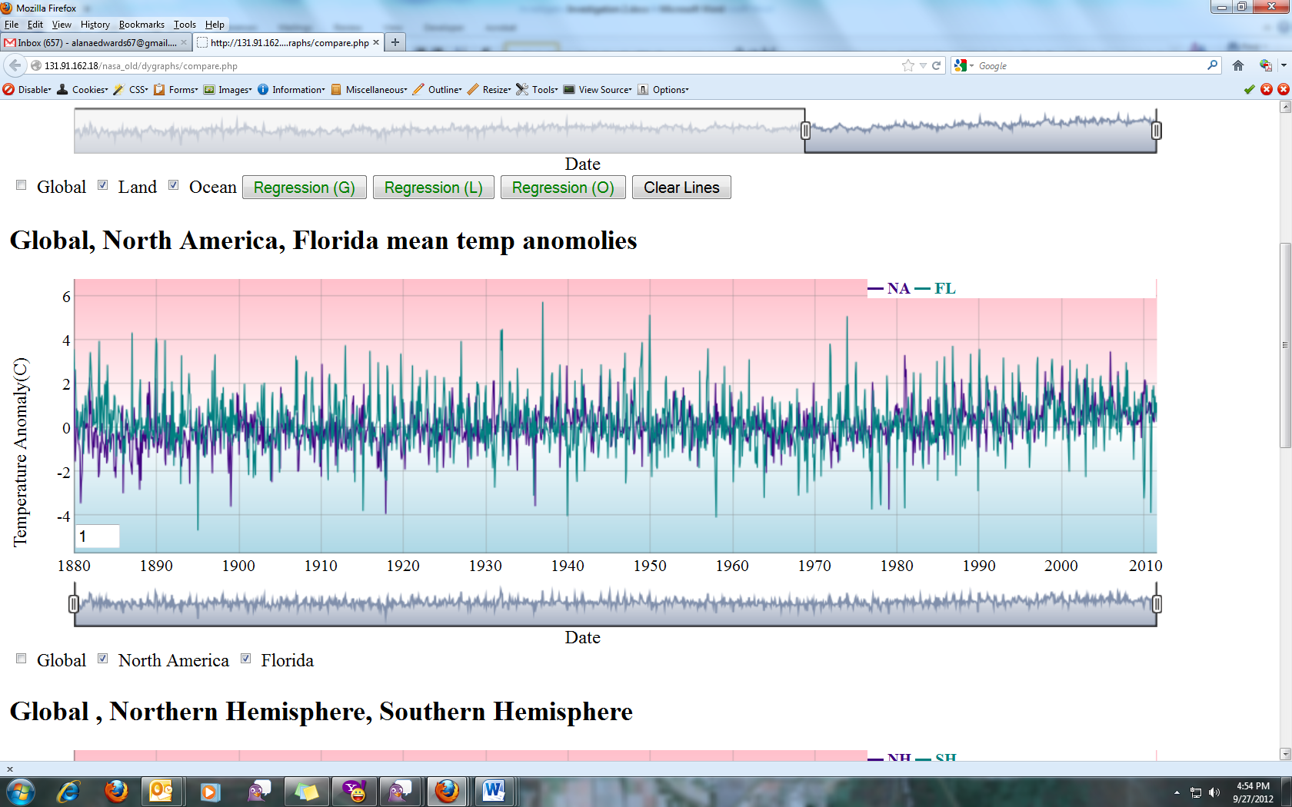

1. Make a few hypotheses before you begin to compare the 130-year for Florida, North America, and Global Temperature Anomalies.
   1. Do you think the Florida, North America, and global temperature anomalies will show a warming trend?

_____ Yes _____ No

* 1. Do you think that the more recent decades will show an increased rate of warming for Florida, North America, and globally?

_____ Yes _____ No

* 1. Which do you think will have a greater range between high and low temperature anomalies?

_____ Florida     _____ North America     _____ Global

* 1. Which do you think has more variable temperature anomalies over time?

_____ Florida     _____ North America     _____ Global

1. Analyze the temperature anomaly variation for Florida: Uncheck the box next to *Global* and check heck on the box next to *FL*. You should see the Florida temperature anomaly data only.
2. Describe the general trend for change in Florida temperature anomalies.
3. What is the lowest temperature anomaly recorded during that time period? What is the highest? What is the range of temperature anomalies (lowest to highest)?
4. Analyze the temperature anomaly variation for North America: Click on the *FL* box beneath the graph to uncheck it, and click on the *NA* box. You should see the North American temperature anomaly data only.
5. Describe the general trend for land temperature anomaly.
6. What is the lowest temperature anomaly recorded during that time period? What is the highest? What is the range of temperature anomalies (lowest to highest)?
7. Look at the global temperature anomaly data for 1880-2010. Check the *Global* Temperature Anomaly box below the graph to see the data displayed on the graph.
8. Describe the general temperature anomaly trend over this time period.
9. What is the lowest temperature anomaly recorded during that time period? What is the highest? What is the range of temperature anomalies (lowest to highest)?
10. Use the data you recorded in questions 1 – 3 to complete the table below.

|  |  |  |  |
| --- | --- | --- | --- |
| **Geographic Space** | **Lowest Temperature Anomaly (**˚**C)** | **Highest Temperature**  **Anomaly (**˚**C)** | **Range (**˚**C)**  **Lowest Temperature Anomaly to Highest Temperature Anomaly** |
| Florida |  |  |  |
| North America |  |  |  |
| Global |  |  |  |

1. Which location has the smallest range in temperature variation? Which has the largest? Explain why you think this trend occurred.

**Explanation – Regional versus Larger Geographic Areas**

Local or regional temperatures show much greater natural variability than larger geographic-scale temperatures. For example, in Boulder, Colorado, the monthly temperature anomaly may vary by 7°C; while in the United States it may vary by 3.9°C and globally, by 0.8°C.

Temperature varies less on a global scale. Global mean temperature is ruled by the simple energy balance. You learned previously that the best way to determine if greenhouse gases are having the effect predicted by the physics of the greenhouse effect is to calculate the Earth’s energy balance. Natural variations are much smaller on a global scale than on a regional or local scale because the many natural variations cancel out when averaged over the entire globe. The natural variations in temperature over a larger geographic scale are canceled out, and therefore, it is easier to detect longer-term temperature trends when comparing global mean temperature (GMT).

**Exploration 4. A Comparison of Polar and Tropical Regions**

In the previous explorations, you used an interactive graphing tool to see how temperature varies in different regions. In this exploration, you will view a video of a visualization and compare polar regions to tropical regions.

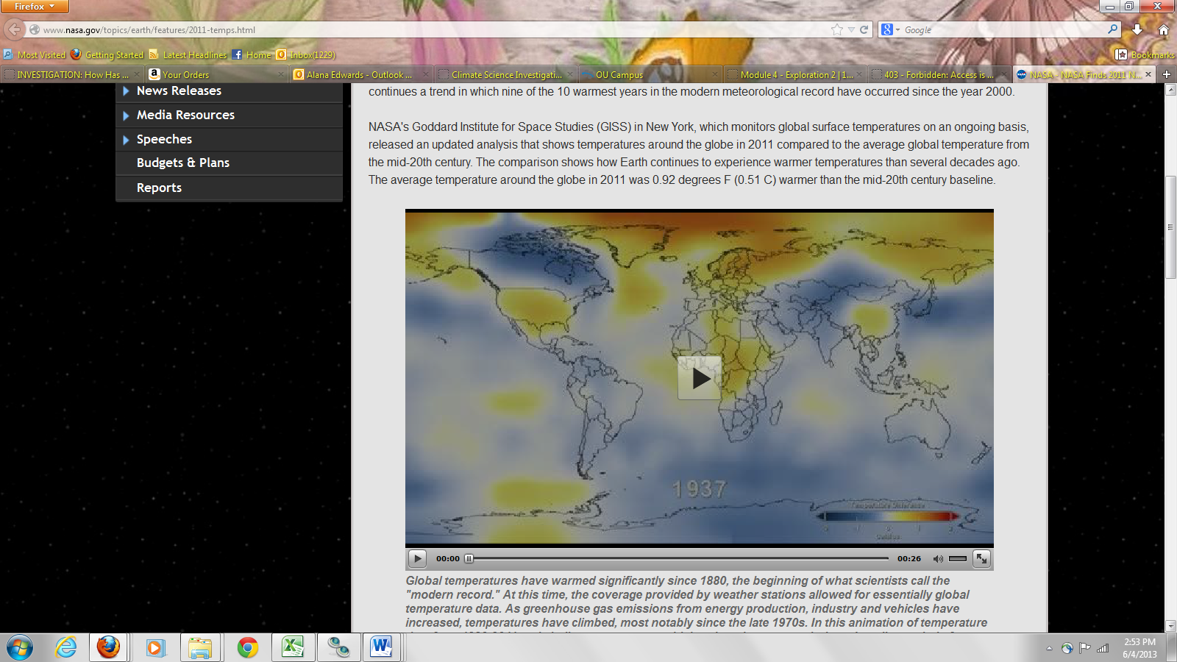This visualization was developed by NASA’s Goddard Institute and shows color-coded maps displaying a progression of changing global surface temperature anomalies from 1880 through 2011. The blue color indicates areas that are 1-2°C cooler than the average global temperature anomaly and the red color indicates areas that are 1-2°C warmer than the average global temperature anomaly. No color (white) indicates that temperatures are normal.

Click on the link below to view the visualization and answer the following questions. (Hint: you may need to play the video several times): [http://www.nasa.gov/topics/earth/features/2011-temps.html](https://exchange.fau.edu/owa/redir.aspx?C=WzdecXMsDUSxd0HlKy4BJPNsTETUMNAIfsAyqPMANM0pnFfiw9yVdMt2EIDwYrX6zAlrRXW7_MY.&URL=http%3a%2f%2fwww.nasa.gov%2ftopics%2fearth%2ffeatures%2f2011-temps.html)

1.      On a global perspective, what do you observe about the change in temperatures over the 131 year period? Explain your reasoning.

2.      Throughout the visualization, what regions start to show the warmest temperature anomalies (2°C indicated by the darker red color)?

3.      Look at the tropical regions in and around the equator. What do you notice about the temperature change? Explain your reasoning.

**Explanation - Polar and Tropical Regions**

The main reason that polar regions are warming more quickly than tropical regions has to do with the reflectivity of the bright ice. Ice has a higher albedo and therefore a higher percentage of solar radiation is reflected back toward space. However, as snow and ice melt, the darker surfaces of the ground or oceans have a lower albedo and more solar radiation is absorbed, which amplifies warming.