Name(s) ________________________________________________ Period __________ Date ___________________
How Did Temperature Change Before the Industrial Revolution?

Exploration 3: Proxy Data and Temperature Before the Industrial Revolution
In this exploration, you will analyze temperature data derived from a variety of proxies to answer the question – how has the average temperature of the northern hemisphere varied between 2,000 years ago and the late 19th century?

As you learned previously, historic temperatures can be gathered from direct sources such as diaries, ship logs, thermometers, and written records, and from indirect sources such as ice cores, tree rings, records of lake levels, glacial movement, and pollen distribution. To reconstruct temperature over the past 2,000 years, Michael Mann, Raymond Bradley, and Malcolm Hughes synthesized proxy data from tree rings, coral, and other temperature data. They calibrated these data by comparing them to the instrumental records of the nineteenth and twentieth centuries.

Use the interactive, time-series graphing tool to answer the following questions.
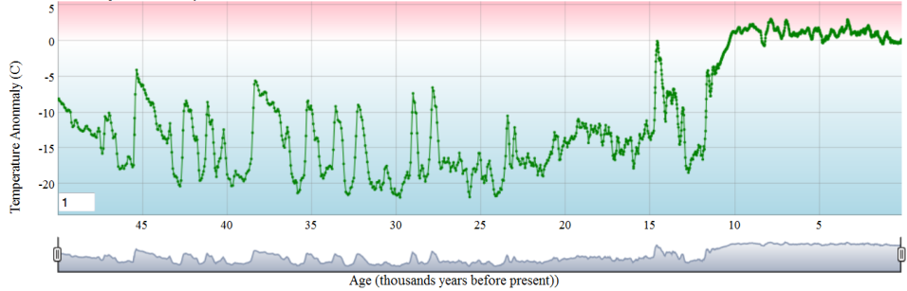
- What do you observe about the temperature anomaly between about 950 and 1250? Approximately, how many times was the anomaly around the norm (0°C)?

- Zoom into the time interval between about 1250 and 1900. What do you observe about the temperature anomaly between about 1300 and 1850? How many times was the anomaly at or below -0.65 °C?

3. What temperature pattern do you observe between the time interval of 1850 and 2006?

