Name(s) ________________________________________________ Period __________ Date ___________________
How Did Temperature Change Before the Industrial Revolution?

Exploration 2: Greenland Ice Cores and Temperature Between 50,000 and 10,000 Years Ago
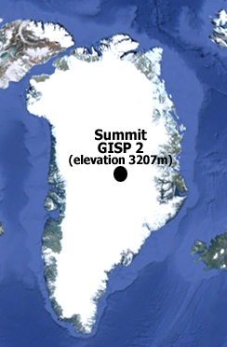
In this exploration, you will analyze temperature data derived from an ice core drilled in Greenland to answer the question – how has the temperature over Greenland varied between 50,000 and 10,000 years ago?
Original image source: Google Earth

The ice cores of Greenland help scientists reconstruct some interesting changes in the Northern Hemisphere’s climate. In this exploration, you will examine the ice core data from Summit Greenland Ice Sheet Project Two (GISP2). This was a joint drilling project of numerous countries, including the U.S. In 1993, after several years of drilling, the project produced an ice core that was over 3,000 meters in length – the deepest ice core recovered in the world at the time. The layer at the bottom was determined to be approximately 250,000 years old. However, because an ice sheet is constantly flowing, these layers can become distorted. Therefore, you will examine the temperature patterns between about 50,000 and 10,000 years ago.

Use the interactive, time-series graphing tool to answer the following questions.
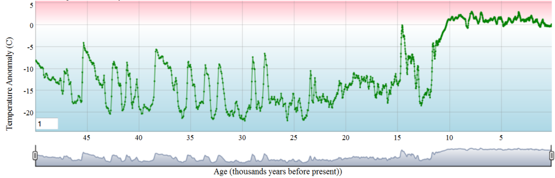
- Look at the temperature anomaly data between 50,000 and 27,000 years ago. Describe the general pattern that you see.

- Zoom in on the period of time between 30,000 years ago and the present. During what span of years was the temperature over 10°C colder than normal in Greenland?

- Describe the temperature pattern that occurred from 13,040 to 11,560. This period was known as the Younger Dryas.

- What general temperature trend do you observe between about 10,000 and 130 years ago? You will examine this in more detail in the next exploration.

- Calculate the estimated rate of change for four sequential glacial-interglacial periods. To do this, zoom in on the time series graph to the glacial-interglacial periods listed in the table below. Complete the table below by answering the following:
  - What is the range of years for each glacial-interglacial period listed?
  - What was the temperature anomaly for this glacial period?
  - What was the temperature anomaly for this interglacial period?
  - Subtract your glacial period estimate from your interglacial period estimate and divide by the range.
___T₂ – T₁___
Year₂ – Year₁
  - Determine the average rate of change per 100 years (century) for each glacial-interglacial period by multiply your estimated rate of change per year by 100.
Glacial-Interglacial  Periods | Years Ago | Range of Years  (Between Glacial and Interglacial) | Temperature  Anomaly Readings | Estimated Rate of Change  (˚C/year) | Average Rate of Change for Estimated Temperature Anomaly Readings  (˚C/100 years)
Glacial | 35,810 | 35,810-35,190 = 620 | -21.28 ˚C | -8.39-(-21.28)  /620 =  0.021˚C /year | 2.1˚C/  100 years
Interglacial | 35,190 |  | -8.39 ˚C
Glacial | 32,880
Interglacial | 32,220
Glacial | 29,740
Interglacial | 28,980
Glacial | 14,930
Interglacial | 14,520

- What was the average range of years between a glacial and interglacial period?

- What was the average low temperature anomaly for the three periods? What was the average high?

- How does the average rate of change of temperature anomaly during these glacial-interglacial periods from the Greenland core compare to that during the glacial-interglacial periods from the 800,000 Antarctica data?

