Name(s) ________________________________________________ Period __________ Date ___________________
How Did Temperature Change Before the Industrial Revolution?
Introduction
You have most likely heard that the planet is experiencing a warming trend. But how do scientists know if Earth is warming, and if so, if the trend is unusual? In the following investigations, you will analyze temperature patterns over different intervals of time and geographic areas to decide whether Earth is warming, and if so, at what rate.

For the several investigations in the Climate Science Investigations (CSI): South Florida program, you will use an interactive, time-series graphing tool. A time-series graph is a line graph with time measured on the horizontal axis and some observed variable, such as temperature or temperature anomaly, on the vertical axis.

Exploration 1: Antarctica Ice Cores and Temperature Over the 800,000 Years
You have learned that Earth’s climate has fluctuated several times over geologic history. In this exploration, you will analyze temperature data derived from ice cores drilled in Antarctica to answer the question – how has the temperature over Antarctica varied over the past 800,000 years?

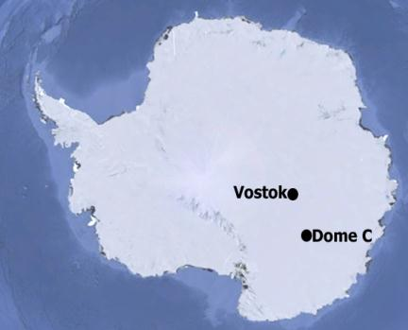
The ice with the longest climate record on Earth is found in Antarctica. Unlike the Arctic where the majority of the ice floats on the sea, most of the ice in Antarctica is over land, making it ideal for deep ice coring. In the mid-1990s, cores drilled at Russia’s famous Vostok station reached depths of over 3 km and provided data for the past 425,000 years. In 2004, the European Union sponsored the European Project for Ice Coring in Antarctica (EPICA) which completed drilling a core several hundred miles from the Vostok Station. The data set used for the time-series graph below is from EPICA’s ice core analyses. These cores were collected at the Concordia Research Station, a facility built in 2005 near Dome C, Antarctica. This core contains climate data as far back as 800,000 years.
Original image source: Google Earth

Use the interactive, time-series graphing tool to answer the following questions.

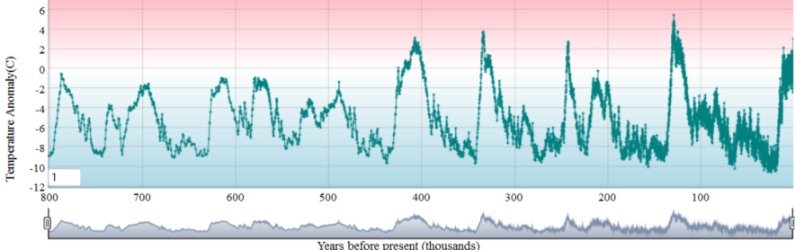

- Look at the temperature anomaly data and describe the general pattern that you see over the past 800,000 years.

- Approximately how many glacial periods do you observe over the past 800,000?

- What is the approximate time period between each glacial period?

- The last ice age began about 2.75 million years ago, but according the time-series graph, approximately when did the last major glacial period begin?

- Are we currently in a glacial or interglacial period? Approximately, when did this most recent period of climate begin?

- Calculate the estimated rate of change for three sequential glacial-interglacial periods. To do this, zoom in on the time series graph to the glacial-interglacial periods listed in the table below. In the table you are given a one thousand year range to examine. You will look at all points in that thousand year period by running your cursor over the points. You will note the temperature anomaly for each point and then estimate the average for that range. Complete the table below by answering the following:
  - What is the range of years for each glacial-interglacial period listed?
  - What is the temperature anomaly estimate for this glacial period?
  - What is the temperature anomaly estimate for this interglacial period?
  - Subtract your glacial period estimate from your interglacial period estimate and divide by the range.
___T₂ – T₁___
Year₂ – Year₁
  - Determine the average rate of change per 100 years (century) for each glacial-interglacial period by multiplying your estimated rate of change per year by 100.

Glacial-Interglacial  Periods | Years Ago | Range of Years  (Between Glacial and Interglacial) | Estimated Average  Temperature  Anomaly Readings | Estimated Rate of Change  (˚C/year) | Average Rate of Change for Estimated Temperature Anomaly Readings  (˚C/100 years)
Glacial | 343,000-344,000 | 343,000-333,000=10,000 | ~-9˚C | 3.5˚C – (-9˚C) / 10,000= 0.0013˚C/year | 0.0013˚C/year *  100 years =  0.13˚C/100 years
Interglacial | 333,000-334,000 |  | ~3.5˚C
Glacial | 252,000-
Interglacial | 242,000
Glacial | 138,000
Interglacial | 128,000

- What is the average rate of change for the three glacial-interglacial periods analyzed in the table above?

