Ocean Currents: How Surface and Deep Currents
Form and Affect Climate

PURPOSE

The purpose of this lesson is to explore how ocean currents are formed and the role they play in Earth’s climate.

ENGAGEMENT
Review global wind patterns at http://www.ces.fau.edu/nasa/content/resources/global-wind-patterns.php within the Causes of Climate Change module. Also, see this video showing an animation of how surface currents form: http://higheredbcs.wiley.com/legacy/college/strahler/0471417416/animations/ch05/page6.mov. As these currents flow along the edges of continents they affect the land’s climate. In this activity, students will identify and label the major surface currents

EXPLORATION
Part A: Surface Currents: Highways of the Sea

Procedure
- Label each of the currents on the blank ocean currents map (next page) by writing the name next to the arrow.
- Choose two different colored pencils. Shade in the arrows that represent the cold-water currents in one color and the warm-water currents in another color. Include a key to identify which colors represent the cold and warm currents.

Number | Name of Surface Current | Characteristic Temperature of Water Transported by Current
1 | Kuroshio Current | warm
2 | California Current | cold
3 | East Australian Current | warm
4 | Antarctic Circumpolar Current | cold
5 | Peru Current (Humboldt) | cold
6 | Gulf Stream | warm
7 | Canary Current | cold
8 | Brazil Current | warm
9 | Benguela Current | cold

Results
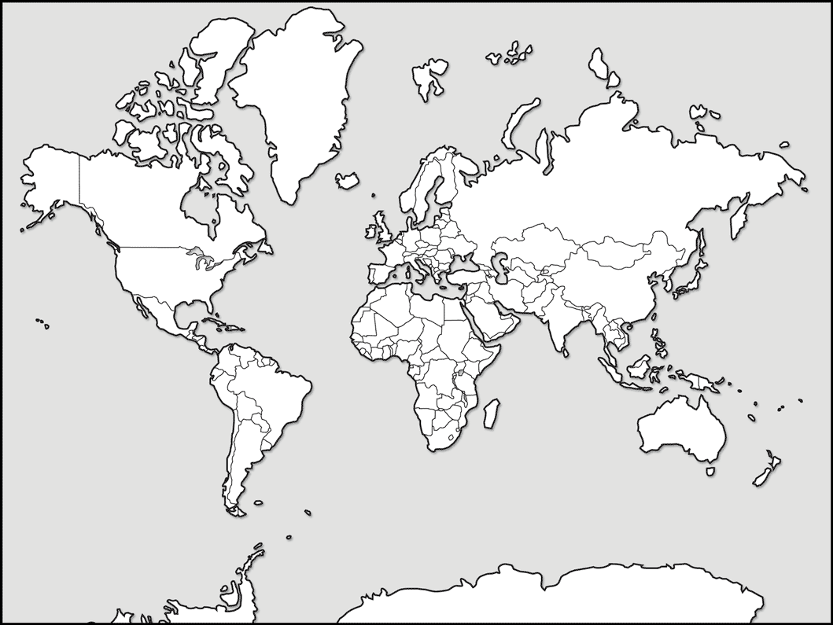
5
8
9
6
7
4
3
2
1
EXPLORATION
Part B: How Density Currents Flow in Water of Different Temperatures
Make a prediction.

___ A cold current will sink and flow across the bottom of the aquarium filled with warm water.
___ A cold current will flow across the top of the warm water in the aquarium.
Explain why you made this prediction (your reasoning).

Procedure
- Pour enough warm fresh (tap) water into the clear plastic aquarium box so that the water level is about 4 cm below the top of the box.
- Fill the Styrofoam cup with cold (ice) water.
- Add 3 drops of food coloring to the cup of cold water. Stir until the food coloring mixes completely with the water.
- Use a clothespin to attach the Styrofoam cup to the inside edge of the aquarium. Most of the cup should be in the water.
- Using a sharp pencil point, carefully make the hole in the Styrofoam cup. The hole should be approximately 5 cm from the cup’s bottom (or just beneath the surface of the water).
- Observe the flow of the cold water as it moves out of the cup into the aquarium water.

Results
Draw a diagram the movement of the cold water through the clear plastic box.

Diagram of a Temperature-Driven Density Current

Part C: How Density Currents Flow in Water of Different Salinities
Make a prediction.

___A saline current will sink and flow across the bottom of the aquarium filled with fresh water.
___ A saline current will flow across the top of the fresh water in the aquarium.
Explain why you made this prediction (your reasoning).

Procedure
- Pour enough room temperature, fresh (tap) water into the clear plastic aquarium box so that the water level is about 4 cm below the top of the box.
- Fill the Styrofoam cup with tap water and add 3 tablespoons of salt to the water.
- Add 3 drops of food coloring to the cup of cold water. Stir until the food coloring mixes completely with the water.
- Use a clothespin to attach the Styrofoam cup to the inside edge of the aquarium. Most of the cup should be in the water.
- Using a sharp pencil point, carefully make the hole in the Styrofoam cup. The hole should be approximately 5 cm from the cup’s bottom (or just beneath the surface of the water).
- Observe the flow of the saline water as it moves out of the cup into the aquarium water.

RESULTS
Draw a diagram of the movement of the saline water through the clear plastic box.

Diagram of a Saline-Driven Density Current

THE SCIENTISTS’ EXPLANATION
The sun’s energy drives the major wind systems of the atmosphere. Because of Earth’s spherical shape, the surface is heated unequally. The result is global wind patterns, which cause winds to blow across the oceans and drive surface ocean currents.

As these currents flow along the edges of continents they affect the land’s climate. Cold-water currents tend to have a cooling effect on the continental coastlines they border, while warm-water currents tend to have a warming effect. On the East Coast, the Gulf Stream, which comes from the equatorial region, carries warm water and keeps the eastern coast of the U.S. relatively warm. The California Current comes from the polar region and carries cold water along the West Coast. This is why it is too cold for most people to swim at northern California beaches.
Deep currents also flow throughout the ocean basins due to differences in the density of different masses of water. Heating and cooling water affects a body of water’s density. Heating water causes water molecules to speed up and bounce off of each other more, and thus move further apart. Therefore, warm water is less dense than cold water. When water is heated, it becomes less dense and rises. Cooler, denser water sinks. As water is cooled, water molecules move more slowly and get closer together, becoming more dense and sinking. The process of warm water rising and cool water sinking forms convection currents. Convection currents transfer most of the heat energy in the oceans. The process of convection also happens in atmosphere when warm air rises and cool air sinks.

Adding or subtracting certain materials to water, such as salt, can also change a body of water’s density. If salt is added to fresh water, the amount of matter within the space the water occupies is increased, since salt molecules are crowded into the same space as the water. This makes salt water more dense than fresh water. Oceanographers use the word salinity to describe the amount of salt in water.

Deep ocean currents form as colder, more saline water masses sink and warmer, less saline water masses rise. Warmer water masses are found near equatorial regions and colder water masses are found near polar regions. More saline water masses are found in areas where there is a lot of evaporation or in polar areas where ice is formed. Less saline water is found where there is more precipitation or river input.

Currents and Earth’s Climate
Together, the surface and deep currents of the oceans distribute heat. The ocean regulates global climate by absorbing and releasing heat as the water is transported around the Earth. The surface ocean currents have a strong effect on Earth’s climate. Areas near the equator receive more heat than areas near the poles. However, these areas are not constantly getting warmer. This is because the oceans and winds transport heat around the Earth from lower latitudes near the equator to higher latitudes near the pole.
Image source: NASA

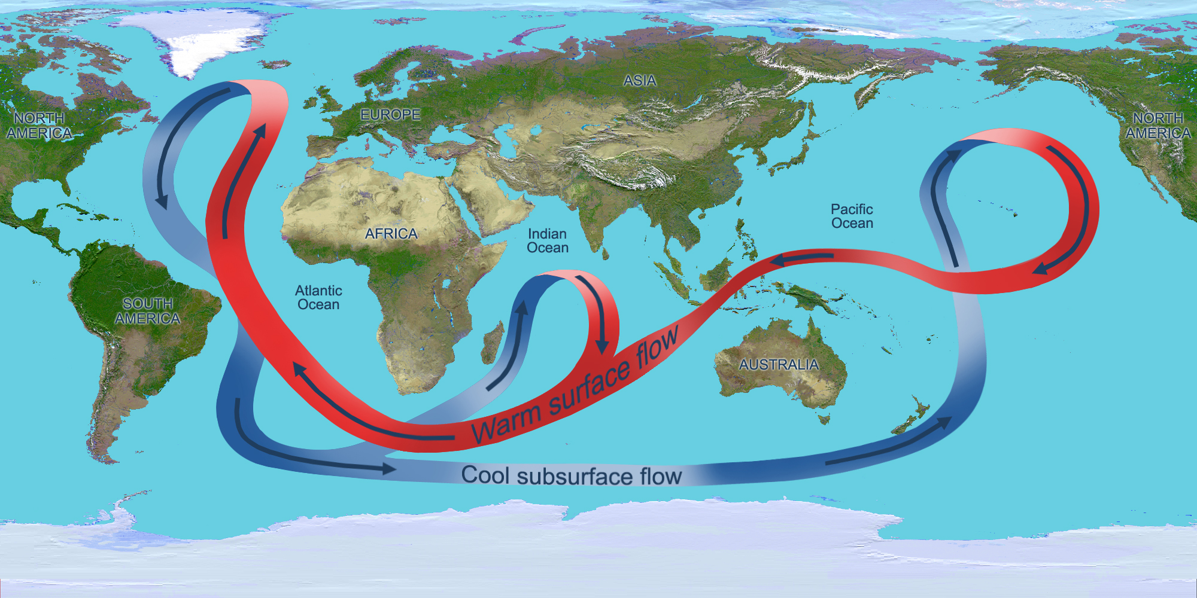
Image source: NASA
The deep (density) ocean currents also have a strong effect on Earth’s climate. Water in the North Atlantic Ocean is cold and salty. This colder, salty water sinks because of its greater density. It then flows southward deep in the ocean. This deep current flows throughout the Earth’s oceans and eventually mixes with the surface currents and helps return surface water to the North Atlantic. This “conveyer belt” circulation of water moves heat around the Earth. One drop of ocean water in the North Atlantic Ocean takes about 1000 years to return to the same spot.
Scientists do not completely understand this flow of water, but they do believe that if Earth’s atmosphere continues to warm, water will not sink as much in the North Atlantic Ocean. This may cause the global flow of ocean water to slow, drastically changing Earth’s climate. Scientists think that if the conveyor slows or stops, the warmer surface water would not be propelled back toward the north Atlantic through the Gulf Stream. This could cause Europe to be frozen.
Over the past few million years, ocean currents have flowed in the same general patterns. Some small changes have occurred as Earth’s climate has slowly varied between ice ages and warmer periods. Today, however, we are facing a situation unlike any in the past. Due to an increased amount of greenhouse gases in Earth’s atmosphere, the Earth’s temperature is rising, causing the oceans to also warm. Warmer ocean temperatures will have a great effect on currents, sea level, and the climate on Earth.

EVALUATION
- In Part A, study the patterns of cold and warm currents. What seems to determine whether a current carries warm or cold water?

- Find Florida on the map. Look at the pattern of currents in the Northern Hemisphere. What current affects Florida and the eastern coast of the United States? How do you think this current affects the climate on the east coast?

- Now, find California on the map. Look at the pattern of currents in the Northern Hemisphere. What current affects California and the western coast of the United States? How do you think this current affects the climate in the western coast?

- In Part B, describe where the cold water went when it emerged from the hole in the cup. Why do you think this happened?

- In Part C, describe where the saline water went when it emerged from the hole in the cup. Why do you think this happened?

- What do you think would happen to water that is both cold and saline as it flows out from a cup?

- At what locations on the Earth would you expect to find very cold and saline water entering the ocean? How would this water cause the deep currents in the ocean?

- How do surface currents affect the Earth’s climate?

- How can deep density driven currents affect Earth’s climate?

EXTENSION
- Global Winds and Surface Currents
http://www.windows2universe.org/earth/Water/ocean_currents.html
http://www.classzone.com/books/earth_science/terc/content/visualizations/es2401/es2401page01.cfm?chapter_no=visualization

- Global Winds
http://earth.nullschool.net/#current/wind/isobaric/1000hPa/orthographic=-83.76,49.80,590

- Ocean Conveyor Animations
http://bcs.whfreeman.com/thelifewire/content/chp58/5802003.html
http://svs.gsfc.nasa.gov/vis/a010000/a010000/a010031/oceanconvey.mpg

- Sea Turtles and Ocean Currents
http://education.nationalgeographic.com/education/media/ocean-drifters/?ar_a=1

