Heat Capacity and Coastal Climates:
Which Absorbs and Loses Heat Faster––Land or Water?

PURPOSE

The purpose of this lesson is to investigate the heat capacity of water and land and to explain how the properties of water influence coastal climates.

EXPERIMENTAL DESIGN
In this experiment, you will heat the same volume of water and sand or soil in two different containers. They will compare the temperatures of the water and the sand or soil as each beaker is heated and as each beaker cools to answer the question:
Which Absorbs and Loses Heat Faster––Land or Water?

Hypothesis
After reading through the methods section below, write a hypothesis to answer the question above.
Hypothesis:

Methods

- Place 100 cm3 of soil in one beaker and 100 mL of water in the other beaker.
- Place a thermometer in soil and in the water.
- Place the lamp approximately 20 cm from the beakers. Make sure that both beakers are equal distance from the lamp and that both receive light at the same angle.
- Turn on the lamp and record the temperature (?C) of the soil and water at 2-minute intervals for 20 minutes. Write your results in the first table and include a title for the table.
- Turn off the lamp and move it away from the beakers. Record the temperature (?C) of the soil and water at 2-minute intervals for 20 minutes. Write your results in the second table and include a title for the table
- Construct a line graph that summarizes your results. Include a title, label the axes, and include a legend.

Results

Table 1– Title: __________________________________________________________________________

Temperature (˚C) | Initial  Temp | 2 min | 4 min | 6 min | 8 min | 10 min | 12 min | 14 min | 16 min | 18 min | 20 min
Soil or Sand
Water

Table 2 - Title: __________________________________________________________________________

Temperature (˚C) | Initial  Temp | 2 min | 4 min | 6 min | 8 min | 10 min | 12 min | 14 min | 16 min | 18 min | 20 min
Soil or Sand
Water

Graph - Title: ___________________________________________________________________________

Findings
Write a summary of your results.

CONCLUSIONS: DEVELOPING EXPLANATIONS FROM EVIDENCE

- Was your hypothesis supported by the data or evidence?

- Explain your rationale for the results.

- What recommendations do you have for improving the experiment and for further study?

- How does having a large lake or an ocean nearby affect the climate of an area?

- The peak of hurricane season is in mid-September, toward the end of the Northern Hemisphere’s summer. How do the results of this experiment help explain the peak being in late summer?

- Each day, land and sea breezes occur near large bodies of water. How do the results of this experiment help explain these daily occurrences?

THE SCIENTISTS’ EXPLANATION

Water is a liquid rather than gas (or water vapor) at room temperature because of the strong hydrogen bond between the molecules of water. (This strong bond causes water to resist molecular motion and remain a liquid at room temperature.) This means that it takes more energy or heat to increase water’s temperature than it does for most other substances. The specific heat of water is greater than that of dry soil, therefore water both absorbs and releases heat more slowly than land.
Large bodies of water tend to moderate the temperature of nearby land due to the high heat capacity of water. This high heat capacity results from both the higher specific heat of water and the mixing of heat throughout a greater depth over oceans. Oceans have a greater heat capacity than land because the specific heat of water is greater than that of dry soil and because mixing of the upper ocean results in a much larger mass of water being heated than land. This causes land areas to heat more rapidly and to higher temperatures and also to cool more rapidly and to lower temperatures, compared to oceans.
The high heat capacity of water explains why the temperatures of land near a body of water are more moderate. The high heat capacity of water keeps its temperature within a relatively narrow range, causing nearby coastal areas to also have a smaller daily and seasonal temperature range. In contrast, areas with similar weather conditions that are farther from the coast tend to have a much wider range of seasonal and daily temperatures.
The high heat capacity of the water also explains why the peak period of tropical cyclones (hurricanes in the Atlantic Ocean or typhoons in the Pacific Ocean) occurs toward the end of the Northern Hemisphere’s summer. Throughout the summer season, the oceans have been slowly absorbing heat and warming.
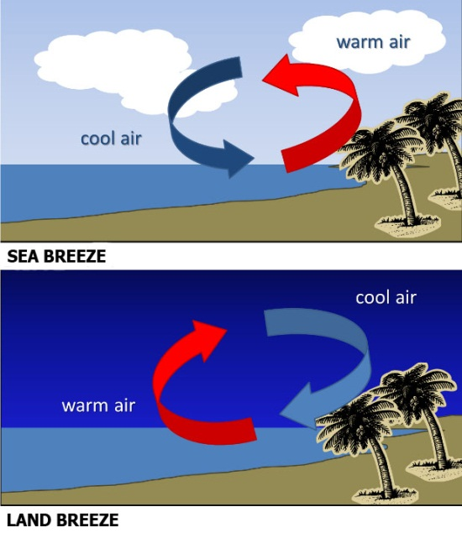
The high heat capacity of water also helps to explain the daily occurrence of land and sea breezes. Land and sea breezes help regulate Earth’s climate; since land is warmer during the day, it heats the air in the atmosphere above it, which causes the air to expand, becoming less dense and thus, creating a low pressure. On the other hand, because water warms up slower, the air above it takes longer to increase in temperature and so, a higher pressure is maintained. As a result, a sea breeze forms when air moves from an area of high pressure to an area of low pressure in an attempt to equalize pressure. At night, as the land becomes cooler, so does the air above it. Therefore, the air over the sea becomes warmer than the air over the land. Again, in an attempt to equalize pressure, the warm air rises and the cooler air moves to replace the rising warm air creating a land breeze. These are some examples of how the properties of land and water help regulate Earth’s climate.

