Name(s) ________________________________________________ Period __________ Date ___________________
How Does Sea Level in the Past Compare to Sea Level in the Present and Future?

INTRODUCTION
You have just learned that Earth is warming and ice is melting, but is sea level also changing and what are the impacts to coastal communities? Sea level has changed throughout Earth history. But how much has it changed over the past few thousand years as human civilization flourished and spread across the planet? Human population over the past has thrived because of development along the coast. Yet these areas are now facing challenges due to sea level changes. This NASA-NOAA animation of city lights at night shows just why learning about sea level rise is important.
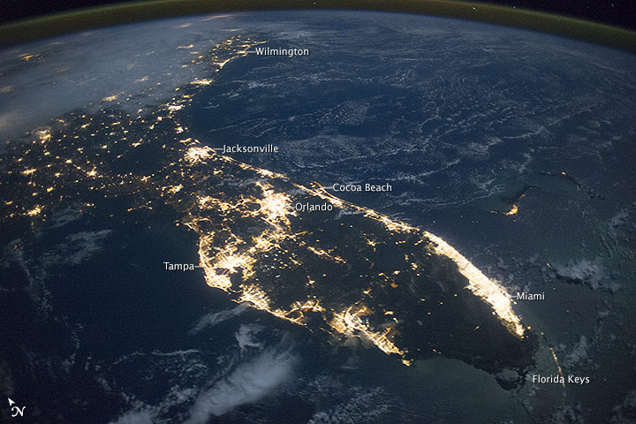
In this investigation, you will first compare global temperature, CO₂ concentrations, and sea level over the past 400,000. You will then calculate the rate of global mean sea level change since the Industrial Revolution and rate projected over the 21st century. Finally, you will study past and projected sea level in Florida. In October of 2014, astronauts aboard the International Space Station took this photograph of Florida. This photograph clearly shows why Florida’s coastal regions are especially vulnerable to sea level rise.
Florida at Night. Image Source: NASA
Use will also use NOAA’s Digital Coast: Sea Level Rise and Coastal Flooding Impacts Viewer to compare sea level and flooding along U.S. coasts.
Exploration 1: Past Sea Level Rise
Exploration 1A – A Comparison of Global Temperature Anomalies, CO2 Concentration, and
Sea Level Over 400,000 Years
Throughout Earth’s geologic history, you learned that the planet’s average global temperature anomaly and CO₂ concentrations have fluctuated. Periods when glaciers and ice sheets extended across large portions of Earth’s surface are known as glacial periods. Interglacial periods occur when large amounts of that ice melts. You may remember from a previous module that we are in an interglacial period of an ice age now. An ice age is a long period of climatic cooling, during which continents have repeated glaciations (glacial periods) interspersed with interglacial periods. However, there have also been times in our distant geologic past that temperatures were as much as 8˚C to 15˚C warmer than today. During these “hot” times, Earth’s polar areas were not covered with ice. View what it would like if we had no polar ice on Earth today.
In this exploration you will analyze global average temperature anomalies, CO₂ concentrations, and global average sea level. Use the figure of global temperature anomalies, CO₂ concentrations, and sea level over the past 400,000 years to answer the following questions.

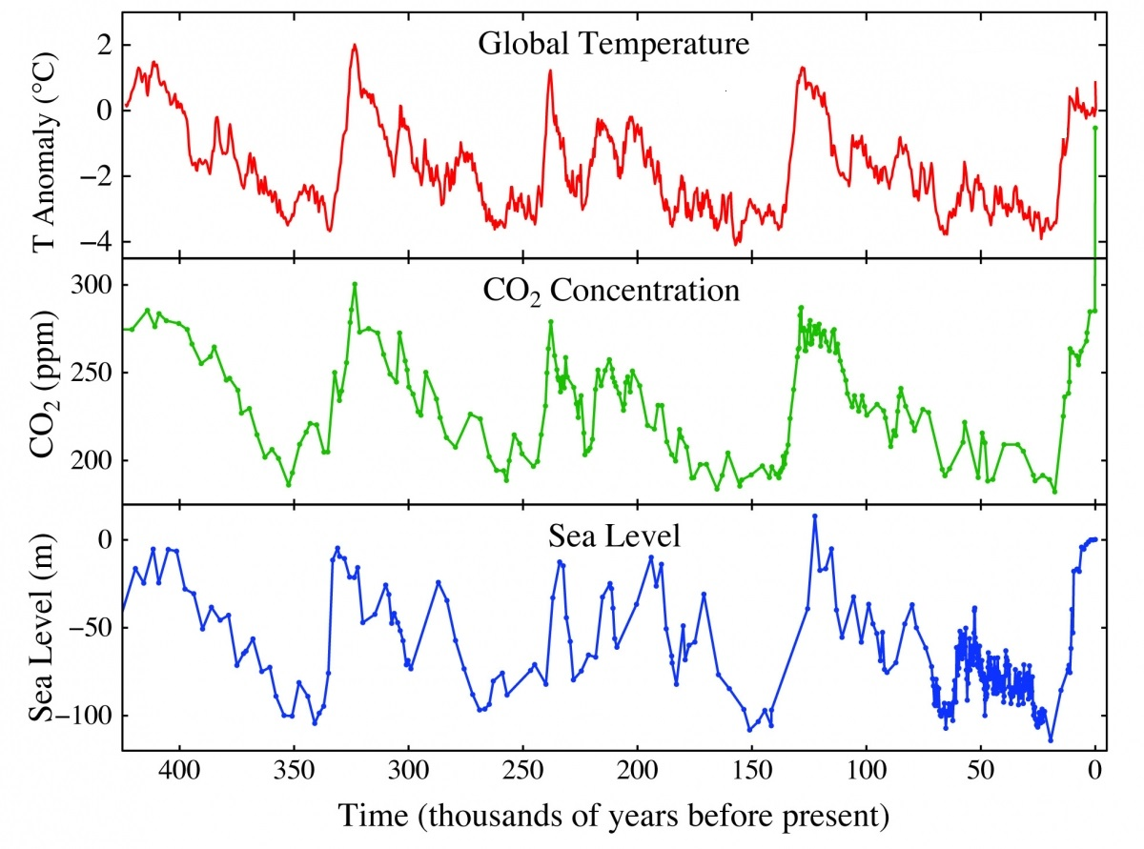
Image Source: John Englander

Compare the graphs global temperature anomalies (°C), CO₂ concentrations (ppm), and sea level (m).
- What general similarities do you observe?

- What general differences do you observe?

- The sea level shown in the graph is relative to our current sea level. Is there a time in the last 400,000 years when sea level was higher than today? If so, approximately when and approximately how much higher was it then?

Exploration 1B – Rapid Sea Level Rise
Sometimes glaciers and ice sheets melt rapidly, causing sea level to also rise rapidly. This phenomenon is known as a meltwater pulse. This figure shows sea level rise since the end of the last glacial maximum and is based on data from several different studies and reports.
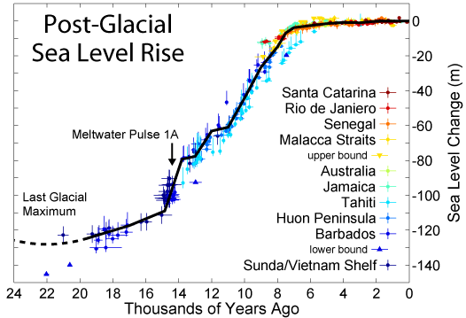
Use the figure to answer the following questions.

- Approximately when did the last glacial maximum end?

- Approximately when did Meltwater Pulse 1A occur?

- Approximately how many meters did sea level rise during this period?

Exploration 1C – Rate of Rise Since the Industrial Revolution
In order to measure sea level, both tide gauges and satellite altimetry are used. Tide gauges measure sea level relative to the ocean floor, and Earth’s center is used as the reference with satellite altimetry. The figure below, you observe a lot of variation from 1880 until the early 1990’s. You will also observe two different lines (current and old). This data is collected from tide gauges and it can be very difficult to derive precise data from these gauges. By the early 1990s, NASA began collecting satellite altimeter data, which is more reliable than tide gauges. However, even with the uncertainty of tide gauge data, the trend of rising sea levels is evident.
Image Source: Church and White

Use the figure to answer the following questions:
- What year does the graph indicate satellite altimetry was first used to measure sea level?

- Calculate the approximate rate of change for two time periods. Complete the table below by answering the following questions.
  - What is the range of years for each time period listed?
  - What is the approximate global mean sea level (mm) for each year at the beginning and end of the range?
  - What is the approximate rate of sea level rise for each time period?
  - Subtract the global mean sea level of the most recent year from the oldest year and divide by the range to obtain the rate of change per year over the time period listed.
GMSL₂ – GMSL ₁
________________________________________________________________________________________________
Year₂ – Year₁

Time Period | Range of Years | Global Mean Sea Level (mm) | Approximate Rate of Change  ( mm/year )
1900  -2009 | 109 years
1961  -2009 | 49 years
1993  – 2009 | 16 years

