Name(s) ________________________________________________ Period __________ Date ___________________
Is Arctic Sea Ice Melting?

INTRODUCTION
The National Snow and Ice Data Center (NSIDC) compiles satellite and field observation datasets from NASA, NSF, NOAA, and other programs. With these data, they provide monthly updates on ice extent in both the northern and southern hemispheres. You will notice that the data begins in 1979. This is because satellite records only date back to that year. Read more about Arctic sea ice before satellites.
In this investigation, you will look at some of the NSIDC data to see how sea ice extent in the Arctic has changed over the last half century.
Exploration 1: Sea Ice Extent
Use the NSIDC Interactive Sea Ice Graph to explore changes in the sea ice extent over the past few decades.
- http://nsidc.org/arcticseaicenews/charctic-interactive-sea-ice-graph/

To answer the following questions, you will need to select the year in the legend on the right side of the graph and then hold your cursor over the line to obtain the data.

- Use the Interactive Sea Ice Graph to determine the highest (generally mid-March) and lowest (generally mid-September) sea ice extent in millions of km² for the years listed in the table. Record the area to the nearest 0.1 million km².
Area of Sea Ice (km²)
DATE | 1983 | 1993 | 2003 | 2013
Highest
March 14th
Lowest
Sept. 13th

- Follow the steps below to calculate the average percentage of end-of-winter sea ice extent decrease per decade in million km² for the 1983-2013 March 14th dates.
  - Calculate the overall change in sea ice extent from 1983 to 2013.

  - Calculate the percentage of sea ice loss from 1983 to 2013.

  - Calculate the average percentage loss per decade.

- Follow the steps below to calculate the average percentage of end-of-summer sea ice extent decrease per decade in million km² for the 1983-2013 September 13th dates.
  - Calculate the overall change in sea ice extent from 1983 to 2013.

  - Calculate the percentage of sea ice loss from 1983 to 2013.

  - Calculate the average percentage loss per decade.

d. How does the rate of summer Arctic sea ice melt over the last decade compare to that of the previous decade?

- The IPCC states that there has been a downward trend of 3.8% per decade in the annual average extent of sea ice in the Arctic from 1979-2012. Explain why you calculated a larger percentage loss above.

Note: If you’d like to keep your graph, you can download it by clicking on the Export to raster or vector image button.
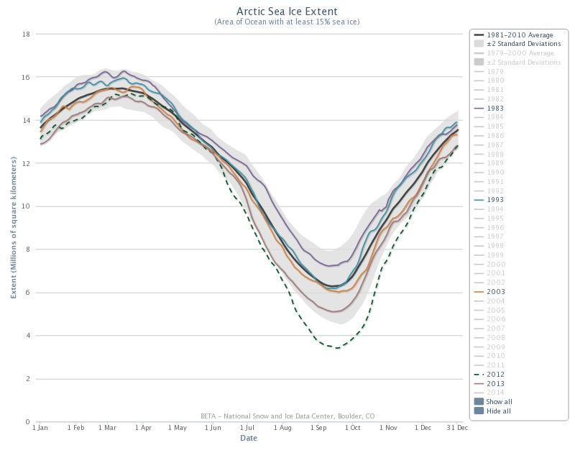
- Click on 1981-2010 Average (top button) to compare highest and lowest sea ice extent.
  - What was the highest and lowest average end-of-winter sea ice extent and corresponding year?

  - What was the highest and lowest average end-of-summer sea ice extent and corresponding year?

Read more about why the NSIDC chose the average for 1981-2010.

Exploration 2: The Rate of Sea Ice Melt Over the Past Few Decades
For this exploration you will analyze geospatial data for sea ice extent as well as anomaly trends of that data over time. The following two definitions will help you throughout this exploration.
- An anomaly is a departure from the long-term average. A positive anomaly means that the sea ice extent was greater than the long-term average, and a negative anomaly means that the sea ice extent was less than the long-term average. Anomalies are useful in analyzing trends.
- The slope of a line is a measurement of how steep the line is. The slope of a line is also known as the rate of change. It is calculated by the following equation: Slope = vertical change (rise)/horizontal change (run) = y² - y¹/ x² – x¹
Go to: http://nsidc.org/cgi-bin/bist/bist.pl?config=seaice_extent_trends
- In the first column, second row choose the month of March from the dropdown menu.
- In the first column, third row, choose the month of September from the dropdown menu.
- In the first column, first row, click on the refresh button.
- You should now see the Sea Ice Concentration Trends for the most recent March and September months in the second and third rows under the second column.
- You should also see a graph that shows the March and September Sea Ice Extent Anomalies for 1979 to the most current year in the second and third rows under the third column.
Using these data trends, answer the following questions.

- Compare the March and September Sea Ice Concentration Trends in the second column. What month and region appears to be experiencing the most melting?

- Focus on the March and September Sea Ice Extent Anomalies data shown in the third column.
  - Compare and contrast the data for March 1979-2014 to the data for September 1979-2014.

  - What is the slope or rate of change for the data for March 1979-2014?

  - What is the slope or rate of change for the data for September 1979-2013?

- Explain why the lowest ice extent is in in late summer (September) rather than in early summer (June or July).

- Explain why there is less change over the 30 years in the ice extent for late winter/early spring data compared to late summer/early fall data?

