Name(s) ________________________________________________ Period __________ Date ___________________
Is Greenland Ice Melting?

INTRODUCTION
The temperature of Greenland has risen by as much as 3°C (5.4°F), but how rapid is the ice covering Greenland melting? In this investigation you will use Google Earth to explore the melting of two massive glaciers––the Jakobshavn and Petermann Glaciers.
You will use Google Earth to visually observe how our planet has been changing over the last few decades. You may have used Google Earth before, but for these explorations, you will be downloading .KML and .KMZ files. KML stands for Keyhole Markup Language and the .KMZ files are several .KML files that have been zipped.
You will be interacting with the Places window on the left of your screen. Once you open a .KMZ file, you will notice a folder with several files underneath. Each of these represents a layer and they are stacked one on top of another so that if all of the boxes of each file in a folder is checked, only the file at the top of the list will be visible. This means that you will need to check (to view) and uncheck (to hide) these files throughout these activities.
When you first download any files, they will be placed in your temporary places folder. However, when you close out Google Earth, you have the option to either save them or discard them. If you save them, they will go to the “My Places” folder. You will also use many of the tools at the top of the screen. Before you begin, make sure that you have Google Earth installed on your computer.
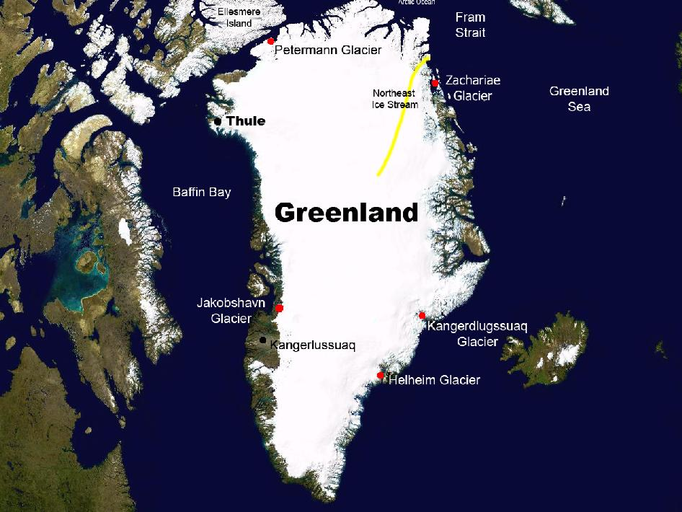
Map of Greenland showing approximate location of Jacobshavn Glacier. Image Source: NASA
Exploration 1: The Melting of Jakobshavn Glacier
The Jakobshavn Glacier, or Jakobshavn Isbræ in Danish, is located along the west coast of Greenland. For most of this century, it extended out into the ocean as a long, narrow sheet of ice, known as an ice tongue. Ice tongues form when glaciers move rapidly out into the ocean. Jakobshavn Glacier is Greenland's largest outlet glacier and the fastest flowing with a surface velocity of 7 km (4.4 miles) year. Consequently, the melting of Jakobshavn Glacier has the potential to contribute to sea level rise more than any other single feature in the Northern Hemisphere. For the last several decades, this glacier has been melting or retreating.
In this exploration, you will determine the rate of change (the retreating or melting) of Jakobshavn Glacier over several time periods. Using Google Earth, you will first mark the location of the retreating terminus, which is the lower-most end of the glacier, for different years. You will then measure the distance between each terminus to determine how far back the glacier has retreated. You will also calculate the rate of melting of the glacier. To begin, follow the steps below.

- Download the Jakobshavn files (source: NASA).
- Once downloaded, you can open the file in Google Earth two ways:
  - Go to the location of the file and double click, OR
  - Open Google Earth>File>Open and navigate to the location of your file.
- When the file is open, you should see it in your Temporary Places under Places (If you have several files already on this list, you will need to scroll down).
- If the map is not zoomed in on the glacier, double click on Jakobshavn Files.
- You will view ONE of these files at a time. First, uncheck the box next to the Jakobshavn Files and notice that all files below will uncheck. Now check the 2001 glacier layer. Be patient as it may still need to load or you might have to check and uncheck a couple of times before the image will appear.
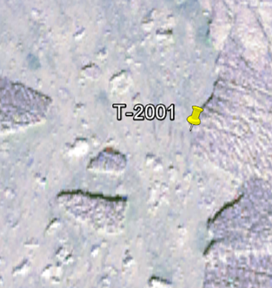
- To mark the terminus with a Placemark, follow these steps. Zoom in to see the terminus of the Jakobshavn Glacier in 2001. Mark this 2001 terminus by creating a Placemark. To do this, select the yellow pin in the top menu bar (image on right). Once selected, a pin will appear on your map with a flashing yellow box around it, indicating that the Placemark can be moved. Move the Placemark to the terminus as seen in the picture and, in the dialogue box, name it T-2001. Click OK and the Placemark will be added to your map and your list on the left in Places.
- Create Placemarks called T-2002, T-2003 and T-2013. Remember that you will need to uncheck the box next to the previously marked terminus and glacier layer files. (You may need to click on and off the selected glacier layer a couple of times for it to activate on the map.)
- Once you have created all four Placemarks, make sure that all Placemarks are checked (under Places) and that only the 2001 glacier layer is checked. The 2002, 2003 and 2013 glacier layers should be unchecked. Your map should appear as the one below.

- To measure the distance between each terminus, follow these steps. First, you will measure between Placemarks T-2001 and T-2002 using the Ruler tool. Once you click on it, a dialogue box will appear. If it appears in front of your Placemarks, move it out of the way so that you can see them. Click on the point of the first Placemark and then click on the second. The distance will appear in the dialogue box. Make sure that you have selected kilometers from the dropdown menu. Repeat this procedure for Placemarks T-2002 to T-2003 and T-2003 to T-2013. Record the distance for each time span in the table below.

Time Span |  | Retreat Distance (km) | Rate of Change/Year
1850 | 1964 | ~60 km
2001 | 2002
2002 | 2003
2003 | 2013
2001 | 2013

- Calculate the rate of change per year for the time spans given and record this rate in the table above: retreat distance/range of years

- Compare the retreat distance of 2002-2003 with that of 2001 -2013. What do you notice about the amount of retreat during these two time periods?

- How does Jakobshavn Glacier’s yearly rate of retreat since 2001 compare to that before 1964?

