Name(s) ________________________________________________ Period __________ Date ___________________
What Temperature Changes Are Projected for Different Emission Scenarios?

INTRODUCTION
In the introduction of this module, you learned about climate models and how important they are for projecting future climatic conditions. You also learned about scenarios or Representative Concentration Pathways (RCPs), which are based on different concentrations of greenhouse gas emissions. These low and high scenarios are used by climate scientists to project temperature change over the century. The low scenario is based on a net radiative forcing of 2.6 W/m2 by 2100, and the high scenario, 8.5 W/m2, by 2100.

EXPLORATION 1: Projected Regional Temperature Change
The figure below shows projected change in the average annual temperature over the period 2081-2100 (compared to the period 1986-2005) under the low scenario (RCP 2.6) and the higher scenario (RCP 8.5). Use the figure to answer the following questions.
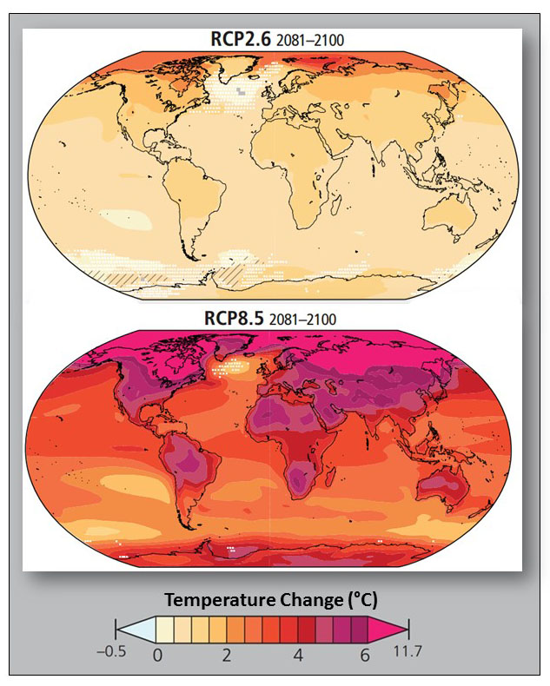
- Which regions will experience the greatest warming in both RCP scenarios?
Image Source: IPCC

2. Focus on the temperature change for Florida.
a. What is the approximate temperature change for the low RCP 2.6 emissions scenario?

b. What is the approximate temperature change for the high RCP 8.5 emissions scenario?

c. What is the difference in temperature change between the lower and higher scenarios?

- Focus on the temperature change for Greenland.

a. What is the approximate temperature change for the low RCP 2.6 emissions scenario?

b. What is the approximate temperature change for the high RCP 8.5 emissions scenario?

c. What is the difference in temperature change between the lower and higher scenarios?

- How much does the temperature in North America vary geographically (southern versus northern regions) for the:
  - Low 2.6 emissions scenario?
  - High 8.5 emissions scenario?
Exploration 2 – Projected Global Mean Temperature
The figure below shows both the observed and projected changes in global mean temperature for the low 2.6 and high 8.5 emission scenarios. Use the figure to answer the following questions.
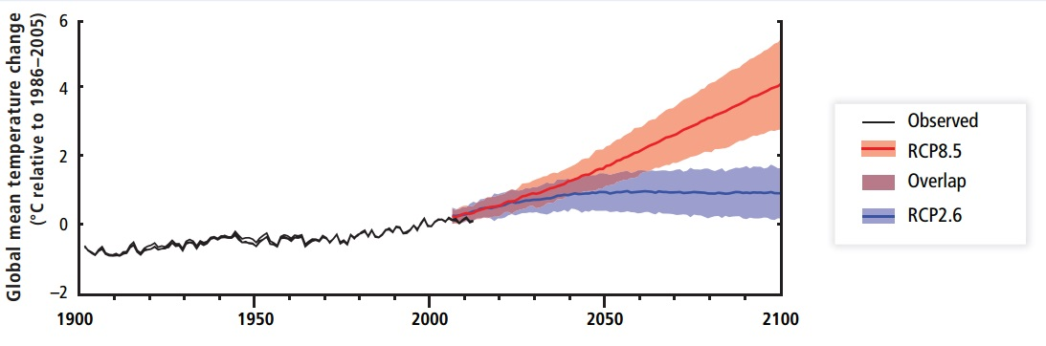
Image Source: IPCC

- What is the increase in global mean temperature since 1900?

- In approximately what year do the projected global mean temperatures for the low 2.6 and high 8.6 emissions scenarios diverge?

- In the year 2100, what is the projected global mean temperature change for the:
  - Low 2.6 emissions scenario?
  - High 8.5 emissions scenario?

- What is the difference in the 1900 and 2100 global mean temperature for the two scenarios?
  - Low 2.6 emissions scenario?
  - High 8.5 emissions scenario?

