The Greenhouse Effect: Does the Concentration of Carbon Dioxide Affect the Air Temperature in a Closed Environment?

PURPOSE
The purpose of this lesson is to investigate the effect of carbon dioxide (CO₂) concentration on air temperature in a closed environment.

EXPERIMENTAL DESIGN
In this experiment, you will construct two models (one with a natural greenhouse effect and another with an amplified greenhouse effect to answer the following question:
Does the Concentration of Carbon Dioxide Affect the Air Temperature in a Closed Environment?
Hypothesis
After reading through the methods section below, write a hypothesis to answer the questions above.
Hypothesis:

Methods

- Fill each bottle with 100 mL of water.
- Label the bottles as “control” and “CO₂.” (The bottle labeled as CO₂ will have 4 Alka-Seltzer tablets in the water).
- Cover the opening of the bottle with a clump of clay. Insert a thermometer into each bottle through the clay. Make sure the thermometer is hanging in the air above the water.
- Place the two bottles under the light at the same distance and angle.
- Tear 2 sheets of plastic wrap and set aside.
- Drop 4 Alka-Seltzer tablets into the water bottle labeled CO₂.
- Immediately cover the top of each bottle (including the thermometer inserted in the clay) loosely with the plastic wrap. Use a rubber band to secure the plastic wrap around the top of the bottle.
- Turn on the light and take an initial temperature reading.
- Record the air temperature (˚C) in each bottle at 2-minute intervals for 20 minutes. Write your results in the table and include a title for the table.
- Construct a line graph that summarizes your results. Include a title, label the axes and include a legend.

Results

Table - Title: ____________________________________________________________________________

Air Temperature (˚C) | Initial  Temp | 2 min | 4 min | 6 min | 8 min | 10 min | 12 min | 14 min | 16 min | 18 min | 20 min
Control/
0 Alka-Seltzers
Experimental/
4 Alka-Seltzers

Graph - Title: ___________________________________________________________________________

Findings
Write a summary of your results.

CONCLUSIONS: DEVELOPING EXPLANATIONS FROM EVIDENCE

- Was your hypothesis supported by the data or evidence?

- Explain your rationale for the results.

- What recommendations do you have for improving the experiment and for further study?

- Compare and contrast the model of the greenhouse effect to Earth’s greenhouse effect.

- What do you predict will happen to the global temperature of Earth as more CO₂ is added to the atmosphere?

- What is the current (past month) concentration of CO₂ in Earth’s atmosphere? ____ ppm (parts per million)
What was the concentration of CO₂ the year that you were born? ____ ppm (parts per million)
You may use: http://co2now.org/ .

THE SCIENTISTS’ EXPLANATION

The control represents a natural greenhouse effect. This bottle contains water vapor and some small amount of CO₂. The bottle with the 4 Alka-Seltzer tablets represents an environment with an increased concentration of CO₂. When Alka-Seltzer is dissolved in water, CO₂ is released and carried to the surface by small bubbles. As bubbles reach the surface, CO₂ is released into the air above the water’s surface. This equation explains what happens when an Alka-Seltzer tablet is dissolved in water.

C₆H₈O₇(aq) | + | 3NaHCO₃(aq) | → | 3H₂O(l) | + | 3CO₂(g) | + | Na₃C₆H₅O₇(aq)
citric acid | + | sodium bicarbonate | → | water | + | carbon dioxide | + | sodium citrate

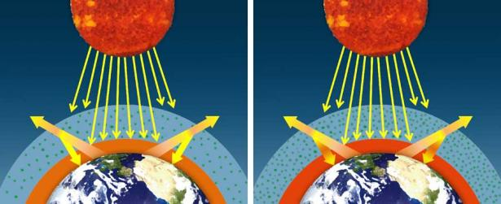
Carbon dioxide is the major greenhouse gas because of it’s relatively long lifetime in the atmosphere (approximately 100 years), and ability to abosrb infrared radiation. When agitated by infrared radiation, the CO₂ molecule vibrates and absorbs heat. It then re-radiates or emit heat in all directions, including back toward Earth. Carbon dioxide absorbs infrared radiation emitted from Earth’s surface before re-emitting the same infrared radiation as was absorbed.

If the concentration of greenhouse gases increases, then more infrared radiation will be absorbed and emitted back toward Earth’s surface, creating an amplified greenhouse effect.
When averaged over the course of a year, the amount of incoming solar radiation received from the sun has balanced the amount of outgoing energy emitted from Earth. But relatively small changes in the amounts of greenhouse gases in Earth’s atmosphere can greatly alter that balance between incoming and outgoing radiation. Earth then warms or cools in order to restore the radiative balance at the top of the atmosphere.

