Name(s) ________________________________________________ Period __________ Date ___________________

**Earth’s Energy Budget:**

**How Is the Temperature of Earth Controlled?**

**Introduction**

As you learned from the reading, the balance between incoming energy from the sun and outgoing energy from Earth ultimately drives our climate. In the following investigation you will learn about Earth’s energy budget and the processes that balance the incoming solar radiation and the outgoing terrestrial radiation. To balance the absorbed incoming energy, Earth must on average, emit the same amount of radiation to space. This balance results from several processes that occur at Earth’s surface and atmosphere.

***Directions:*** As you read the following explanations of how incoming and outgoing energy are balanced at Earth’s surface and atmosphere, fill in the blanks on the next page. Check that you have input the correct units of energy gained and lost in the diagram, by filling out each table online following the reading. Your total units of energy gained and lost should match (or balance).

**Incoming Solar Radiation**

In the reading, you learned that the average amount of solar energy falling on one square meter of level surface outside of Earth’s atmosphere is about 342 watts. To simplify this investigation, we will use a measurement of 100 units in place of 342 watts as the base unit of measurement for incoming solar radiation falling on 1 square meter. Many scientific publications also use 100 units for simplification.

Of the 100 units of incoming solar radiation, 30 are scattered or reflected back to space by the atmosphere and Earth’s surface. Of these 30 units, 6 units are scattered by the air, water vapor, and aerosols in the atmosphere; 20 units are reflected by clouds; and 4 units are reflected by Earth’s surface. The 70 units of incoming solar radiation make it into Earth’s atmosphere. This is equivalent to 240 watts per square meter (70% of 342 W/m2). The atmosphere and clouds absorb 19 units of this incoming solar radiation, leaving 51 units of solar radiation that is absorbed at Earth’s surface. These incoming 51 units consist of shorter wavelength solar radiation (mostly in the visible region of the electromagnetic spectrum), which is absorbed by land, water, and vegetation.

**Outgoing Terrestrial Radiation**

In the process of being absorbed, the radiation is converted into heat energy. Some of this absorbed radiation or heat energy is then emitted away from Earth’s surface as longer wavelength infrared radiation.

To understand how incoming solar radiation and outgoing terrestrial radiation are balanced, we will need to look at the energy gains and losses. First, we will consider Earth’s surface and atmosphere individually, and then we will look at the two together. As you read the following explanations of how incoming and outgoing energy are balanced at Earth’s surface and atmosphere, fill in the blanks on the next page.

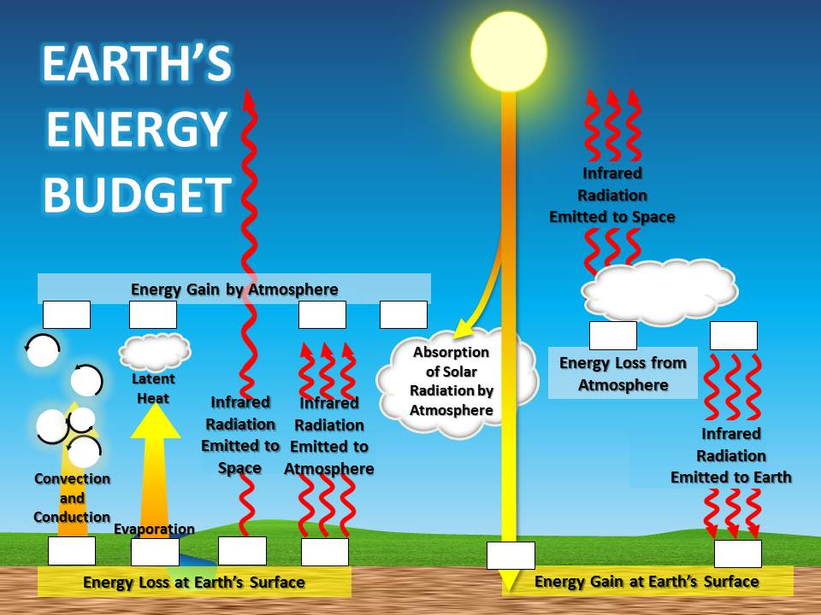

**Exploration I. The Radiation Balance at Earth’s Surface**

*Read the following section and study the diagram. As you read, use the information to balance the energy budget at Earth’s surface. To balance the energy budget, write the units of energy gained or lost for each process in the table. The total units of energy gained and lost should balance (or be the same on both sides).*

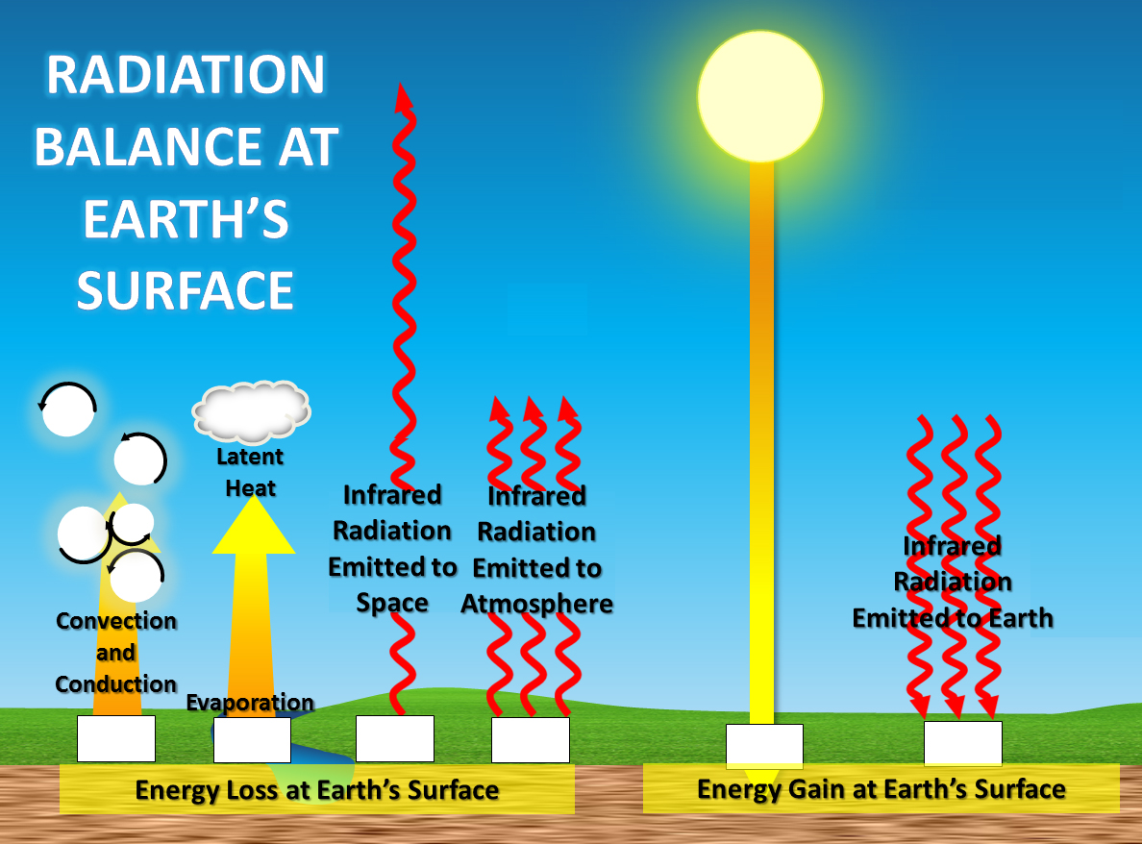

Of the 51 units of solar radiation absorbed by Earth’s surface, 23 units are used to evaporate water, causing a loss of 23 units of heat at Earth’s surface. Seven (7) units are used for the processes of conduction and convection, also causing a loss of heat at Earth’s surface. The remaining units of the original 51 units of solar radiation are emitted from Earth’s surface as outgoing infrared radiation, also known as terrestrial radiation. However, Earth actually radiates 117 units away from the surface, not 21 units (51 − 23 − 7 = 21). This happens because Earth receives solar radiation only during the daylight hours; but emits infrared radiation during both the day and the night hours. Only 6 of these 117 units are emitted into space beyond Earth’s atmosphere. The remaining 111 units of infrared radiation, which was emitted to the atmosphere from Earth’s surface, are absorbed by greenhouse gases and clouds.

Much of this infrared radiation (96 units) is then emitted back from the Atmosphere to Earth’s surface. This process is known as the greenhouse effect. Without this process, Earth would be much colder.

**Table 1. Radiation Balance at Earth's Surface**

|  |  |  |  |
| --- | --- | --- | --- |
| **Processes Causing an Energy Gain** | **Units** | **Processes Causing an Energy Loss** | **Units** |
| Absorption of Solar Radiation |  | Heat Loss by Evaporation of Water |  |
| Absorption of Infrared Radiation from Atmosphere |  | Heat Loss by Conduction and Convection |  |
|  |  | Infrared (Terrestrial) Radiation Emitted to Space |  |
|  |  | Infrared (Terrestrial) Radiation (Absorbed by clouds and greenhouse gasses) |  |
| **Total Units of Energy Gained** |  | **Total Units of Energy Lost** |  |

**Exploration 2. The Radiation Balance for Earth’s Atmosphere**

*Read the following section and study the diagram. As you read, use the information to balance the energy budget for Earth’s atmosphere. To balance the energy budget, write the units of energy gained or lost for each process in the table. The total units of energy gained and lost should balance (or be the same on both sides*).

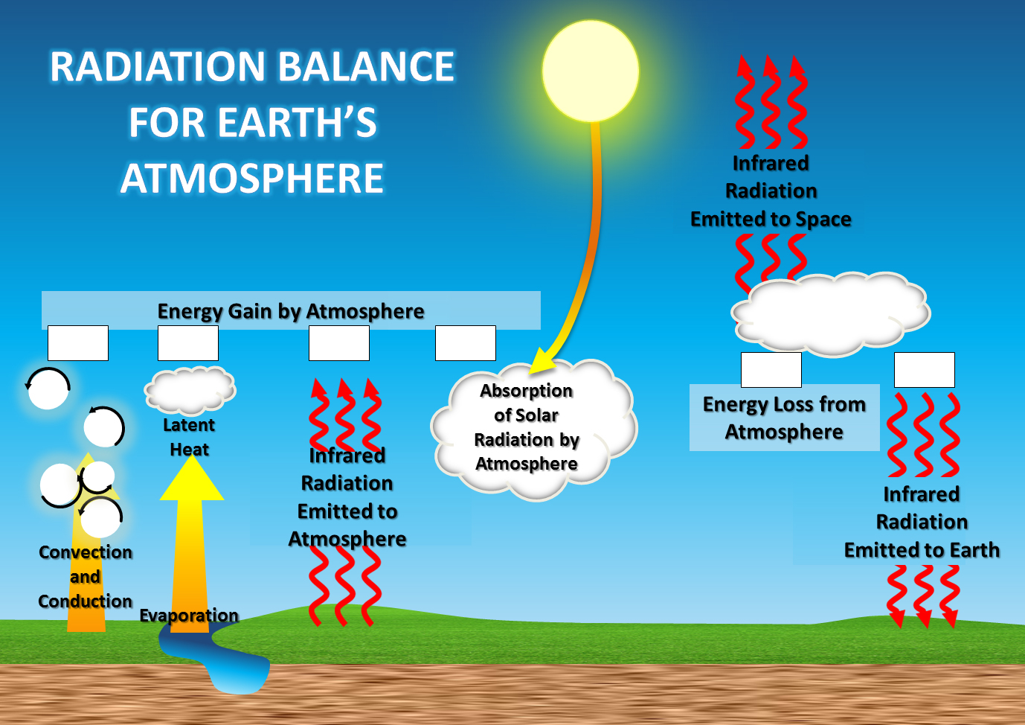Energy gains and losses are balanced not only at Earth’s surface, but also in Earth’s atmosphere. In the previous Incoming Solar Radiation section, you learned that 19 units of incoming solar radiation and 111 units of infrared (terrestrial) radiation are absorbed by greenhouse gases and clouds. Twenty-three (23) units of energy are also transferred to the atmosphere from the earth’s surface as water vapor condenses and latent heat is released. Finally, 7 units of energy (or sensible heat) are gained through the processes of convection and conduction.

The main process that causes energy loss from the atmosphere is the emission of infrared radiation inward to Earth’s surface and outward to space. As you have learned, 96 units of infrared radiation are emitted back from the atmosphere to Earth. Another 64 units of infrared radiation are emitted from the atmosphere into space.

**Table 2. The Radiation Balance for Earth’s Atmosphere**

|  |  |  |  |
| --- | --- | --- | --- |
| **Processes Causing an Energy Gain** | **Units** | **Processes Causing an Energy Loss** | **Units** |
| Absorption of Solar Radiation by Atmosphere (greenhouse gases and clouds) |  | Infrared Radiation Emitted to Earth |  |
| Absorption of Infrared (Terrestrial) Radiation by Atmosphere (greenhouse gases and clouds) |  | Infrared Radiation Emitted to Space |  |
| Latent Heat Released by Condensation of Water Vapor |  |  |  |
| Sensible Heat Released by Convection and Conduction |  |  |  |
| **Total Units of Energy Gained** |  | **Total Units of Energy Lost** |  |

**Exploration 3. Energy Balance for Both Earth’s Surface and Atmosphere**

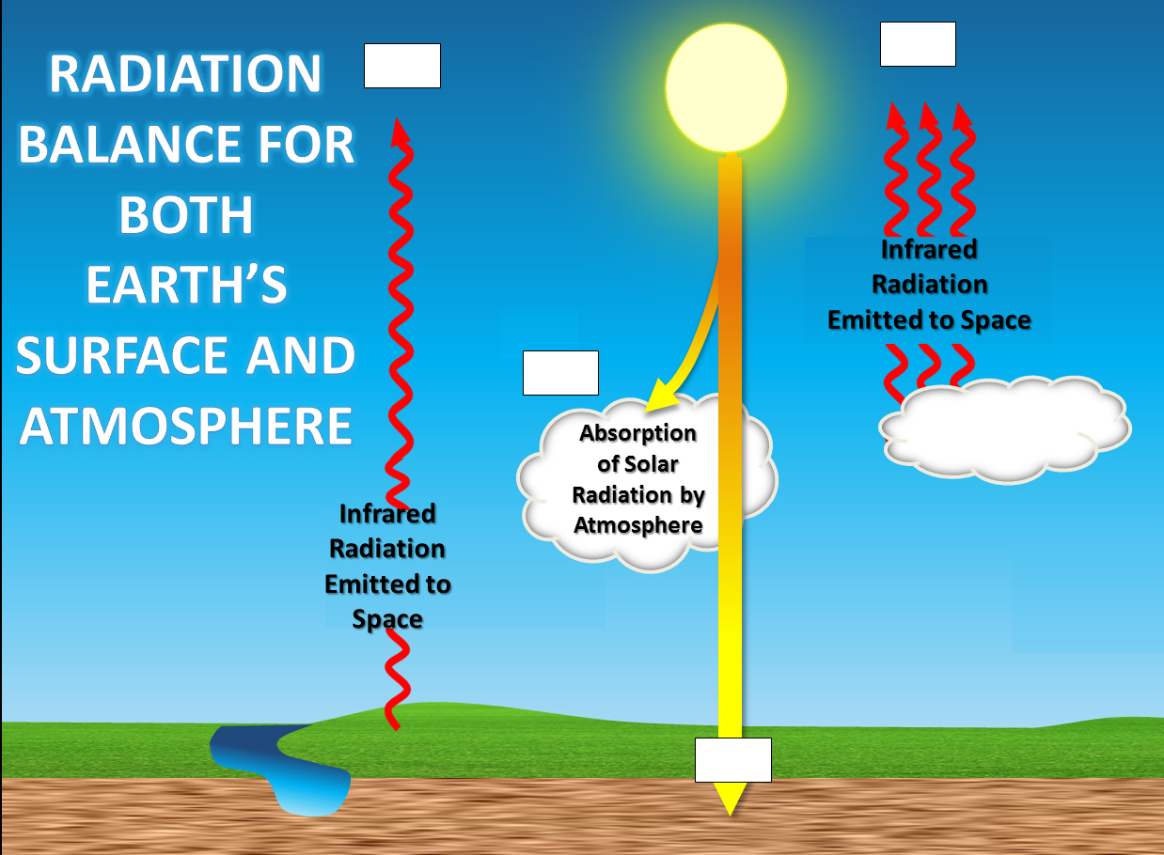*Read the following section and study the diagram. As you read, use the information to balance the energy budget at Earth’s surface. To balance the energy budget, write the units of energy gained or lost for each process in the table. The total units of energy gained and lost should balance (or be the same on both sides).*

The incoming solar radiation is absorbed at Earth’s surface (51 units) and by the atmosphere and clouds (19 units). This is balanced by the infrared radiation emitted from Earth’s surface (6 units) and from the atmosphere (64 units) which are both lost to space.

**Table 3. The Radiation Balance for Earth’s Surface and Atmosphere Combined**

|  |  |  |  |
| --- | --- | --- | --- |
| **Processes Causing an Energy Gain** | **Units** | **Processes Causing an Energy Loss** | **Units** |
| Absorption of Solar Radiation at Earth’s Surface |  | Infrared Radiation Emitted from Earth’s Surface to Space |  |
| Absorption of Solar Radiation by Atmosphere (greenhouse gases & clouds) |  | Infrared Radiation Emitted From Earth’s Atmosphere to Space |  |
| **Total Units of Energy Gained** |  | **Total Units of Energy Lost** |  |

In all of the energy exchanges described, you have seen that the energy gained is balanced by the energy lost. Because there is essentially no annual net gain or loss of energy, Earth’s average temperature remains constant. However, if this fragile balance changes and Earth either gains or loses heat energy, then the global atmospheric temperature would increase or decrease, respectively.

**Analyzing Your Findings**

**Use the information you have learned to answer the following questions.**

1. What is the first law of thermodynamics (or the law of conservation of energy)? How is this law applicable to the Earth’s energy balance?
2. Generally, what happens to the energy from the sun (incoming solar radiation) once it passes into the Earth’s atmosphere? (You do not need to include the units.)
3. What range of wavelengths is outgoing terrestrial radiation? Explain why by reviewing the Correlation Between Temperature and Radiation section.
4. In the reading, you learned that out of the 51 units of solar radiation, 21 units are available to be emitted as outgoing radiation. Explain why the earth actually radiates 117 units, not 21 units, and why Earth’s temperature isn’t so much colder.
5. What do you think would happen to the Earth’s energy balance if the concentration of greenhouse gases increases? Explain. What law explains your response?