Extreme Heat:
How Probable Are Warmer-than-Normal Seasons?

PURPOSE
The purpose of this lesson is to use mathematical probability to predict the likelihood of warmer-than-normal seasons.

EXPERIMENTAL DESIGN
In this experiment, you will compare the probability of the occurrence of warmer-than-normal seasons represented by the rolls of a normal (un-weighted) die to rolls of a weighted die. Students will answer the following question:
How Probable Are Warmer-than-Normal Seasons Today Compared to Before 1980?

Hypothesis
After reading through the methods section below and observing the dice, write a hypothesis for Part A – A Normal Die and Part B – A Weighted Die to answer the question above.

Hypothesis for Part A.:

Hypothesis for Part B:

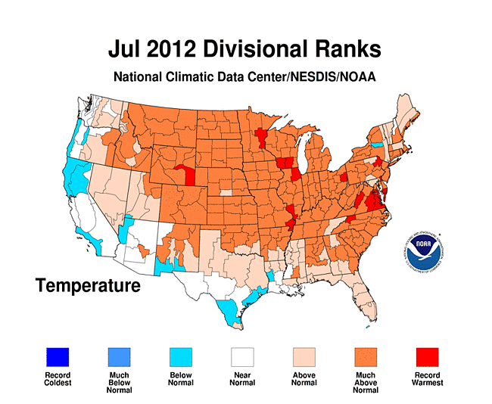

Methods
Part A. A Normal Die
- Roll the die and record the type of seasonal temperatures that occur (represented by the color facing up). The blue sides represent colder than normal seasons; the green sides, normal seasons; and the gold sides, the warmer than normal seasons.
- Make a tally mark for the type of seasonal temperatures in the table below.
- Continue to roll the die and record the seasonal temperature 20 times.
- Record the total for each type of seasonal temperature in the last row.
- If time permits use the totals and averages for the class to obtain more accurate probability of the seasons.

Results

Table 1 - The Un-Weighted Die (Die 1) – Probability of Type of Seasonal Temperatures Occurring 1951-1980
 | Type of Seasonal Temperatures
Roll Number | Colder than Normal  (Blue) | Normal  (Green) | Warmer than Normal  (Gold) | Extremely Hot  (Red)
1
2
3
4
5
6
7
8
9
10
11
12
13
14
15
16
17
18
19
20
Total

Methods
Part B. A “Weighted” Die
- Roll the die and record the type of seasonal temperatures that occur (represented by the color facing up). The blue sides represent colder than normal seasons; the green sides, normal seasons; and the gold sides, the warmer than normal seasons, and the red sides, extremely hot seasons.
- Make a tally mark for the type of seasonal temperatures in the table below.
- Continue to roll the die and record the seasonal temperature 20 times.
- Record the total for each type of seasonal temperature in the last row.
- If time permits use the totals and averages for the class to obtain more accurate probability of the seasons.

Results
Table 2. The Weighted Die (Die 2) - Probability of Type of Seasonal Temperatures In More Recent Years
 | Type of Seasonal Temperatures
Roll Number | Colder than Normal  (Blue) | Normal  (Green) | Warmer than Normal  (Gold) | Extremely Hot  (Red)
1
2
3
4
5
6
7
8
9
10
11
12
13
14
15
16
17
18
19
20
Total

Results
Construct a bar graph that shows the number of times you rolled each type of seasonal temperatures for each of the two die.

Graph – Title: __________________________________________________________________________

Colder Colder Normal Normal Warmer Warmer Hot Hot
(<1980) (Recent) (<1980) (Recent) (<1980) (Recent) (<1980) (Recent)

Findings
Write a summary of your results.

CONCLUSIONS: DEVELOPING EXPLANATIONS FROM EVIDENCE

- What should be the probability of colder-than-normal seasonal temperatures with the un-weighted die (which represent the years 1951-1980)? What probability did the class calculate?

- What should be the probability of warmer-than-normal seasonal temperatures with the un-weighted die (which represents the years 1951-1980)? What probability did the class calculate?

- What should be the probability of colder-than-normal seasonal temperatures with the weighted die (which represents more recent years)? What probability did the class calculate?

- What should be the probability of a warmer-than-normal seasonal temperatures with the weighted die (which represents more recent years)? What probability did the class calculate?

- What should be the probability of extremely hot seasonal temperatures with the weighted die (which represents more recent years)? What probability did the class calculate?

- What do you think that the weighted die represents in this activity?

THE SCIENTISTS’ EXPLANATION
Climate is the average weather over a specified period of time. Generally (according to the World Meteorological Foundation) this time period is 30 years. Recently, climate scientists have been noticing trends in climate data that show changes in global climate. One of these changes is an overall warming of surface land and ocean temperatures referred to as global warming.

Dr. James Hansen, the most well-known climate expert, and his colleagues analyzed extreme temperatures from all over Earth for the years 1951 through 2010. They compared the temperatures for the more recent decades (1981 – 2010) to those for the earlier decades (1951 -1980) by calculating the frequency of temperatures. These results indicated that extreme high temperatures were 100 times more likely to occur in the recent decades than in the earlier decades.

Hansen used the analogy of the weighted or loaded dice to explain the difference between the probability of extremely high temperatures for the two time periods. The first die represents the normal distribution of temperatures between 1951 and 1980. On this die, two sides (the green color) represent normal temperature seasons; two sides (the blue color), cooler than normal, and two (the gold color), warmer than normal. The second die, represents the temperatures for 1981 through 2010. The second die has one side (the green color) representing normal temperature seasons; one side (the blue color), cooler than normal; three sides (the gold color), warmer than normal; and one side (the red color), extremely hot seasons.

Statisticians use the term, standard deviation, to quantify how far the range of a set of data differ from the average range. Unusually hot or unusually cold seasons naturally occur less frequently that the average temperature seasons. The second die represents the probability of warmer than normal or extremely hot seasons occurring on a warmer Earth. You can still have colder than normal seasons, but they are less frequent.

