Name(s) ________________________________________________ Period __________ Date ___________________
How Has Concentration of Atmospheric Carbon Dioxide Changed Since the Industrial Revolution?

In this exploration, you will watch a video of an animated graph that traces the 800,000-year history of atmospheric CO₂. This video was developed by NOAA’s Earth System Research Laboratory’s Global Monitoring Division. The animated graph shows CO₂ concentrations collected from various locations using different methods of collection. The animated graph begins by showing recent CO₂ concentrations between 1979 and 2012. The graph then presents CO₂ concentrations back to 2,000 years ago, and then ever further back, to 800,000 years before common era (BCE). After you view the video once, play it again to answer the following questions. You may need to pause the video to study the graph. Note the legend in the upper right corner of the graph on the right. This legend will continue to update as you continue viewing the video.

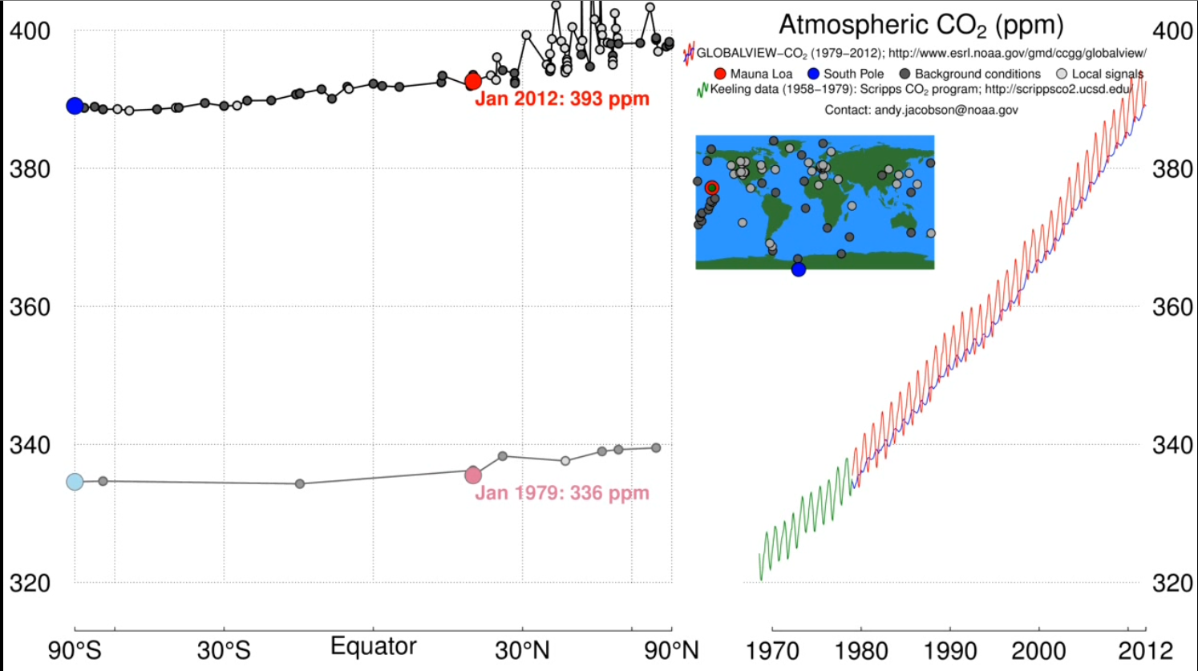

- Watch the video of the animated graph and listen to the narration. After watching the entire video once, read through the questions below and re-play the video focusing on the line showing the changing (moving) CO₂ concentration in the graph on the left side of the animation. You will also need to look at the time clock.
- Describe the general change in atmospheric CO₂ concentration over a year.

- Why do you think that atmospheric CO₂ concentration varies over a year?

c. How do the patterns of Northern and Southern Hemisphere CO₂ concentrations compare in the winter and summer months?

d. Which hemisphere shows more variation in the annual concentration of CO₂ between winter and summer months?

- The industrial revolution began in Europe in the mid-1700s and the American industrial revolution began in the mid-1800s. Fill in the table below by stopping the video at specific times to get the CO₂ concentration for that time period.
Stop Times | Year | CO₂ Concentration (ppm)
2:23 (see concentration written in red on left graph) | 1979
 | 2012
2:45 (estimate concentration using the graph on the right of the animation) | 1750
 | 1850

- What is the current level of atmospheric CO₂? (Use http://co2now.org/ to find the most recent recording.)

- Calculate the rate of change for the time periods listed below. Complete the table by answering the following:
  - What is the range of years for the time period listed?
  - What is the difference in CO2 concentration for the time period listed?
  - Divide the CO₂ concentration by the range of years.
  - Multiply the yearly CO2 concentration by 100.

Time Period | Range of Years | Difference in CO₂ Concentration | Rate of Change of Atmospheric CO2 Concentrations (per year) | Rate of Change of Atmospheric CO2 Concentrations (per century)
1979 to 2012
1750 to 1850

- Use the data you recorded in previous questions to complete the table below and answer the questions. (Note: for some answers, you may need to multiply by 100 to get the CO2 concentration per century.)

Investigation and Question # | Time Period | Rate of Change of Atmospheric CO₂ Concentrations (per century)
Causes Investigation 1 – Question 3 | Average for glacial and interglacial periods in the 800,000 year data | 1.03 ppm
Causes Investigation 2 Question 4 | 1750-1850
Causes Investigation 2 Question 4 | 1979-2079 (based on recent rate)

- Determine the percentage increase since the American Industrial Revolution. Complete the table by following the steps below.
- Subtract the 1850 CO₂ concentration from the most recent CO₂ concentration.
- Divide the result by the 1850 CO₂ concentration.
- To get the total percent increase, multiply the resulting value by 100.
 | Atmospheric CO₂ concentration | The difference between current CO₂ | Difference divided by beginning concentration | Percentage Increase
Since 1850

