Name(s) ________________________________________________ Period __________ Date ___________________
How Has the Concentration of Atmospheric Carbon Dioxide Changed Over 800,000 Years?
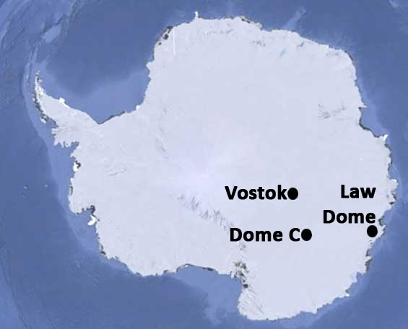
INTRODUCTION
Take a look at the graph below. Does the data on the interactive graph look familiar? In the last module, you learned how temperatures changed over time by analyzing temperature data derived from Dome C ice cores in Antarctica. You examined temperature data over 800,000 years and saw a similar pattern of peaks (interglacial periods) and valleys (glacial periods). Not too far from Dome C is the Law Dome, which is named after Australian scientist and explorer, Philip Law. In this investigation, you will analyze CO₂ data obtained from the Law Dome and compare it to 800,000 years of temperature data.
Use the interactive, time-series graphing tool to answer the following questions.
- 1 Look at the concentration of atmospheric CO₂ and describe the general pattern that you see over the past 800,000 years.

- Calculate the rate of change for three sequential periods of extreme low to high concentrations of CO2. To do this, zoom in on the time series graph to the time periods listed in the table below. In the table, you are given a specific date to examine. Complete the table below by answering the following:
- What is the range of years for each high to low period listed?
    - What is the low CO₂ concentration for this time period?
    - What is the high CO₂ concentration for this time period?
    - Subtract your low CO₂ concentration from your high CO₂ concentration and divide by the range of years.
___CO₂ _{For Year 2} – CO₂ _{For Year} ₁___
Year₂ – Year₁
  - Determine the average rate of change per 100 years (century) for each time period by multiplying your estimated rate of change per year by 100.

Time  Periods | Years Ago | Range of Years  (Between Low and High) | Estimated CO₂ concentration | Estimated Rate of Change  (ppm/year) | Average Rate of Change for estimated high CO₂ concentration (ppm/100 years)
Low | 340,456 | 340,456-332,919=7,537 | 200.7 ppm | 298.6-200.7/7,537=  0.013 ppm/year | 0.013 ppm/year *  100 years =  1.3 ppm/100 years
High | 332,919 |  | 298.6 ppm
Low | 252,739
High | 242,346
Low | 138,185
High | 128,609

- What is the average rate of change of the three time periods analyzed in the table above?

- Check the box for temperature on the interactive graph. Compare the patterns of CO₂ concentrations and temperature anomalies over the past 800,000 years. What do you observe about these patterns?

