Global Climate Modeling
Climate models are used by scientists to understand present climate and project future changes in climate. A climate model is a computer program that describes the most important components, processes, and interactions in the climate system. They are based on mathematical equations that represent the basic laws of physics governing the interactions (processes) that occur in the climate system. Scientists use the computer to simulate how changes in the flow of energy and mass impacts the climate system. A more recent type of climate model is the Global circulation model (GCM), which is a three-dimensional computer model of Earth’s air-land-water system. These may also be referred to as atmospheric-ocean general circulation models (AOGCMs).
Climate models are tested against observations so that scientists can see if the models correctly simulate what happened in the past. If the model accurately shows what we observed in the past (such as temperature trends), we can be more confident about the model’s projections of future observations.
Over the past 30 years, scientists have developed a better understanding the climate system and computers have become more powerful. This increased scientific knowledge and computer capability has led to greater accuracy in climate models used by the Intergovernmental Panel on Climate Change (IPCC). The recent IPCC fifth assessment report, known as AR5, compared results of 40 different GCMs to make predictions about the future. Climate models will continue to become more accurate with increased spatial resolution.
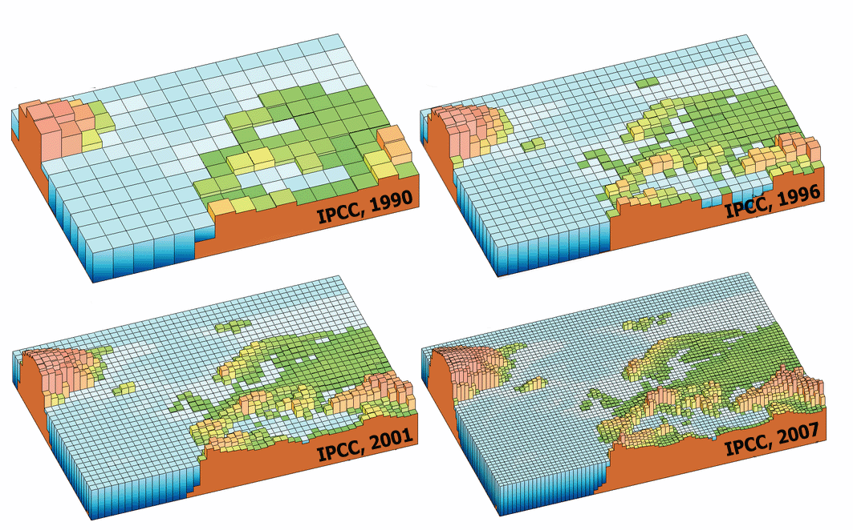
Increasing Resolution of Global Climate Models. Image Source: IPCC
To predict how human activities could affect the climate system, scientists change factors in their models (such as, greenhouse gas concentrations, land use and land cover). The degree of future global warming ultimately depends on the amount of greenhouse gas concentration in the atmosphere both now and in the future. In order for scientists to compare their research and make projections about the impacts of climate change, it is necessary to have a standard set of scenarios as a starting point. A scenario is not a projection or a prediction, but a possible way in which the future may develop. Scenarios depend on population growth, economic development, use of fossil fuels, life-style choices, land use and rate of deforestation, technological change, availability and use of energy alternatives, etc. We will discuss these factors in the next module, “What We Can Do,” and how the actions that we take now affect future climate.
In the publication of the recent IPCC fifth assessment report, known as AR5, for Working Group II––Impacts, Adaptation, and Vulnerability, these scenarios are called Representative Concentration Pathways, or RCPs. Each scenario is based on different concentrations of greenhouse gas emissions which affect radiative forcing––the imbalance that develops at the top of the atmosphere between the amount of incoming solar radiation and the outgoing terrestrial radiation.
Forcings and Feedbacks

You learned in the module, “Energy: The Driver of Climate,” that the balance between incoming energy from the sun and outgoing energy from Earth ultimately determines Earth’s climate. Incoming solar energy from the sun primarily consists of shorter wavelengths of energy, mostly in the visible part of the electromagnetic spectrum. To balance the absorbed incoming energy, Earth must, on average, emit the same amount of radiation back into space. Because Earth is colder than the sun, it emits radiation at much longer wavelengths (in the infrared part of the spectrum). The Stefan-Boltzman law explained that if the incoming and outgoing energy are not in balance, a planet either cools or warms.
Global average temperature is determined by the balance of incoming and outgoing energy from Earth. This energy balance may be altered in three ways. The sun’s intensity or solar radiation may increase or decrease. The reflection of solar radiation by clouds, aerosols (airborne particles), snow, or ice may increase or decrease, causing either more or less radiation to be reflected to space rather than to Earth’s surface. Or the amount of infrared radiation from Earth’s atmosphere to space may increase or decrease.
Any factor that causes a change to Earth’s energy balance is known as a radiative forcing or a forcing. A radiative forcing is expressed in W/m² (watts per square meter). Forcings may be either natural- or human-caused (also known as anthropogenic). Forces may also be positive or negative. A positive forcing, such as that produced by increasing concentrations of greenhouse gases, tends to warm the Earth’s surface. For example, when the concentration of greenhouse gases increases, there is a net imbalance in the overall budget. This occurs because greenhouse gases absorb and emit infrared radiation back to Earth. The higher the concentration of greenhouse gases, the more energy is emitted back to Earth’s surface, causing Earth’s average global temperature to increase. This is positive forcing because it causes additional energy to be taken up by the Earth’s climate system. A negative forcing, such as that produced by aerosols, that reflect solar energy, tends to cool the Earth’s surface.
To understand impacts of climate change, it also important to review climate feedbacks. Often, one change in the climate system causes an impact that triggers even more of a change. These changes can be positive or negative. For example, as Arctic sea ice, which has a high reflectivity or albedo, melts, the ice is replaced by a darker ocean, which has a low reflectivity or albedo. The darker ocean absorbs more heat and warms even further and causes more melting of sea ice. Another example is that as the atmosphere warms, it can hold more water vapor. Water vapor is also greenhouse gas, so warming is enhanced further. A positive feedback intensifies the forcing, which in turn, results in more rapid warming. A negative feedback weakens the forcing and slows the warming. For example, as the atmosphere warms more trees may be able to grow at higher latitudes and remove more carbon dioxide. Climate feedbacks are an active focus of research among climate scientists.
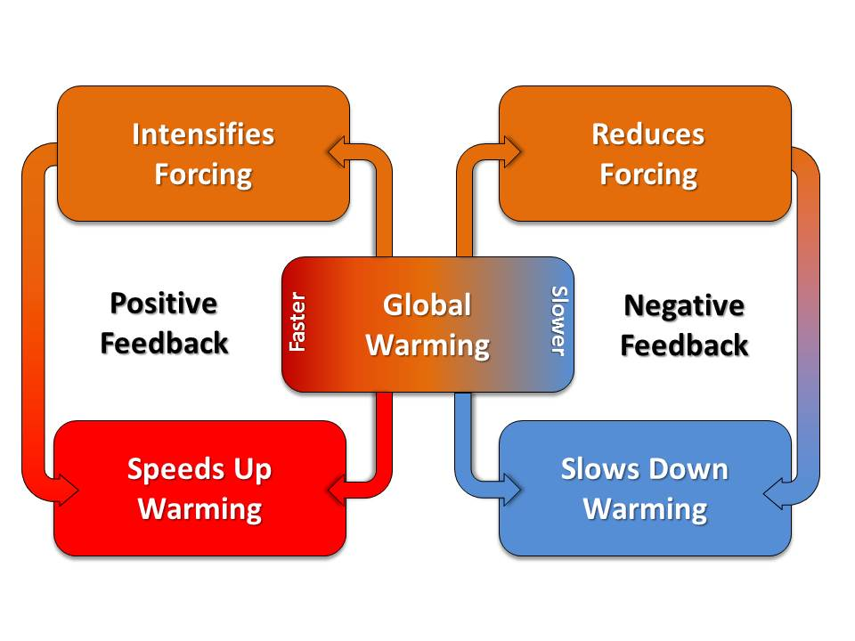
Future Scenarios and RCPs
Positive and Negative Climate Feedbacks

There are four scenarios or RCPs used in the 2013 IPCC Fifth Assessment Report. Each. Each scenario is based on different amounts of radiative forcing––the imbalance that develops at the top of the atmosphere between the amount of incoming solar radiation and the outgoing terrestrial radiation. The amounts of radiative forcing range from 2.6 to 8.5 W/m² (watts per square meter).
In this module, we will focus on the lowest (best case) and the highest (worst case) emission scenarios. The best case scenario means that by 2100, there is a net radiative forcing of 2.6 W/m². The highest (worst case) scenario means that by 2100, there is a net radiative forcing of 8.5 W/m². The table below compares the future scenarios for different variables and the lowest and highest RCP. The RCP 2.6 presents a future where ambitious greenhouse gas emissions reductions would be required over time. The RCP 8.5 presents a “business as usual” future of exponential growth of greenhouse gas concentrations.
Scenarios and Representative Concentration Pathways (RCPs)
 | RCP 2.6 | RCP 8.5
Reliance on Fossil Fuels | Declining use | Heavy use
Energy Intensity | Low | High
World Population by Year 2100 | 9 billion | 12 billion
CO₂ Emissions by 2100 | Stay at today’s level until 2020, then decline and become negative in 2100 | Three times today’s emissions
Methane Emissions | Reduced by 40% | Rapid increase
Use of Croplands | Increase due to bio-energy production | Driven by an increase in population
Reference: A Guide to Representative Concentration Pathways
In this module, you will see how scientists are using these scenarios to make projections of impacts on global mean temperature, melting ice, sea level rise, precipitation and drought patterns, and ecosystems and societies.
Confidence and Likelihood: How the IPCC Addresses Uncertainty

One aspect of science that is often confusing to the public is the lack of certainty. However, uncertainty is an inherent part of scientific research. If scientists were certain about a finding, they would NOT need to continue to research the problem.
The authors of the IPCC reports evaluate their own scientific understanding of the research. They use both qualitative and quantitative metrics to communicate their degree of certainty.
The qualitative metric is referred to as the confidence level. Confidence levels are based:
- The type, amount, quality and consistency of evidence (described as limited, medium, or robust) and
- The degree of scientific agreement (described by the low, medium or high).

Combining the level of evidence and agreement results in one of five levels of confidence: very low, low, medium, high, and very high. When these qualifiers are used, they are written in italics. For example, “there is very high confidence that glaciers world-wide are persistently shrinking as revealed by the time series of measured changes in glacier length, area, volume and mass.” Note in the figure above that as the amount of evidence and agreement increases, the confidence increases.
Confidence Based on Evidence and Agreement. Image Source: IPCC

The quantitative metric used by the IPCC is referred to as likelihood and expressed probabilistically (based on statistical analysis of observations or model results, or expert judgment). The table below defines the terms used to describe the likelihood (% probability) of an outcome. Again, these terms are written in italics, just as with confidence level.
Likelihood (% Probability) of an Outcome
Certainty | Likelihood of the Outcome
Virtually certain | 99–100% probability
Very likely | 90–100% probability
Likely | 66–100% probability
About as likely as not | 33–66% probability
Unlikely | 0–33% probability
Very unlikely | 0–10% probability
Exceptionally unlikely | 0–1% probability

For example, “For average annual Northern Hemisphere temperatures, the period 1983–2012 was very likely the warmest 30-year period of the last 800 years (high confidence) and likely the warmest 30-year period of the last 1400 years (medium confidence).”

